太保國中 111學年度 第一學期 二年級 英文科第二次段考試題 出題：王蕙瑩 班級 _______ 座號 ____ 姓名 __________
一．聽力測驗 15% (每題1分)
(A) 聽CD，配合圖片，選出最適當的答案。 5%
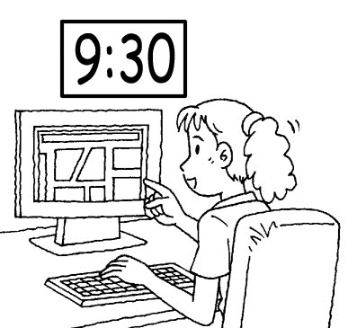
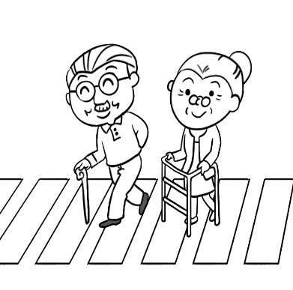
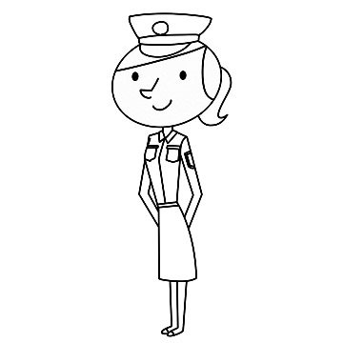
( ) 1. ( ) 2. ( ) 3.

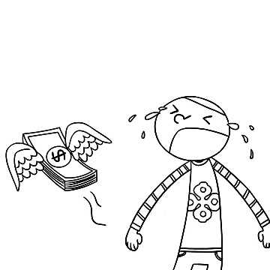
( ) 4. ( ) 5.
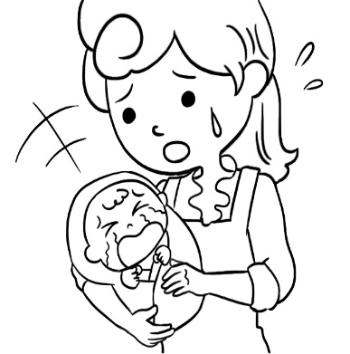

(B) 基本問答： 5%
每題均有三個選項，請根據所聽到的內容，選出一個最適合的回應。
( ) 6. (A) Sure. It’s not for me. (B) Hey, I’m busy, too.
(C) OK. Do you have a map?
( ) 7. (A) Because I’m a teenager. (B) Because I’m good at acting.
(C) Because I never thought about it.
( ) 8. (A) You can wash it again. (B) You can wear my T-shirt.
(C) You look great in the bright color.
( ) 9. (A) I don’t like it at all. I can’t take my eyes off it.
(B) Very much. I fell asleep (睡著的) in the middle of it.
(C) Very much. It caught my eye at the beginning of it.
( )10. (A) Maybe yes, when they are famous. (B) Yes, it’s a very famous game.
(C) No, but they have to fight one another.

(C) 言談理解：5%
每題均有三個選項，請根據所聽到的對話與問題，選出一個最適當的答案
( )11. (A) He is acting. (B) He is crying. (C) He is uploading his video.
( )12. (A) Before the meeting. (B) After the meeting.
(C) In the middle of the meeting.
( )13. (A) A writer (B) A singer. (C) A pro gamer.
( )14. (A) She is a housewife. (B) She enjoys doing the housework.
(C) She plans to go to the movies with the man.
( )15. (A) After her dad got home. (B) Before she mopped the floor.
(C) After she washed the dishes.

二、文意選擇 30% (每題2分)
( )16. Charlie won the race, and his parents were ＿＿＿ of him.
(A) top (B) bright (C) clear (D) proud
( )17. Allen writes about news events（新聞事件）for a newspaper. He is a ＿＿＿.
(A) reporter (B) police office (C) singer (D) secretary
( )18. A：What is Daniel doing?
B：He’s looking for his keys. He can’t get into his house ＿＿＿ them.
(A) next to (B) through (C) past (D) without
( )19. My family and I had a short ＿＿＿ in Taitung last month. We went to the
Harvest（豐收）Festival and danced with the indigenous people（原住民）there.
(A) hand (B) stay (C) question (D) song
( )20. I just got a ＿＿＿ on my cellphone. It was from Richard, and he said, “I will
（將）be five minutes late.”
(A) message (B) headache (C) stomach (D) coat
( )21. Please ＿＿＿ the trash on the floor and throw（丟）it in the trash can.
(A) pick up (B) think of (C) walk along (D) give up
( )22. The science camp yesterday ______ any fun. Gary and I ______ lots of fun.
(A) wasn’t; weren’t (B) wasn’t; didn’t have
(C) didn’t have; weren’t (D) didn’t have; didn’t have
( )23. A：Look! Your cat is dancing! ______ it do that before?
B：Yes, it ______ did when it was happy.
(A) Does; usually (B) Did; seldom (C) Did; danced (D) Did; always
( )24. ______ is my sister’s hobby（嗜好）. She finishes ______ at least（至少）five
books every month.
(A) To read; to read (B) To read; read
(C) Reading; reading (D) Reading; to read
( )25. Playing in the water ＿＿＿ wonderful on a hot summer day.
(A) is (B) are (C) has (D) have
( )26. Taking photos and buying basketball cards ＿＿＿ my favorites. I never get
tired of（厭倦）them. (A) is (B) are (C) to be (D) being
( )27. Chris ＿＿＿ a lot many years ago, but he ＿＿＿ now.
(A) exercises; doesn’t (B) exercised; doesn’t
(C) exercised; does (D) exercises; didn’t
( )28. A：I usually get up at eight fifteen from Monday to Friday.
B：Do you get up at ______ eight on weekends, too?
A：No, I usually get up at ______ on weekends.
(A) a quarter past; eight forty-five (B) a quarter to; a quarter to nine
(C) a quarter after; eight and a quarter (D) a quarter before; eight forty-five
( )29. When I ______ Ben at seven last night, he ______ on the sports field with Mary.
They both looked（看起來）very happy.
(A) saw; is jogging (B) see; was jogging
(C) saw; was jogging (D) see; is jogging
( )30. My sister has a gift ____ painting. (A) at (B) to (C) with (D) for

三、題組 30% (每題2分)
My son, Zack, is 16 years old. He enjoys cooking, so he goes to a vocational school and learns cooking skills there. After school, he always practices cooking at home and makes delicious dinner for us. His food is good for health because __31__. He dreams of __32.__ a cook in the future. __33.__ He plans to run the restaurant with his sister, Belle. She can help serve the dishes when he prepares food in the kitchen. __34.__ us, my husband and I can sometimes help clean the restaurant when we have free time. I am very proud of him because he has a very clear goal as a(n) __35.__.
vocational school 職業學校 skill 技巧 run 經營 serve 上菜 goal 目標

( )31. (A) I often help him do the housework
(B) he seldom washes vegetables (蔬菜)
(C) he uses a lot of vegetables
(D) we go to the gym and exercise
( )32. (A) be (B) ╳ (C) being (D) to be
( )33. (A) He wants to be a waiter.
(B) He plans to go camping with us.
(C) He likes to go jogging every morning, too.
(D) He also wants to open a restaurant.
( )34. (A) As for (B) Without (C) In fact (D) For example
( )35. (A) waiter (B) writer (C) teenager (D) actor

Steve was a junior high school teacher. He had to go to bed early, but his
neighbor, Bob, got home late from work every night. He made a lot of noise
when he walked and always threw his shoes on the floor. This kept Steve awake.
One day, Steve went and had a talk with Bob. Steve said, “I go to work at
6 a.m. and go to bed at 9 p.m. Could you be quiet after 9 p.m.?” Bob said,
“I’m sorry. I will keep the noise down.” Over the next five days, Bob put his
shoes down quietly and walked on tiptoe after he got home.
The other day, Bob met Steve and asked, “Did you sleep well?”
Steve said, “No, I didn’t.”
“Why not?” asked Bob.
“I usually went to bed after you threw your shoes on the floor. I waited for
that noise to come every night, but it never did,” said Steve
neighbor 鄰居 awake 清醒的 will 將會 on tiptoe 踮著腳尖 well 好地

( )36. How did Bob feel after Steve talked to him?
(A) Sick. (B) Happy. (C) Poor. (D) Sorry.
( )37. Why COULDN’T Steve sleep well after he had a talk with Bob?
(A) He had to work at nights.
(B) Bob still made a lot of noise every night.
(C) Bob kept the noise down, but it was still very loud.
(D) He kept waiting for Bob to throw his shoes on the floor.

The following is Mike and Judy’s schedule for the trip to Taipei last weekend.

schedule 行程 store 店 national 國家的 stadium 體育場

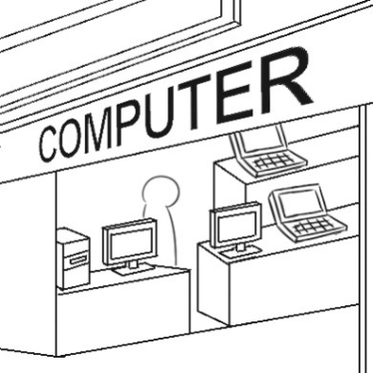
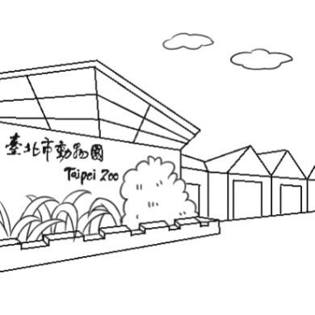
( )38. Where were Mike and Judy at 11 a.m. last Saturday?
(A) (B)

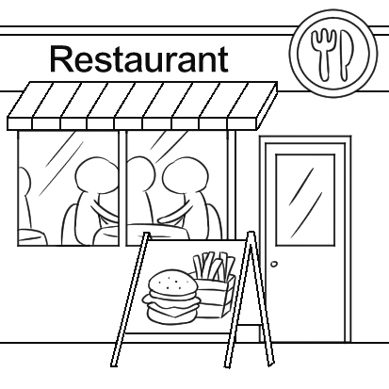
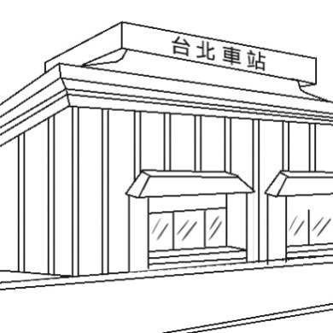
(C) (D)

( )39. Mike and Judy just enjoyed the cable car (纜車) ride and delicious tea. Where
did they go next?
(A) To Maokong. (B) To Taipei Zoo.
(C) To Yangmingshan. (D) To Tianmu Baseball Stadium.
( )40. Which is true about Mike and Judy?
(A) They stayed at Yangmingshan for three hours.
(B) They watched a baseball game on the first day.
(C) They visited some famous restaurants in Taipei.
(D) They didn’t see animals or hike in the mountains.

Sam got the flyer after school, and he gave it to his mom. She is reading it now.

flyer（廣告）傳單 indoor 室內的 candy shop 糖果店 funny 有趣的 price 價錢

( )41. What can you buy at Jojo Indoor Playground?
(A) Warm tea. (B) Medicine. (C) Fruit. (D) Candy.
( )42. Last Saturday, Sam and his mom went to Jojo Indoor Playground. They had a
lot of fun there. What DIDN’T Sam do?
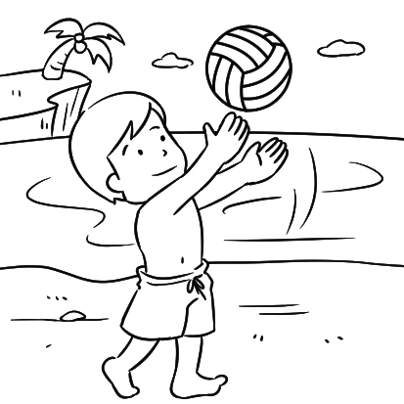
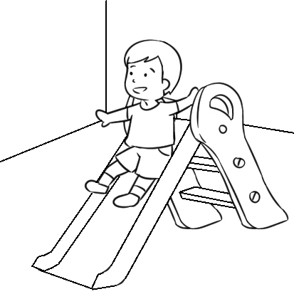
(A) (B)

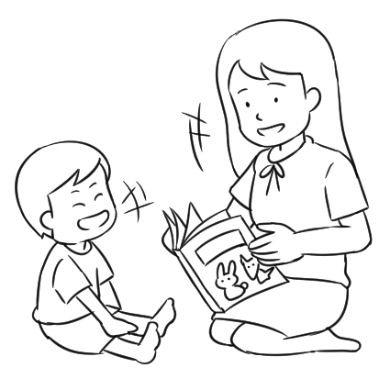
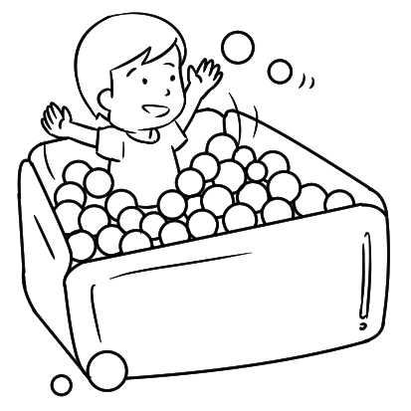
(C) (D)

(Jenny is giving a report in front of the class.)
“Do you have your dream job?” We asked our classmates this question. We
also asked the “yes” group, “What do you want to do in the future?”
Please look at the graphs. According to our study, 85% of our classmates have
their dream jobs (see Graph 1). As for the kind of jobs (see Graph 2), eleven of
our classmates want to be YouTubers, and nine want to be singers or actors. Eight
of them want to become public servants. Six choose other kinds, like cooks,
writers, or reporters.

As a result of our research, we found half of the class want to work in the
entertainment business. They think those jobs are more interesting than others.
That was a big surprise to us.

according to 根據 public servant 公務員 result 結果 research 研究 entertainment 娛樂 surprise 使人驚訝的事 more…than…. 比…更…..

( )43. What is the first paragraph (段落) talking about?
(A) The number of students in Jenny’s class.
(B) The research questions of Jenny’s report.
(C) The most popular dream job for teenagers.
(D) Different kinds of entertainment business jobs.
( )44. What does “That” mean in this report?
(A) In Jenny’s class, six students had no idea about their future.
(B) Many students want to get into the entertainment business.
(C) Jenny’s group asked their classmates, “Do you have your dream job?”
(D) The school can do more to help students prepare for the world of work.
( )45. What can we learn from Graph 1 and Graph 2?
(A) No one wants to be a singer or an actor.
(B) There are thirty-four students in Jenny’s class.
(C) Being a YouTuber is the most (最…) popular dream job.
(D) 85% of Jenny’s classmates want to be YouTubers in the future.

四、寫出正確動詞形式 (每格1分，每格不限一個字) 10%
___________ 46. She is not good at ___ (cook), so she always eats out.
___________ 47. It is not polite (有禮貌的) ___ (talk) in class.
___________ 48. When I _____ (see) Mary then, she ____ (talk) to my mom.
___________
___________ 49. Jenny enjoys ____ (help) poor people. She is so nice.
___________ 50. He can’t stop __＿ (talk) because he likes to share his school life with
other people.
___________ 51. I don’t feel good. I think I need ＿＿ (see ) a doctor now.
___________ 52. Look! The little dog ___ (run) in the yard.
___________ 53. Don’t forget ____ (bring) your English homework tomorrow.
___________ 54. My teacher had us ____ (clean) the classroom every morning.

五、依提示作答與翻譯 10%
55. It is not easy for these students to speak English. (以動名詞為句首改寫句子)
__________________________________________________________________ 2%
56. Jason finished his homework at 7:45 p.m..
Jason played the computer games at 8:00 p.m. (用…after…合併成一句)
__________________________________________________________________ 2%
57. 成為 YouTuber 對青少年來說是很令人興奮的。他們想要有名又受歡迎。
It is ____ for teenagers to be YouTubers. They want to be _____ and _____. 3%
58. 你昨天打電話給我時，我正在幫助一位老太太過馬路。
__________________________________________________________________ 3%

太保國中 111學年度 第一學期二年級 英文科第二次段考試題 手寫卷
班級 _______ 座號 ____ 姓名 ____________

四、寫出正確動詞形式 (每格不限一個字) 10%

46. ___________________________

47. __________________________

48. __________________________ _________________________

49. __________________________

50. __________________________

51. __________________________

52. __________________________

53. __________________________

54. ___________________________

五、依提示作答與翻譯 10%

55. __________________________________________________________________ 2%

56. __________________________________________________________________ 2%

57. ________________ _________________ _________________ 3%

58. __________________________________________________________________ 3%

太保國中 111學年度 第一學期 二年級 英文科第二次段考試題 答案卷

1. C 2. C 3. A 4. B 5. C 6. B 7. B 8. B 9. C 10. A
11. A 12. B 13. C 14. A 15. C 16. D 17. A 18. D 19. B 20. A
21. A 22. B 23. D 24. C 25. A 26. B 27. B 28. A 29. C 30. D
31.C 32. C 33. D 34. A 35. C 36. D 37. D 38. B 39. D 40. B
41. C 42. C 43. B 44. B 45. C
( 1 ~ 15題，每題1分；16 ~ 45題，每題2分 共75分)

五、寫出正確動詞形式 (每格一分，每格不限一個字) 10%
46. cooking 47. to talk 48. saw was talking 49. helping
50. talking 51. to see 52. is running 53. to bring
54. clean

55. Speaking English is not easy for these students. 2%

56. Jason played the computer games after he finished his homework. 2%

57. exciting famous popular

58. When you called me yesterday, I was helping an old woman cross (to cross) the road. 3%

太保國中 111學年度 第一學期 二年級 英文科第2次聽力試題
(A) 聽CD，配合圖片，選出最適當的答案。 5%
1. (A) Jane is a busy housewife. She loves cooking.
(B) Jane enjoys being a singer. She’s good at writing songs, too.
(C) Jane is proud to be a police officer. It’s her dream job.

2. (A) The old man was walking past the young lady then.
(B) The old man was crossing the forest then.
(C) The old man was crossing the road then.

3. (A) The girl was using the computer at half past nine.
(B) The girl was reading a map at a quarter to nine.
(C) The girl was playing a computer game at a quarter past nine.

4. (A) When the mother put her son down, he began to cry.
(B) The mother was worried because her son kept crying.
(C) When the mother was making milk, her son began to cry.

5. (A) The boy felt sad because he wasn’t healthy.
(B) The boy is crying because he just lost a game.
(C) The boy feels terrible because he lost his money.

(B) 基本問答：每題均有三個選項，請根據所聽到的內容，選出一個最適合的回應。 5%
6. Judy, could you pick up the phone? I’m in the middle of something.
7. Why do you want to be an actor?
8. My T-shirt isn’t dry yet. What can I do?
9. How do you like the movie?
10. Do pro gamer make a lot of money?

(C) 言談理解：每題均有三個選項，請根據所聽到的對話與問題，選出一個最適當的答案。 5%
11. W: Hey, check out this video. M: Is the YouTuber really crying?
W: Well, not really. It’s all acting. M: Why is he doing that?
W: He wants more people to watch his videos.
Question: What is the YouTuber doing?

12. M: Why are you late for the meeting this morning?
W: It was rainy, and there were a lot of cars on the road.
M: Why didn’t you call me? It was an important meeting!
W: I tried to call you, but I couldn’t reach you.
Question: When did the talk take place?

13. B: What’s your dream job?
G: My mom wants me to be a singer. However, I love playing games, so I want to be a pro gamer.
What about you?
B: I love telling stories, so I want to be a writer.
Question: What does the girl want to be?

14. M: Martha, let’s go to the movies today.
W: Sorry. I don’t have time.
M: Come on. Why are you always busy?
W: Because there’s always a lot of housework to do.
M: But you have a whole day to do it.
W: Well, why don’t you do the housework, and I go to work?
Question: Which is true about the woman?

15. G: Dad, I did a lot of housework today?
M: Really? I’m all ears.
G: First, I mopped the floor in the living room. After that, I did the dishes. And then I washed the
dirty clothes.
M: You did all of them?
G: Yes. Mom gave me 50 dollars for doing all the housework.
Question: When did the girl wash the dirty clothes?

太保國中 111學年度 第一學期 二年級
英文科第二次段考 口說試題

1. A lot of kids and teenagers want to be pro gamers.
2. Tina flew over to the rocks and then picked up a big one
with her beak.
3. By the way, do you want to be a YouTuber in the future?
4. How can rocks help us get the water?
5. It was half past three, and Tina and Billy finished the work
and got ready to enjoy the water.

太保國中 111學年度 第一學期 二年級
英文科第二次段考 口說試題

1. A lot of kids and teenagers want to be pro gamers.
2. Tina flew over to the rocks and then picked up a big one
with her beak.
3. By the way, do you want to be a YouTuber in the future?
4. How can rocks help us get the water?
5. It was half past three, and Tina and Billy finished the work
and got ready to enjoy the water.

