1. **聽力(基本問答)-根據聽到的內容，選出合適的回應**

**(每題1分，共7分)**：

1. (A) Thank you.  
   (B) No problem.  
   (C) That can’t be easy.
2. (A) Sleep.  
   (B) Chicken.  
   (C) Basketball.
3. (A) Yes, he’s always there.  
   (B) Yes, he’s always happy.  
   (C) Yes, he’s always hungry.
4. (A) No, he never does.  
   (B) No, there aren’t any.  
   (C) Yes, he likes weekends.
5. (A) We’re finally here.  
   (B) Oh no. This is the wrong way.  
   (C) Walk along the street. It’s next to the clothes shop

on your right.

1. (A) I don’t really care.  
   (B) Yes, everything’s fine.  
   (C) Thank you very much.
2. (A) It must be very hard.  
   (B) It’s rainy here these days.  
   (C) It’s on the chair in the corner.
3. **聽力(言談理解)-根據聽到的對話內容與問題，選出正確的**

**答案**：**(每題1分，共8分)**

1. (A) The girl trains twice a day.  
   (B) The boy can get another win.  
   (C) The boy is on the school team.
2. (A) He usually sleeps early.  
   (B) He always gets up early.  
   (C) He is never late for work.
3. (A) He gets another win.  
   (B) He trains almost every day.  
   (C) He plays with his brother on weekdays.
4. (A) They usually visit their friends.  
   (B) They seldom go out on weekends.  
   (C) They never plan for their weekends.
5. (A) By bus.  
   (B) On foot.  
   (C) By metro.
6. (A) He is eating.  
   (B) He has a map.  
   (C) He can’t find the way.
7. (A) It’s next to the cake shop.  
   (B) It’s across from the restaurant.  
   (C) It’s between the toy shop and the restaurant.
8. (A) Sunny Hotel is across from the park.  
   (B) Go down Apple street, the hotel is at the corner.  
   (C) Walk straight through the park, and you can see the hotel.

**三、字彙選擇**：**(每題1分，共16分)**

1. Leo 　　　 every day.　  
    (A)jumps　(B)trains　(C)eats (D)travels



1. The restaurant is open on 　　　.　  
    (A)weeks 　(B)weekdays　(C)weekends



1. You need to pull（拉）a rope hard with your team during the

　　　 games.　  
(A)basketball　(B)swimming 　(C)tug of war　(D)rope jumping

1. We seldom notice athlete’s 　　　, sweat, and tears.　  
   (A)blot 　(B)blood　(C)black　(D)block
2. On Christmas Eve, Santa Claus（聖誕老人）rides on his 　　　 and gives gifts to kids.　  
   (A)boat　(B)carpet　(C)horse　(D)sleigh
3. I join a 　　　 club at school. Now I can do some easy card

tricks（招數）.　  
 (A)man　(B)music　(C)magic 　(D)Maggie

1. Barry doesn’t write with his right hand. He writes with his 　　　 hand. 　  
   (A)back　(B)left　(C)wrong　(D)dangerous
2. A: This is the 　　　 way.  
   B: It’s OK. Let’s ask the police.　  
   (A)right　(B)left　(C)magic　(D)wrong
3. The 　　　 is so blue. Today is another sunny day.　  
   (A)ski　(B)sky　(C)skate　(D)corner
4. Sam’s friends are 　　　 for him.　  
   (A)caring　(B)noticing　(C)cheering (D)cheating



1. If you get lost in the train station, you can 　　　 someone for help.　  
   (A)go　(B)drive 　(C)ask　(D)run
2. Look at the timetable. How often does BUS No. 8 run?  
   　  
   (A)Every ten minutes.

(B)Every half an hour.

　(C)Every one and a half hours.

　(D)Every other hour.

1. Take a 　　　 after dinner. That brings you good health.　  
   (A)walk　(B)work　(C)will　(D)wake
2. There is a very nice 　　　 near our school. We usually go to a movie once a month.　  
   (A)park　(B)hotel　(C)museum　(D)theater
3. I am late, so I 　　　 run to school.　  
   (A)most　(B)need　(C)must　(D)try
4. Mom goes to the supermarket on Mondays and Thursdays. She goes there 　　　 a week.　  
   (A)twice　(B)twelve　(C)once (D)twenty

**四、文法選擇**：**(每題1分，共15分)**

1. He 　　 busy on Saturday morning. He can’t go out with us.　  
   (A)does usually　(B)usually does 　(C)is usually　(D)usually is
2. Superman is very strong and healthy. He is 　　　 sick.　  
   (A)always　(B)often　(C)seldom　(D)still
3. A: Does Tom ever go to school late?   
   B: 　　　 He always goes to school early.　  
   (A)No, never.　 (B)No, he never.

(C)No, he is never. (D)Yes, he is.

1. The player 　　　 late for games.　  
   (A)goes never　(B)seldom is　(C)doesn't often　(D)is usually
2. A: 　　　 does Dora go to the library?   
   B: Twice a month. 　  
   (A)How many　(B)How old 　(C)How 　(D)How often
3. A: 　　　 you usually finish your homework early?   
   B: Yes, we do. We seldom do it late.　  
   (A)Are　(B)Do　(C)Is　(D)Does
4. Albert: How often do you play basketball?   
   George: 　　　　  
   (A)It’s in the morning.

(B)Yes, I always play basketball.

(C)I don’t like to go out.

(D)I do it twice a week.

1. A: 　　　   
   B: No, I watch movies once a week.　  
   (A)How do you like the movie?

(B)Don’t you like the park?

(C)Do you watch movies once a month?

(D)How often do you watch movies?

1. A: 　　　 can I get to the new restaurant?  
   B: Go along Main Street and turn right Second Road. You’ll see it.　  
   (A)What 　(B)Who 　(C)Where 　(D)How
2. A: Excuse me. Where is Dodo’s Restaurant?  
   B: It’s 　　　 the toy shop and the museum. 　  
   (A)during　(B)between　(C)next 　(D)across
3. Go down the road and the supermarket is 　　　 the left.　  
   (A)in　(B)on　(C)to　(D)from
4. Let’s walk 　　　 the river in the evening. Flowers there are beautiful now. 　  
   (A)cross　(B)along　(C)between　(D)behind
5. A: Mom, I’m on my way home.  
   B: Great, Honey. Are you driving home?  
   A: No, I’m 　　　.　  
   (A)going by car　 (B)taking metro

(C)going in a car　 (D)taking a train

1. Tom: How can I get to the museum?  
   Mary: 　　　 the bridge and go down Fulin Road.

It is on the right.　  
(A)Walk cross　(B)Check　(C)Across (D)Cross

1. The toy shop is 　　　 to the hotel.　  
   (A)across 　(B)next　(C)near (D)Behind

**五、克漏字選擇**：**(每題2分，共16分)**

1. Taipei is a good place for visitors（訪客）to visit.

47. Most people choose（選擇）to take Taipei Metro to where they want. Also, taking the bus is convenient（方便）, too. Ubike is another way to travel in Taipei City. On the metro, 48. , so it’s very clean. Each train comes every 1.5 minutes to 15 minutes depending on（依據）the line and time . It saves time. However, some people like to take a bus because 　49.　. They don’t need to walk so much.

As for（至於）those people who want to save money, they rent（租借）the Ubikes. People can work out（鍛鍊身體） and go on sightseeing（觀光）　50.　. How smart they are!

47. (A) It is famous for its hot weather.

　(B) Taipei doesn’t have many shops and parks.

　(C) The city is more than 100 years old.

　(D) There are many ways to travel around here.  
48. (A) there is free wi-fi

　(B) there are many people

　(C) people can sit or stand

　(D) people can’t eat or drink  
49. (A) it’s never to be late

　(B) there are many people

　(C) buses go into the streets

　(D) buses are new and beautiful  
50. (A) about the night　 (B) in the sky

　(C) at the same time　(D) without the light

1. Girl: Excuse me. 　51.　 any watch shop near here?  
   Boy: Yes, there is one on Green Street.  
   Girl: Can you 　52.　 me the way there?  
   Boy: Sure. Go straight down the road 　53.　 three blocks

and turn left. Then you will（將）see the watch shop

on your right.  
Girl: OK, I see. And is there a bank around here?  
Boy: Well, I don’t know.  
Girl: It’s OK. I can 　54.　 another person.

Thank you so much.

51. (A) Is there　(B) Are there　(C) Is it　(D) Are they  
52. (A) ask　(B) put　(C) give　(D) show  
53. (A) in　(B) on　(C) of　(D) for  
54. (A) ask　(B) put　(C) give　(D) show

**五、閱讀測驗**：**(每題2分，共38分)**

1. **Why Do I Have to Clean My Teeth?**  
   　 We eat and drink every day. Our teeth get dirty

easily（容易地）. Dirty teeth usually hurt, and it even

leads to（導致）getting sick. Everyone should（應該）

clean their teeth every day. You should always brush（刷）

your teeth after breakfast, lunch, and dinner. Never eat too

many desserts（甜點）because they are very bad to your

teeth.

55. Which one is NOT a reason（理由）for cleaning teeth?  
 (A) Dirty teeth usually hurt.   
 (B) We want to get sick.  
 (C) Our teeth get dirty easily.   
 (D) We eat every day.  
56. According to（根據）the article（文章）, when should we

brush our teeth?  
 (A) After we eat things.　 (B) On Mondays.　  
 (C) Before we eat desserts.　(D) Every weekend.

57. The cram school is next to the 　　　.   
 (A) park

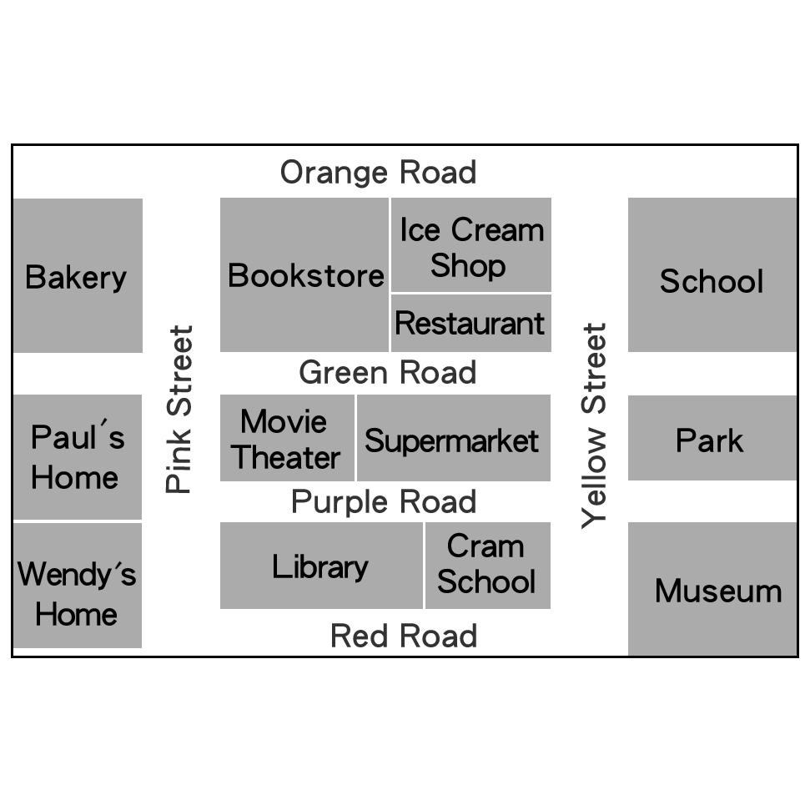

　(B) museum

　(C) library

　(D) bookstore  
58. Paul’s home is 　　　 the movie theater.  
 (A) next to

　(B) beside

　(C) in front of

　(D) across from  
59. On the corner of Pink Street and Orange Road is

the 　　　.  
 (A) bakery

(B) museum

　(C) supermarket

　(D) ice cream shop   
60. I’m at Wendy’s home. How can I get to the ice cream shop?  
 (A) Walk along Red Road and turn right on Yellow Street.

(B) Walk along Pink Street and turn right on Orange Road.

　(C) Go along Purple Road and turn right on Yellow Street.

　(D) Go along Pink Street and turn left on Green Road.

1. There is a new tourist attraction in Kaohsiung—National Kaohsiung Center for the Arts (Weiwuying).



61. Ms. Greene is checking out Weiwuying’s website（網站）and

reading the information（資訊）: “Take the metro, Orange Line,

to Weiwuying Station. Take Exit 6. The Center is on your right.”

Which part on the website is she looking at?  
 (A) ABOUT. (B) PROGRAMS. (C) GETTING HERE.  
62. Ms. Greene is taking her twenty-five students to “Weiwuying

Showtime: Fun Music!”. She teaches in Kaohsiung. All her

students live in Kaohsiung, but she doesnʼt. How much money

does she need to pay（付）?

1. NT$0 (B) NT$100 (C) NT$2,080 　(D) NT$2,600

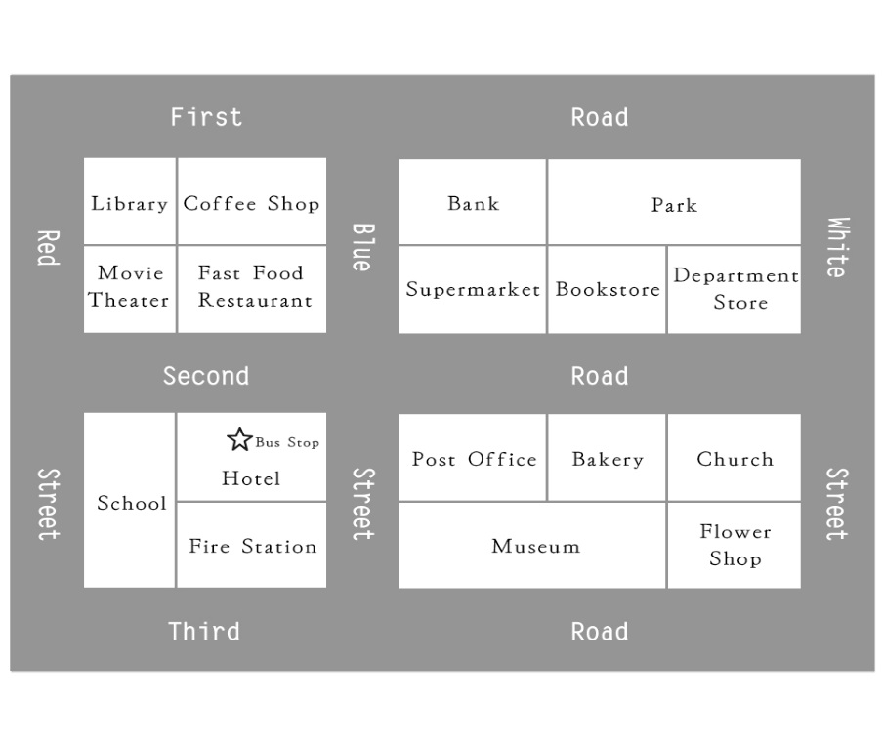  
63. Bob is studying in the library. His friend is waiting for him

in the museum. How can he get there?  
 (A) Go down First Rd. and turn right on White St. It’s on

the right.　  
 (B) Go down Red St. and turn left on Third Rd. It’s on

Third Rd., and next to the Fire Station.　  
 (C) Go down Red St. and turn left on Second Rd. It’s on

the corner of Second Rd. and Blue St.　  
 (D) Go down First Rd. and turn right at the first corner.

Go straight again for two blocks. It’s on the left.  
64. Rita usually buys bread in the bakery. It is across from her

office. Where does Rita work?  
 (A) Bank.

　(B) Museum.

　(C) Bookstore.

　(D) Fast Food Reataurant.  
65. A store is having a big sale（特價）now. You can see a lot

of people on the corner of White Street and Second Road.

Which is the store?  
 (A) Church.

　(B) Bookstore.

　(C) Flower shop.

　(D) Department store.

1. Alice is a senior high school student. She is always busy on the weekend. On Saturday, she usually gets up early and jogs with her friends in the morning. After lunch, she and her friends often play basketball at the park. In the evening, she goes to dance class. On Sunday, she also jogs in the morning. Then, she does her homework. After dinner, she usually reads her favorite books and goes to bed early. She is really busy.

66. What do we know about Alice?  
 (A) She usually goes to bed early on Sunday.   
 (B) She usually goes to dance class on Sunday.   
 (C) She usually does her homework on Saturday.  
67. According to the reading, what is Alice usually doing

on Saturday afternoon?

(A)  
 

(B)



(C)



1. Jason Yang wants to take his family to ABC Park this weekend. There isn’t a train or metro to get there, so he is checking the website for information.

Hours  
 　Weekday: 9:30 a.m. – 5:00 p.m.  
　 Weekend: 9:30 a.m. – 5:30 p.m.  
 　 February: 9:30 a.m. – 7:00 p.m.  
  
 TICKETS  
 NT$300 / person  
 ***20% off for students with students IDs*** 30% off for groups with over 30 people  
  ***50% off for elders（年長者）over 65, kids under 6,***

***and disabled people（身障者）***  
  
 PARKING  
 Car / Bus NT$100  
 Motorcycle NT$30  
  
 ACTIVITY  
 ．Great shows on the hour after 11a.m.  
 ．Free walk around the park  
 ．Free park trains every 30 minutes

68. In February, people can stay longer in ABC Park.

What holiday or festival is it related to（有關）?  
 (A) Christmas.

　(B) Halloween.

　(C) Moon Festival.

　(D) Chinese New Year.

69. Jason plans to drive with his wife and two kids there, watch

shows and take park trains through the park. His son is 13

years old, and his daughter is 5. How much should they

pay?  
 (A) NT$990.

　(B) NT$1,090.

　(C) NT$1,200.

　(D) NT$1,300.  
70. Which is WRONG?   
 (A) ABC Park is open at 9:30 a.m. all year round.

(B) People can get to ABC Park by car, bus, motorcycle,

or train.　  
 (C) The word “groups” means 30 people or more come to

visit together.　  
 (D) The show plays once an hour, and the park train runs

twice an hour.

(In Kevin’s home)

Mrs. Wei: Get up, Kevin! Don’t you need to meet your friends

at the metro station at eight thirty?  
Kevin: What time is it?  
Mrs. Wei: It’s eight o’clock now.  
Kevin: It’s still（仍然）early. I can get there in ten minutes

by bus.  
Mrs. Wei: No. You need more exercise. Why don’t you go

there on foot?  
Kevin: On foot? It’s too far away（遠的）. Maybe I can

ride my bike there.  
Mrs. Wei: Well, it’s raining, and it’s dangerous.  
Kevin: All right. I’m always late anyway（反正）.

(At the metro station)  
Eric: Hi, Tony. You’re early today.  
Tony: Why do you say that? I’m always on time.  
Eric: But, where’s Kevin? Is he coming by bike?  
Tony: He always rides his bike. Maybe he’s still on his way.  
Eric: How can we get to Taipei Children’s Amusement Park?  
Tony: We go to Shilin by metro first. Then we can take a bus.  
Eric: Look! It’s Kevin.  
Kevin: Hi, guys. Am I late?

71. How does Kevin get to the metro station?  
 (A) On foot.

(B) By bike.

(C) By bus.

72. What do we know about Kevin?  
 (A) He gets up at eight thirty.   
 (B) He’s going out with his friends today.   
 (C) He gets to the metro station on time.

73. What can we know from the dialogue?  
 (A) Kevin and his friends get to Taipei Children’s Amusement

Park at eight thirty.   
 (B) Taipei Children’s Amusement Park is ten minutes away

from Kevin’s home by bus.   
 (C) Kevin and his friends can take a bus at Shilin to Taipei

Children’s Amusement Park.

**Enjoy the summer vacation!!!**