太保國中109學年度第一學期第1次段考一年級英語科試卷(P.1)
命題教師:李貞凌 命題範圍:B1Starter~B1R1 ___ 年 ___ 班 ___ 號 姓名 ______
PART I聽力測驗
1~40題請將答案畫在電腦卡上
I.辨識句意(根據聽到的內容，選出正確的圖片代碼)：5%
( ) 1. (A) (B) (C)
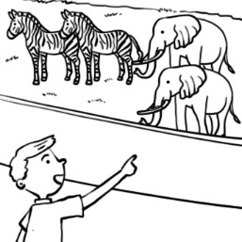 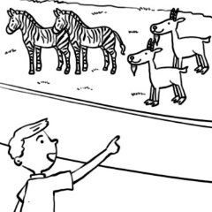 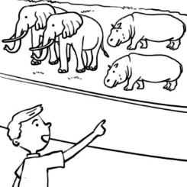
( ) 2. (A) (B) (C)
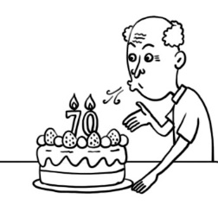 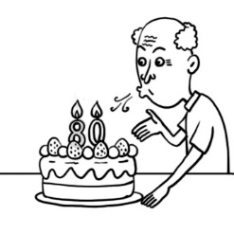 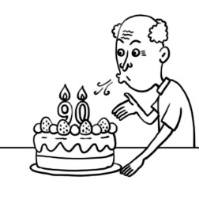
( ) 3. (A) (B) (C)
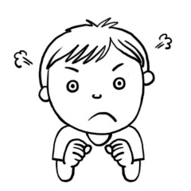
( ) 4. (A) (B) (C)
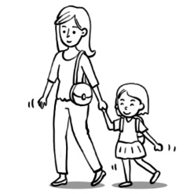 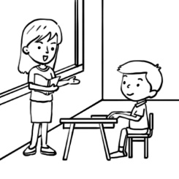
( ) 5. (A) (B) (C)
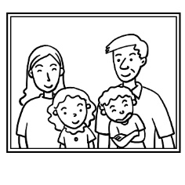 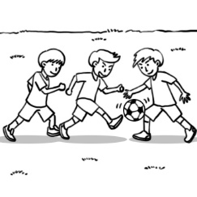

II.基本問答(根據聽到的內容，選出合適的回應)：5%
( ) 6. (A) He is strong. (B) He is a student. (C) He is twenty years old.
( ) 7. (A) Me, too. (B) I’m fine. (C) I’m from Taiwan.
( ) 8. (A) It’s five thirty. (B) It’s 2020-1234. (C) That is my phone.
( ) 9. (A) She’s my sister. (B) She’s from India. (C) She’s 19 years old.
( )10. (A) Yes, he is. (B) No, she is short. (C) Yes, he is very strong.

III.言談理解(根據聽到的對話內容與問題，選出正確的答案)：10%
( )11. (A) The girl. (B) The boy. (C) The game.
( )12. (A) 1:15 p.m. (B) 1:30 p.m. (C) 1:50 p.m.
( )13. (A) The boy’s mom is a doctor (B) The boy’s mom is a teacher.
(C) The boy’s mom is a housewife.
( )14. (A) He is strong. (B) He is the girl’s friend. (C) He is thirteen years old.
( )15. (A) It’s eight. (B) It’s eight fifteen. (C) It’s seven fifteen.

PART II讀寫測驗
IV.綜合測驗:40%
( )16. A: Where are you from? B: ___ are from Japan.
(A)I (B)She (C)We (D)You
( )17. Taipei 101 is a very well-known(有名的) ___.
(A)footprint (B)landmark (C)forest (D)tomb
( )18. A:___ is that man? B:He’s Andy, my son.
(A)What (B)How (C)Where (D)Who
( )19. Nancy is ___.
(A)eight years (B)an eight-year-old girl (C)eight old (D)a eight girl
( )20. The letter(字母) before(在…前面) “O” is ___.
(A)M (B)N (C)U (D)P
( )21. ___ strong bear?
(A)That is a (B)Is that (C)Is a that (D)Is that a
( )22. A:Aren’t these your cats? B:___
(A)No, they are. (B)Yes, these are.
(C)Yes, they are. (D)No, these are.
( )23. People in my class ___ so nice .
(A)is (B)are (C)am (D)be
太保國中109學年度第一學期第1次段考一年級英語科試卷(P.2)
命題教師:李貞凌 命題範圍:B1Starter~B1R1 ___ 年 ___ 班 ___ 號 姓名 ______ ( )24. A:Is the question(問題) easy? B:___
(A)Yes, it’s a piece of cake. (B)Yes, they are easy.
(C)No, it’s from Taiwan. (D)No, I’m not easy.
( )25. It is ___ small apple, not a big one.(A)an (B)a (C)the (D)x
( )26. A:What ___? B:Geese.
(A)are this (B)is that (C)are those (D)is these
( )27. The ___ is so beautiful.
(A)feet (B)goose (C)people (D)women
( )28. 10:53
What time is it?
(A)It’s seven after ten. (B)It’s seven to eleven.
(C)It’s fifty three after ten. (D)It’s ten to fifty three.
( )29. A:___ is your brother?
B:He’s sixteen.
(A)What (B)How old (C)What time (D)Where
( )30. A:Are you Mrs. Li’s students? B:____.
(A)Yes, I am. (B)Yes, you are. (C)Yes, we are. (D)Yes, he is.
( )31. A:___ B:It’s 2745876.
(A)How old is your mother? (B)Where is the girl from?
(C)What’s your phone number? (D)Who is the man?
( )32. Is ___?
(A)clean your room (B)your clean room
(C)clean room your (D)your room clean
( )33. Those are fish. ___ swimming(游泳) in the river(河).
(A)He’s (B)You’re (C)It’s (D)They’re
( )34. A:What is that? B:___
(A)Sorry, I’m late. (B)The tomb of my grandpa.
(C)It is seven thirty. (D)It is from Taiwan.
( )35. The king has three ___. Queen Ann is his favorite.
(A)sons (B)wifes (C)houses (D)wives

V.克漏字測驗:10%
Judy is the contestant(參賽者) in the talent show(才藝表演) and she is talking to the host(主持人), Andy.

Andy: Hi, Judy. 36
Judy : I’m twenty one.
Andy: 37 are you from?
Judy : I’m from Taipei.
Andy: 38 are you?
Judy : I’m a nurse.
Andy: 39 you nervous(緊張的)now?
Judy : No, I’m 40 for the show.
Andy:Great! Now it’s your show time.

( )36. (A)What’s your name? (B)What do you do?
(C)Who are you? (D)How old are you?
( )37. (A)Where (B)What (C)Who (D)How
( )38. (A)What (B)Who (C)Where (D)How
( )39. (A)Is (B)Are (C)Am (D)Be
( )40. (A)angry (B)clean (C)ready (D)late
41~59題請將答案寫在第3頁的答案欄
VI.根據圖示，用英文填入正確的稱謂(每格1分):6%
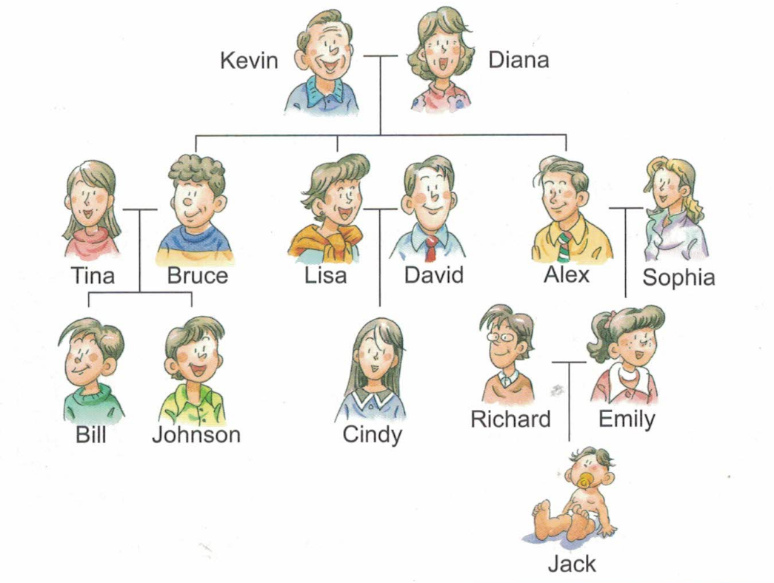
太保國中109學年度第一學期第1次段考一年級英語科試卷(P.3)
命題教師:李貞凌 命題範圍:B1Starter~B1R1 ___ 年 ___ 班 ___ 號 姓名 ______
41. Alex is Sophia’s ____.
42. Kevin is Johnson’s ____.
43. Bruce and Lisa are ____ and ____.
44. Cindy is Lisa’s ____.
45. Diana is Alex’s ____.

VII.文意字彙:10%
46. We keep(養) a cat because(因為) there are many(許多) m e in this house.
47. A:It’s 7:20. Are you r y for school?
B:Yes, let’s go now.
48. My grandmother is y g. She’s only(只有) 42 years old.
49. A:Who’s the girl in the p e?
B:Oh, that’s my sister. She’s in the USA now.
50. Ice cream is my f e food. I have(吃) it every day.
51. A:Is that boy your s ?
B:No, his father is Mr. Wu.
52. Miss Wang is a y at Jack because he is late for class.
53. Vegetables(蔬菜) and f t are good for your health(健康).
54. You have to put on(穿上) your coat(外套). The wind(風) is so s g outside(外
面).
55. Peter and his twin(雙胞胎) brother,David are d t. He is short but David is tall.

VIII.翻譯(56~57每格1分；58~59每題3分):14%
56. A:你父親是做什麼的?
B:他是農夫。
A: ___ your father?
B: ___ a ___.
57. A:現在幾點? B:3:48
A: ___ ___ is it?
B: ___ three ___-___.
58. 這是Bruce寄來的明信片。
_______________________________________
59. Tina的妹妹是個有名的女演員。
_______________________________________

答 案 欄

____ 年 ____ 班 ____ 號 姓名 ____________
VI.根據圖示，用英文填入正確的稱謂(每格1分):6%

41. ____________

42. ____________

43. ____________ ____________

44. ____________

45. ____________
VII.文意字彙:10%

46. ____________ 47. ____________

48. ____________ 49. ____________

50. ____________ 51. ____________

52. ____________ 53. ____________

54. ____________ 55. ____________
VIII.翻譯(56~57每格1分；58~59每題3分):14%

56. ____________ ____________ ____________

57. ____________ ____________ ____________ ____________ ____________

58. ___________________________________________________

59. ___________________________________________________
解答
- 5 ACCAA 6-10 CABAA 11-15 CACAB
16-20 CBDBB 21-25 DCBAB 26-30 CBBBC
31-35 CDDBD 36-40 DAABC
VI.根據圖示，用英文填入正確的稱謂(每格1分):6%

41. husband

42. grandfather

43. brother sister

44. daughter

45. mother
VII.文意字彙:10%

46. mice 47. ready

48. young 49. picture

50. favorite 51. son

52. angry 53. fruit

54. strong 55. different
VIII.翻譯(56~57每格1分；58~59每題3分):14%

56. What’s He’s farmer

57. What time It’s forty eight

58. This is a postcard from Bruce.

59. Tina’s sister is a famous actress.

