太保國中 111學年度 第二學期 二年級 英文科第一次段考試題 出題：王蕙瑩 班級 _____ 座號 ____ 姓名 _________
一．聽力測驗 15% (每題1分)

(A) 辦識句意：
每題均有三張圖片，請依據所聽到的句子，選出符合描述的圖片。 5%
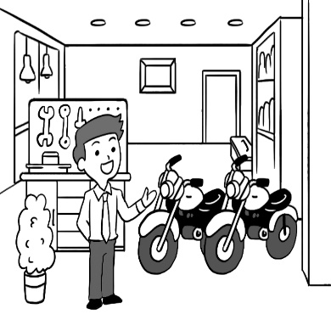
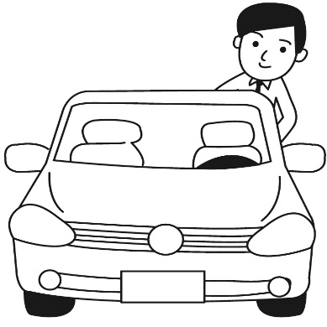
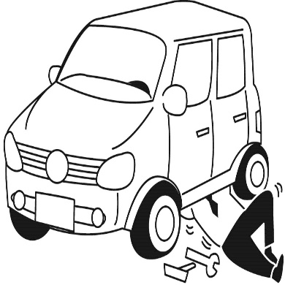
( ) 1. (A) (B) (C)

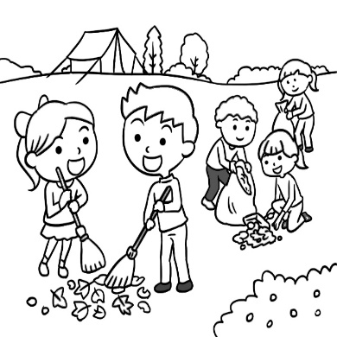
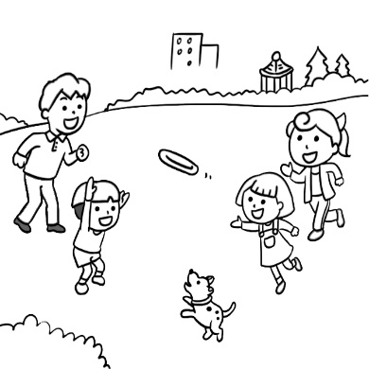
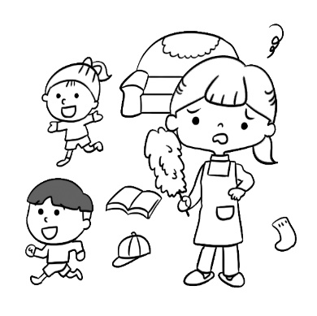
( ) 2. (A) (B) (C)

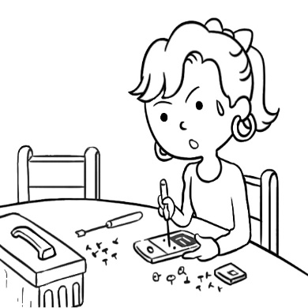
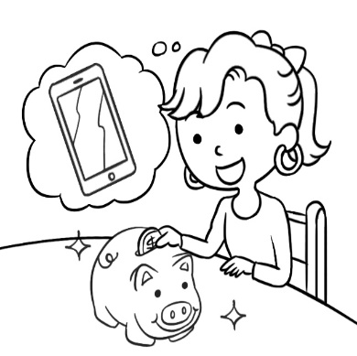
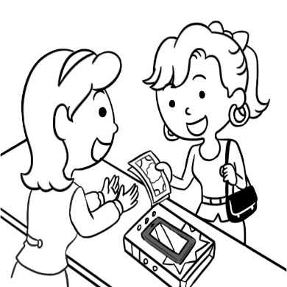
( ) 3. (A) (B) (C)

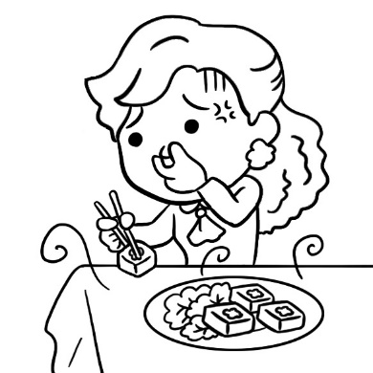
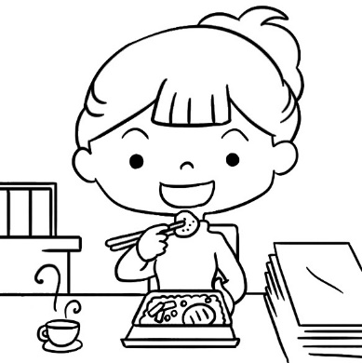
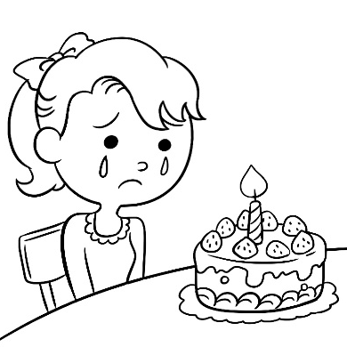
( ) 4. (A) (B) (C)

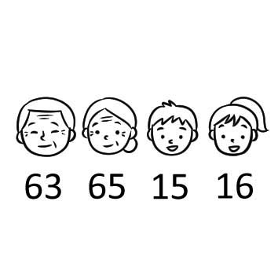
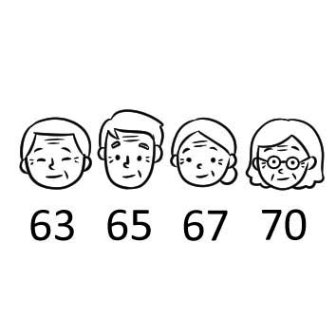
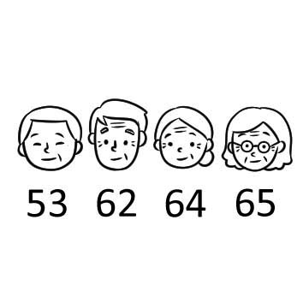
( ) 5. (A) (B) (C)

(B) 基本問答： 5%
每題均有三個選項，請根據所聽到的內容，選出一個最適合的回應。
( ) 6. (A) No, problem. Let me tell you the story of our town.
(B) Sure. You can view the picture files on my computer.
(C) Yes, you can save the videos on your smartphone.
( ) 7. (A) It’s fifty thousand NT dollars. Let me show it to you.
(B) This watch may be old, but it’s cheap and useful.
(C) To me, every watch has a story to tell.
( ) 8. (A) Because her old ones are already broken.
(B) Because her old ones are fashionable.
(C) Because her old ones go well with her dress.
( ) 9. (A) Yes. I’m heavier than my brother.
(B) I think so. It is lighter than my old one.
(C) Of course not. He is the heaviest in my family.
( )10. (A) Yes, my throat still hurts.
(B) Yes, the medicine doesn’t work.
(C) Yes, I can go back to work this afternoon.

(C) 言談理解：5%
每題均有三個選項，請根據所聽到的對話與問題，選出一個最適當的答案
( )11. (A) It’s more comfortable, (B) He likes the color. (C) It’s cheaper.
( )12. (A) His smartphone is out of order.
(B) The woman turned off his smartphone.
(C) These is no more space to save photos or videos.
( )13. (A) Save his old apartment.
(B) Sell apartments to people.
(C) Look for an apartment near his work.
( )14. (A) Because she cared about the Earth.
(B) Because she needed to save money.
(C) Because she had too many clothes.
( )15. (A) Recording a story. (B) Fixing a tape recorder.
(C) Making dinner for his family.

二、文意選擇 30% (每題2分)
( )16. Liz: The music is noisy. How do I stop it?
Ivy: Just push the pause (暫停) ____.
- fan (B) drawer (C) button (D) butter
( )17. Look at the trees and mountains around us. For the Earth, we should ____ the
resources (資源) and help protect (保護) them.
(A) throw (B) save (C) fix (D) agree
( )18. Sean is six years old, so we put six ____ on his birthday cake.
(A) candles (B) lamps (C) drawers (D) buttons
( )19. Kelly doesn’t live here ____. She’s now living with her husband in Japan.
(A) finally (B) anymore (C) already (D) somewhere
( )20. You don’t have to ____ all the lights. It is too bright in the room.
(A) try on (B) put on (C) turn off (D) turn on
( )21. Peter, the farmer, made ___ money because his apples are as small as a
strawberry.
(A) less and less (B) fewer and fewer (C) more and more (D) least and least
( )22. Tokyo is bigger than ____ in Taiwan.
- any city (B) any other city (C) all the other cities (D) all city
( )23. Jane: How does the dress look on me?
Jean: Well, not bad, but ____ is a little too long. Why don’t you try ____ in a
smaller size?
(A) it ; it (B) it ; one (C) one ; one (D) one ; it
( )24. Pamela is popular with teenagers. She is ____ more popular than Howard, the
best YouTuber last year.
(A) so (B) much (C) very (D) really
( )25. This vacation spot (地點) is a must-see. It has ____ beach in the country.
There is no ____ view than this.
(A) more beautiful ; better (B) more beautiful ; best
(C) the most beautiful ; best (D) the most beautiful ; better
( )26. My husband used to _____ me flowers every week before we got married (結婚).
But now he never does. (A) sending (B) send (C) sent (D) sends
( )27. She is younger than ____ in her class. That is, she is the youngest in her class.
(A) anyone (B) all the other student (C) any other student (D) all students
( )28. Mr. Lin is the most hard-working man ___. He always works very late.
(A) than his brother (B) of the three (C) of the two (D) as other workers
( )29. Sue is not as smart _____ Joe, but she is ______ serious about her work.
(A) than ; much (B) as ; much (C) than ; more (D) as ; more
( )30. Annie is 175 cm tall. Her brother is 150 cm tall. She is ____ of the two.
(A) taller than (B) much taller (C) taller (D) the taller

四、題組 30% (每題2分)
Emily: Hey, Frank, did you watch the basketball game yesterday?
Frank: Yes, I did. The Elephants won, 85-73.
Emily: Really? That’s great! They are my favorite team.
Frank: Didn’t you watch it? It was __31__ game of the season.
Emily: My mom wouldn’t let me. She said today’s English test was __32__
than a basketball game.
Frank: But it was really an exciting game.
Emily: I know. I wanted so __33__ to watch it.
Frank: You can watch the rerun (重播) this evening.
Emily: No, I can’t. I have to go to cram school at five o’clock.

( )31. (A) the more important (B) most important
(C) the most important (D) more important
( )32. (A) the more important (B) more important
(C) most important (D) the most important
( )33. (A) much (B) many (C) a little (D) a few

When you do your work on the computer, you always remember to save your
files on a USB or even on “the cloud.” What about people in the past? How did
they do that before these inventions? In fact, back in the 1960s, when people
started to know about computers, they __34.__ save the data on a floppy disk.
You can read, write, and add data to a floppy disk. Almost like a tape,
__35.__. At first, the floppy disk was 5.25 inches, and you could only save 360
KB of data with it. Finally, until the 1980s, the 3.5-inch floppy disk came to the
market, and it was good for up to 1.44 MB. It was light, cheap, and easy to use.
Because of the size, by the 1990s, the 5.25-inch floppy disks were not in use
__36.__. The 3.5-inch floppy disk was __37.__ way back then until CDs became
popular.
Most computers now don’t come with floppy disk drives because no one uses
them at all. You will have to find a special machine just to read it when you see
one in your parents’ old stuff. However, don’t treat them as trash! They are not
__38.__, but there might be valuable memories in them.
invention 發明物 data 資料 floppy disk 磁碟片 inch 吋 drive 硬碟機 stuff 物品

( )34. (A) used to (B) forgot to (C) decided to (D) planned to
( )35. (A) you can record people’s singing on it
(B) push the button on top and pull it out
(C) it’s for you to save things on a computer
(D) this might be the oldest thing in your apartment
( )36. (A) either (B) around (C) anymore (D) even

( )37. (A) more convenient (B) best convenient
(C) most convenient (D) the most convenient
( )38. (A) strange (B) useful (C) sweet (D) broken

Here is this year’s report on the Top Five Cities of Animal Land by Best
Livin.Com.

Deertown
Deertown is the most popular city once again. Year after year, more and more
people come to visit it. It is because its sights are the most beautiful of all. The
food here is more delicious than anywhere else.

Kittyville
Kittyville was not as popular as Rextown last year, but this year people like it
better than Rextown. Kittyville is a beautiful city, and it’s as green as ever.

Bearland
The city still stays in the top three this year. It is getting cleaner for next year’s
Soccer World Cup. To many people, it will soon be the number one city.

Rextown
Not just a famous business city, Rextown is getting greener and greener. With
more gardens in the city, it is a garden city now.

Frogville
This city is famous for its culture and beautiful gardens. It is the first city from
the north to enter our top five.
anywhere 在任何地方 green 綠化的 as ever 同往常一樣
soon 很快地 culture 文化 enter 進入
( )39. Which is NOT true about the report?
(A) It shows some good things about the cities.
(B) This year, Best Livin. Com. did the report twice.
(C) It tells us about the best cities in Animal Land.
(D) Green space plays an important part in the report.
( )40. Which most likely (可能) is the ranking (排名) of LAST year’s Top Five Cities of
Animal Land?
(A) 1. Deertown 2. Bearland 3. Rextown 4. Kittyville 5. Foxville
(B) 1. Rextown 2. Bearland 3. Deertown 4. Kittyville 5. Foxville
(C) 1. Deertown 2. Rextown 3. Kittyville 4. Bearland 5. Frogville
(D) 1. Rextown 2. Deertown 3. Bearland 4. Kittyville 5. Frogville

Stores saw more people buying home appliances in mid-2020. Because of
COVID-19, many people in the US had to stay at home from March to June.
During these months, bread machines were the most popular in stores because
people had much more time to start new hobbies.
At the beginning of 2020, COVID-19 made many people sick all over the
world. This caused many public places to stay closed for months. People had
to think of things to do at home. Studies show that watching movies and TV
shows, cooking, and more indoor activities were more popular than the same time
in 2019. That’s why TVs, video games, and other home appliances were selling
well earlier this year. Bread machines were doing the best of all. All you need
is flour and butter, and then just push the button. In less than four hours, you can
enjoy the freshest bread at home. People loved the idea because they could go to
stores less often. Also, with one bread machine, you can make different kinds of
bread. “It looks like the most useful thing to have at home at the time.” one clerk
said. Even on the Internet, there were more people looking up bread recipes than
in the past.
home appliance 家電 mid 中間的 bread machine 麵包機
hobby 嗜好 cause 造成 indoor 室內的 fresh 新鮮的 recipe 食譜
( )41. Where might people read this?
(A) On TV. (B) In a bakery.
(C) In the newspapers. (D) In a computer report.
( )42. Which might be the chart (圖表) of the bread machine sale?
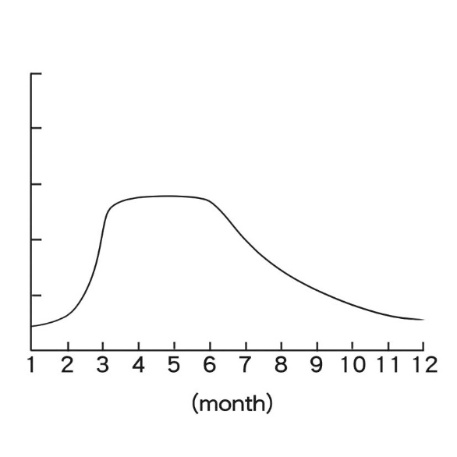
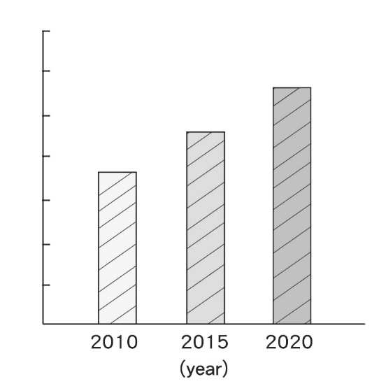
(A) (B)

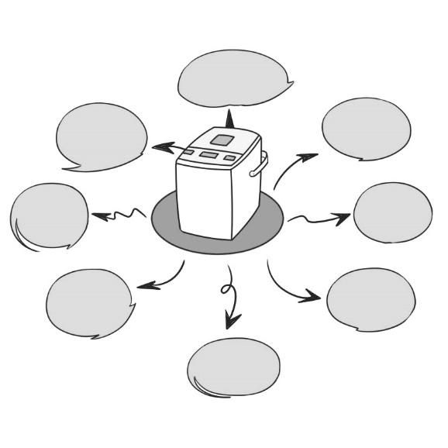
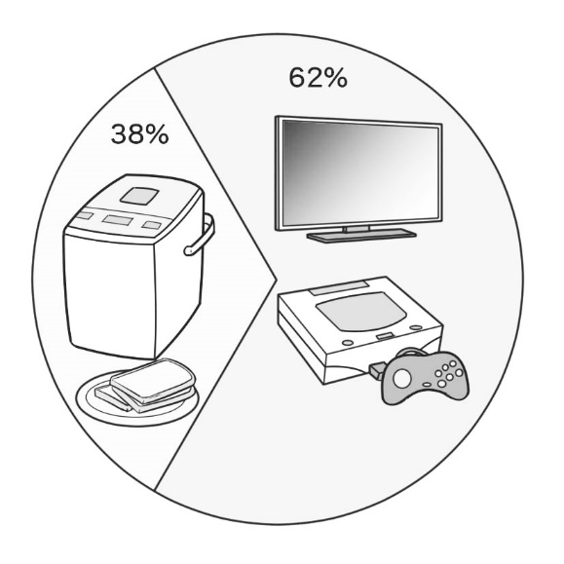
(C) (D)

( )43. Which is NOT true?
(A) Many places were closed because of COVID-19.
(B) People learn new hobbies when they have more time.
(C) Bread machines were popular because they were easy to use.
(D) Summer in 2020 was the hottest, so people stayed home more.

Please call： 0933-123456

( )44. Which house is the cheapest?
(A) House A. (B) House B. (C) House C. (D) House D.
( )45. Mr. Wang has a large family. His parents will live with him, and his younger
brother will, too. He has one son and one daughter. Also, he needs a space for
his car. Which one is the best for him?
(A) House A. (B) House B. (C) House C. (D) House D.

五、依提示作答與翻譯 25%
46. This book is NT$120. That book is NT$99.
（用 this book 開頭，並以「兩者之中的比較」合併句子）
__________________________________________________________________ 2%
47. Susan and Leo are poor.
Josh is poorer than Susan and Leo. （用 最高級 合併句子）
__________________________________________________________________ 2%
48. A：恐怕我們今天要手洗衣服了。洗衣機故障了。
B：什麼！又壞了？爸爸上個月才找人來修理耶。 6%
A：I’m afraid we have to wash our clothes by hand today. The ＿＿＿＿＿＿
＿＿＿＿＿＿ is ＿＿＿＿＿＿ ＿＿＿＿＿＿ ＿＿＿＿＿＿.
B：What! It’s ＿＿＿＿＿＿ again? Dad just had someone fix it last month.
49. 對我而言，這臺錄音機是世界上最有價值的東西。我能藉由這些錄音帶聽到我
祖父母的聲音。 4%

To me, the ＿＿＿＿＿＿ ＿＿＿＿＿＿ is the most ＿＿＿＿＿＿ thing in the
world. I can hear my grandparents’ voices with these ＿＿＿＿＿＿.
50. A：嘿，這間商店充滿不同款式的衣服。你不這麼認為嗎？
B：你說的沒錯。此外，這裡的衣服也比較時尚。 4%
A：Hey, this shop is ＿＿＿＿＿＿ ＿＿＿＿＿＿ different ＿＿＿＿＿＿ of
clothes. Don’t you think so?
B：You can say that again. Also, the clothes here are more ＿＿＿＿＿＿.
51. 我弟弟是快時尚的狂熱愛好者。他每年都購買許多件長褲、毛衣、襯衫和
其他項目。 7%
My brother is a ＿＿＿＿＿＿ of ＿＿＿＿＿＿ ＿＿＿＿＿＿. He buys many
pairs of ＿＿＿＿＿＿, ＿＿＿＿＿＿, ＿＿＿＿＿＿, and other ＿＿＿＿＿＿
every year.

太保國中 111學年度 第二學期二年級 英文科第一次段考試題 手寫卷
班級 _______ 座號 ____ 姓名 ____________

五、依提示作答與翻譯 25%

46. _________________________________________________________________ 2%

47. _________________________________________________________________ 2%

48. _______________ _______________ ________________ _______________

______________ ________________ 6%

49. ______________ _______________ _______________ _______________ 4%

50. ______________ _______________ _______________ _______________ 4%

51. _______________ _______________ ________________ _______________

______________ ________________ ________________ 7%

