嘉義縣太保國民中學109學年度第二學期二年級第一次段考英文科試題
命題老師：陳湘宜 範圍：Lesson 1～ Review 1 二 年 班 號 姓名：
一、單字選擇-選出聽到的單字：：每題1分，共5分
1. (A) ride (B) side (C) fight
2. (A) story (B) steak (C) stomach
3. (A) salesman (B) sandwich (C) something
4. (A) deal (B) dear (C) meal
5. (A) butter (B) better (C) brother
二、辨識句意-根據聽到的內容，選出正確的圖片代碼：每題1分，共5分
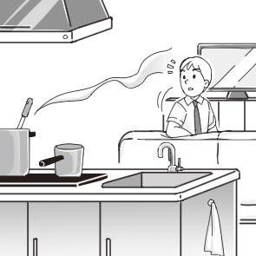
- (A) (B) (C)
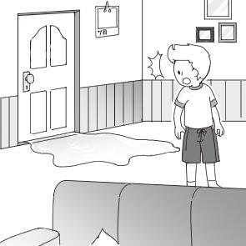 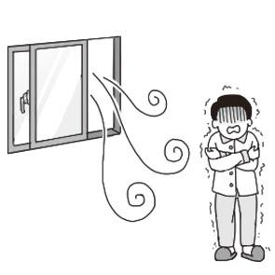
- (A) (B) (C)
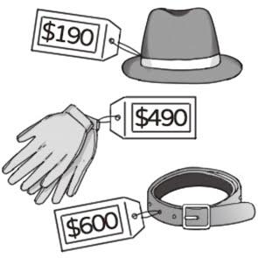 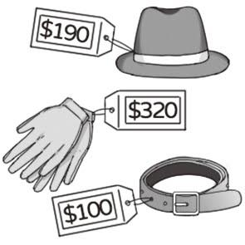 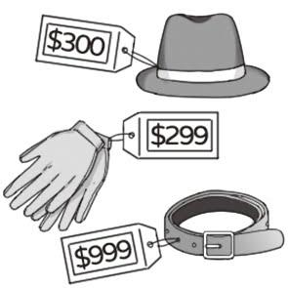
- (A) (B) (C)
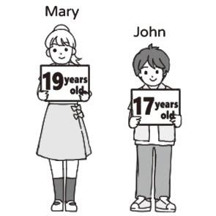 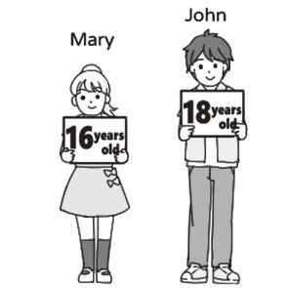 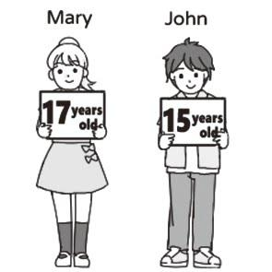
- (A) (B) (C)
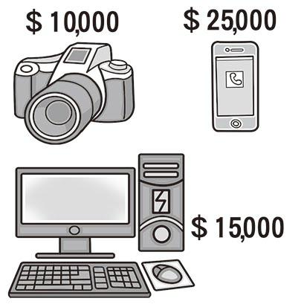 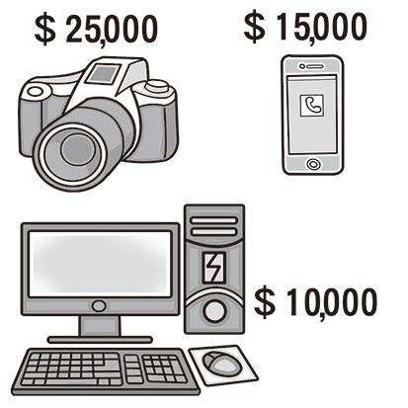 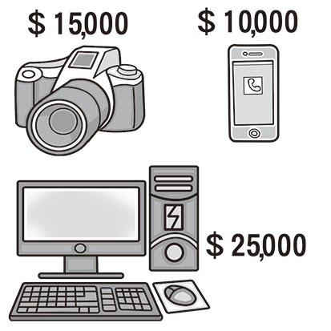
- (A) (B) (C)
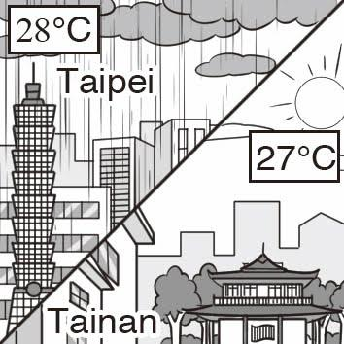 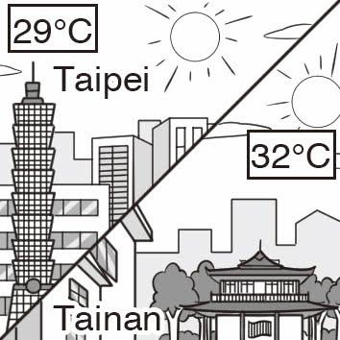 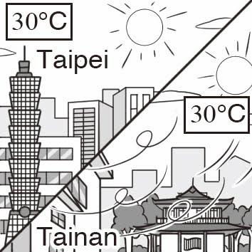
三、言談理解-根據聽到的對話內容與問題，選出正確的答案：：每題2分，共10分
11. (A) Buy birthday gifts after school. (B) Have a guitar lesson with the girl. (C) Sing a song for the girl’s birthday.
12. (A) The woman took the wrong coat. (B) The man found his coat on the sofa. (C) The woman’s coat is bigger than the man’s.
13. (A) He is sick. (B) He is tired. (C) He is hungry.
14. (A) She doesn’t buy a sofa. (B) She agrees to buy a sofa for NT$20,000. (C) She is happy to pay NT$25,800 for the first sofa.
15. (A) They will buy some popcorn. (B) They smell something bad. (C) They are at a restaurant.
四、字彙與語法選擇：每題1分，共26分

嘉義縣太保國民中學109學年度第二學期二年級第一次段考英文科試題
命題老師：陳湘宜 範圍：Lesson 1～ Review 1 二 年 班 號 姓名：
16. It a lot in winter, and the mountains become white. (A) blows (B) snows (C) found (D) misses
17. When you called me, I was taking a . (A) hat (B) skirt (C) towel (D) bath
18. Allen the school bus again, so he was late for school. (A) missed (B) found (C) blew (D) snowed
19. Sandy is a kind girl, and she always wears a on her face. (A) ring (B) steak (C) hat (D) smile
20. Tina a little cold, so she put on her coat. (A) smelled (B) sounded (C) felt (D) cut
21. My hat is NT$ 500. Hers is NT$ 950. My hat is __________ than hers.
(A) more cheaper (B) as cheaper (C) very cheaper (D) much cheaper
22. I bought a today, I’ll use it to make soup. (A) bell (B) pumpkin (C) deal (D) skirt
23. A: Time for breakfast. What do you want to eat? B: I would like some .
(A) salads (B) milks (C) rices (D) sandwiches
24. Jack is good at running. He is runner of the four boys. (A) worse (B) best (C) the best (D) the most best
25. Peter is in his class. He is popular with girls.
(A) kind (B) more handsome (C) the most handsome (D) the most kindest
26. Your book bag is heavier than _________. (A) I (B) her (C) his (D) my
27. The cheese cake great. Can I try some? (A) look (B) looks like (C) tastes like (D) looks
28. Who is , Tony or Mark? (A) more fat (B) the fattest (C) the fatter (D) fatter
29. Which one is , Tony, Mark or Henry? (A) taller (B) the tallest (C) the taller (D) less tall
30. Susan is taller than in her class. (A) any girl (B) all the students (C) all the girls (D) all the other students
31. A: does it smell? B: It smells good. (A) What (B) When (C) How (D) Where
32. A: do I look like in the dress? B: You look like a princess. (A) What (B) When (C) How (D) Where
33. A: Which T-shirt do you like, pink or blue? B: I will buy the blue one because it is .
(A) beautiful (B) more beautifuler (C) as beautiful (D) more beautiful
34. Mr. Lee is thinner than Mr. Black. (A) much (B) very (C) a lot of (D) more
35. Ann’s eyes are big, but small. (A) my are (B) my sister’s (C) Cindy’s are (D) Helen’s is
36. Taipei is city in Taiwan. (A) bigger (B) the biggest (C) the most biggest (D) the bigger
37. Speaking is harder than . (A) write (B) writing (C) to write (D) to writing
38. The black tea smells like . (A) great (B) strawberries (C) stinky (D) song
39. I never heard of this song. It a new one. (A) listens (B) sounds (C) sounds like (D) listens to
40. With more practice, your English will be .
(A) good and good (B) from good to worse (C) good and better (D) better and better
41. A: Is Ted your good friend? B: Yes. He is an old friend of . (A) I (B) me (C) mine (D) my
五、克漏字選擇:每題1分，共9分
(一)
Tina: How are you doing in Taiwan, Susan?
Susan: Great. I gained a few pounds these two weeks. The food in Taiwan 42. delicious.
Tina: Really? Tell me more about it.
Susan: Well, there is a night market near my place. I fall in love with pearl milk tea there. I drink at least two cups every day.
Tina: Pearl milk tea? It 43. beautiful.
Susan: And it 44. great, too. Drinking tea is quite healthy, so I drank a lot. But I was wrong. I become heavy now.
Tina: I guess that’s because there’s a lot of sugar in it.
Susan: Yes. Sugar is bad, but I became so crazy about it.
- (A) is (B) can (C) are (D) will
- (A) says (B) listens (C) hears (D) sounds
嘉義縣太保國民中學109學年度第二學期二年級第一次段考英文科試題
命題老師：陳湘宜 範圍：Lesson 1～ Review 1 二 年 班 號 姓名：
- (A) drinks (B) tastes (C) eats (D) has
(二)
Ten years ago, my parents found a stray dog, Bob, in the park. We took him home and gave him some food. He became one of my family and my 45. friend.
My family moved to the city when I was thirteen. The new house was 46. than the old one, so we can’t take Bob with us. Bob had to stay at my uncle’s house near the farm. After that, life was very different. Because I was shy and seldom talked to other people, I made few friends. When I was down, I would miss Bob. He was really a good dog.
45. (A) better (B) best (C) the better (D) as good
46. (A) smaller (B) as big (C) the smaller (D) more smaller
(三)
Joyce and Stella are very good friends. Both of them are beautiful. Joyce is tall, but Stella is short. In fact, Joyce is 10 cm taller
47. Stella.
They often go shopping together on Sundays. They like to buy skirts, shirts, and dresses. Joyce is too thin. She usually can’t find her size. Many clothes are too big for her. Although Stella is short, she looks 48. than Joyce. She looks good in dresses.
Joyce is 49. smart 49. Stella. However, they like different subjects. Joyce likes music and art, but Stella likes English and history. They often help 50. with homework.
47. (A) as (B) than (C) from (D) to
48. (A) health (B) more health (C) healthier (D) more healthier
49. (A) as；as (B) so；as (C) too；as (D) very；than
50. (A) another (B) both (C) each other (D) each one
六、閱讀測驗：每題2分，共18分
(一)
The National Palace Museum is one of the best museums in the world. It has the world’s largest collection of Chinese art, around 700,000 pieces in all. Because the museum only has space to show 15,000 pieces at a time, most of the artwork is kept in storerooms. Every three months, they change the display. It means only 60,000 pieces are shown a year. It takes about 12 years to see all of them. October is the best time to visit because there are special displays of the most important works. There are also free tours in different languages.
The museum’s gift shop is another good place to visit. You can buy T-shirts, books, or postcards with famous artwork on them. However, you need to know one thing: you must not take pictures in the museum. Also, you may not bring food or drinks inside. The museum has its own restaurant. You can enjoy coffee, tea, and good food there. The National Palace Museum is on Zhishan Road, Taipei City. Visitors can take the MRT, get off at the Shilin Station and take a bus there.
The National Palace Museum 故宮博物院 piece 藝術作品 storeroom 儲藏室 are shown 被展示
51. What does “collection” mean in the reading?
(A) Works of art. (B) A restaurant. (C) A gift shop. (D) People working in the museum.
52. How many pieces are there in the National Palace Museum? (A) 15,000. (B) 60,000. (C) 700,000. (D) 85,000.
53.What do we learn from the reading? (A) Visitors have to pay for a tour. (B) Visitors can bring food inside the museum.
(C) There is no place to eat at the museum. (D) People can get to the museum by MRT and bus.
(二)

嘉義縣太保國民中學109學年度第二學期二年級第一次段考英文科試題
命題老師：陳湘宜 範圍：Lesson 1～ Review 1 二 年 班 號 姓名：

Do you like animals?
The four students in Ms. Huang’s English class write the animal poems. Let’s guess!

Look!
They are swimming freely in the sea.
They grow new teeth nonstop.
People call them the great white.
They are strong, smart and careful.
They sometimes spend time together in pairs.
They are now in danger
because more fishermen kill them.

Connie Chiu
Listen!
They go “moo.”
They have black and white colors.
They feed on grass.
People raise them to get milk.
We use their milk to make butter, cheese and ice cream.
They are one of the most common farm anmails around the world.

Hank Li
Look!
They are the world’s largest jumping animals.
They have short front legs and stand on their back legs .
They each have a strong and long tail.
Although they look taller than koalas,
they are friendly to people.

Allen Wu
Look!
They are running so fast on the grass.
More and more people in Taiwan love to walk with them.
They jump up and down to play or catch a Frisbee.
They love eating bones.
People say they are man’s best friends.

Sara Chen
Jacky Huang

54. Whose animals do NOT live on land? (A) Jacky Huang’s (B) Allen Wu’s (C) Sara Chen’s (D) Hank Li’s
55. Whose animal do people usually keep as a pet? (A) Jacky Huang’s (B) Allen Wu’s (C) Sara Chen’s (D) Hank Li’s
56. Which animals are NOT in the reading? (A) Sharks. (B) Dogs. (C) Kangar (D) Zebras
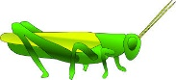
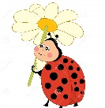
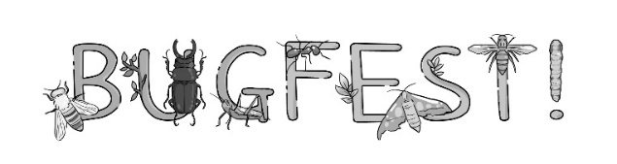

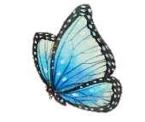
Over 35,000 people will come to Bugfest this year!
Spend time learning about insects with your family or friends! Come have fun and learn with us.
1. Insects Help Farmers!
Dung beetles help cow farmers by feeding on cow poop. Without poop, there aren’t any flies. Without flies, cows live healthier lives. Come and learn more!
2. Wear Bug Clothes
Some bugs are cute, and some are just cool. Come take a look at our bug hats and bug T-shirts.
3. Cafe Insecta
Some insects are very safe to eat and they taste good. Cafe Insecta’s wonderful cooks will make many insect snacks. Give them a go, and you will be surprised!
When: September 21
Where: North Carolina Museum of Natural Sciences
Time: 9 AM to 7 PM
Cost: FREE! insects 昆蟲 dung beetles 糞金龜 flies 蒼蠅
(三)

嘉義縣太保國民中學109學年度第二學期二年級第一次段考英文科試題
命題老師：陳湘宜 範圍：Lesson 1～ Review 1 二 年 班 號 姓名：
- What is the main idea of the reading?
(A) Some poop is useful. (B) Cooking insect dishes. (C) Learning about food for insects. (D) A fun event about insects.
- What does give them a go mean in the reading?
(A) To try some new things. (B) To go to some places. (C) To give up some things. (D) To stop eating some things.
- Who will NOT go to this event?
(A) Sandy. She wants to try some special dishes. (B) Tina. She likes to try new things.
(C) Steve. He likes to learn about insects. (D) John. He is scared of insects.
七、請填入適當的形容詞原級、比較級及最高級: 每題1分，共6分(不限填一字)
60. Carol is as (thin) as Sara.
61. For Ann, the English test is (easy) than the math test.
62. The pink dress is (beautiful) of all in the shop.
63. I have (many) friends than you do.
64. The weather today is (hot) than yesterday.
65. Tom’s grade is (bad) in his class.
八、依提示作答:每題3分，共9分
66. Rita is older than Kelly.
Kelly is older than Doris. (用of the three合併)
.
67. The cake tastes great. (依畫線部分造原問句)
.
68. Dora is 165 cm.
Tina is 165 cm. (請用as合併句子)
.
九、翻譯填空:每格1分，共12分
69. 越快越好。 This sooner, the .
70. 爸爸每天像蜜蜂一樣忙碌。 Father is as a bee every day.
71.他的房子比我的大。His house is than .
72. 哪一道菜餚最美味? dish was the ?
73. 這糖果聞起來像爆米花。The candy like .
74. 我的胃感覺不太對勁。My doesn’t right.
<<辛苦了!請交回此卷!>>

