嘉義縣立太保國中111學年度第2學期第二次段考二年級英語科試卷
命題教師:李貞凌 命題範圍:B4 L3-R2 ___ 年 ___ 班 ___ 號 姓名 _________
I.聽力測驗
I.聽 CD，配合圖片選出最適當的答案:5%
1. 2. 3.
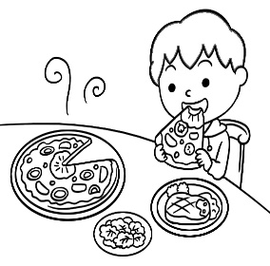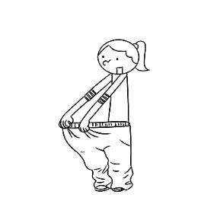
4. 5.
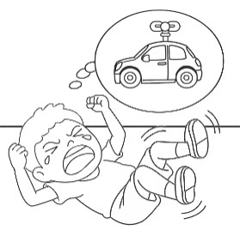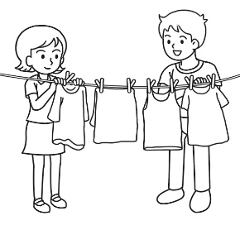

II.基本問答：每題均有三個選項，請依據所聽到的內容，選出一個最適合的回應:5%
6. (A) We’ll shout her name and clap loudly.
(B) Let us try again. We practiced hard for the show.
(C) We won’t be able to arrive at the movie theater on time.
7. (A) That’s right. He always packs quickly than everyone else.
(B) Sure. He laughed loudly when our team came in last in the race.
(C) Yes, he talks to everyone gently and always wears a smile on his face.
8. (A) I want to become thinner, so I only have vegetables for dinner.
(B) I want to put on some weight.
(C) I’m too heavy, so I decided not to have dinner.
9. (A) Pork or chicken is fine.
(B) Some toast for sandwiches.
(C) One bag of sugar is enough.
10. (A) Yes, let’s put some pictures up on the wall.
(B) Yes, the wall is so thin.
(C) Yes, I want to make the room look brighter.

III.言談理解：每題均有三個選項，請依據所聽到的對話與問題，選出一個最適當的答案:5%
11. (A) The woman doesn’t eat meat.
(B) The man will probably order steak.
(C) The man and the woman are talking on the sidewalk.
12. (A) He arrived after seven.
(B) He arrived later than the woman.
(C) He arrived at the end of the movie.
13. (A) Fried chicken.
(B) Chicken.
(C) Oil and flour.
14. (A) It’s a starry night.
(B) It’s dark in the sky.
(C) The moon shines brightly.
15. (A) The man counted the number wrong.
(B) The man spelt the woman’s name wrong.
(C) The man is sorry for forgetting the woman’s name.

II.讀寫測驗
IV.單題:30%
16. The juice really tastes like ___.
(A)terrible (B)medicine (C)yummy (D)badly
17. Linda did the work ___ of the four girls.
(A)badly (B)worse (C)worst (D)the badest
18. David helped his mom ___ the floor.
(A)to mopping (B)mopping (C)in (D)mop
19. Why don’t you turn on the lamp? It’s ___ here.
(A)bright (B)brightly (C)dark (D)clear
20. David studied ___ every day. No wonder(難怪) he always gets good grades.
(A)hardly (B)hard (C)harder (D)hardest
21. The boy ___ on the grass and read comic books ___.
嘉義縣立太保國中111學年度第2學期第二次段考二年級英語科試卷
命題教師:李貞凌 命題範圍:B4 L3-R2 ___ 年 ___ 班 ___ 號 姓名 _________ (A)lies ; happy (B)lay ; happily (C)lied ; happily (D)lies ; happily
22. My father ___ than my mom.
(A)got up earlier (B)got earlier up (C)earlier got up (D)got up early
23. A:How did Emily dance? B:___ Everyone clapped for her.
(A)She has a good voice. (B)She did it beautifully.
(C)She danced worst. (D)She is not a great dancer.
24. The love story made my friend, Linda ___, and she cried ___ when reading it.
(A)sad; sadly (B) sadly; sadly (C) sadly; sad (D) sad; sad
25. A:How’s Judy’s voice? B:No one sings as ___ as she does.
(A)good (B)better (C)well (D)worse
26. Did your mom look ___ at her birthday party?
(A)happily (B)happy (C)more happily (D)like happy
27. Allan plays the violin very ___. His mother makes him ___ two hours every day.
(A)good ; practicing (B)well ; to practice
(C)good ; practices (D)well ; practice
28.Don’t worry. I will ___ finish my report in two days.
(A)can (B)has to (C)be able to (D)must
29. We can’t go camping ___ the bad weather.
(A)because (B)to (C)because of (D)with
30. Here come ___. Please keep quiet.
(A)the teacher (B)my parents (C)they (D)the man

V.題組:30%
[A]
If you want to have a pet, you should think very 31 before you get one. If you live in 32 , you are not usually allowed to keep a dog because they need space and exercise.
You should take your dog for walks at least twice a day, and shouldn’t leave them alone too 33 .
I don’t have a pet, but my parents say they are going to buy me a dog if 34 . I’m very excited about that because I love 35 . When I leave school, I want to study to be a vet, so I can help people when their pets are sick.
◎allowed 被允許

31. (A)good (B)carefully (C)fast (D)careful
32. (A)a house (B)a room (C)an office (D)an apartment
33. (A)many (B)short (C)often (D)quiet
34. (A)I pass all my exams (B)I fight with my classmates
(C)I break the window (D)I get bad grades
35. (A)delicious food (B)animals (C)sports (D)reading
36. What does the word “they” mean in the reading?
(A)Pets. (B)Parents. (C)Dogs. (D)Apartments.
37. What is NOT true about the writer?
(A)He’s an animal lover. (B)He keeps a dog as his pet now.
(C)He wants to be a vet in the future. (D)He is going to take some exams.
38. What does the word “vet” mean in the reading?
(A)An animal trainer. (B)An animal lover. (C)An animal doctor. (D)An animal keeper.

[B]
Arron is a good student. He studies hard and gets high grades. He listens 39 in class. If he has questions, he will ask the teacher or his classmates. He also plays basketball on the school team. He spends one hour 40 it every day. He plays basketball with friends in his free time. He is popular at school.
He is also a good boy at home. His parents work very 41 because they are doctors. Although his parents are not often at home, he can take care of himself and his brother. He sometimes helps his grandmother 42 the housework. His grandma is good at cooking, and Arron and his brother enjoy 43 dinner at home after school. After that, he usually 44 thirty minutes helping his brother with his homework, two hours studying, and one hour listening to English songs to learn English. Both of his parents are proud of him.
◎although 雖然

39. (A)careful (B)more careful (C)carefully (D)care
40. (A)practicing (B)to practicing (C)practice (D)to practice
41. (A)lately (B)early (C)earlier (D)late
42. (A)did (B)to do (C)doing (D)to doing
嘉義縣立太保國中111學年度第2學期第二次段考二年級英語科試卷
命題教師:李貞凌 命題範圍:B4 L3-R2 ___ 年 ___ 班 ___ 號 姓名 _________
43. (A)to eat (B)ate (C)eat (D)eating
44. (A)spends (B)costs (C)takes (D)pays
45. What will Arron do if he has free time?
(A) 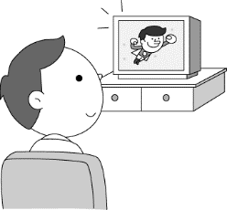 (B) 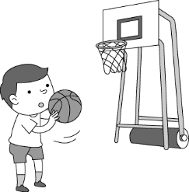 (C) 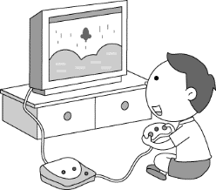 (D) 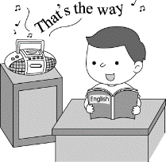
46. How long does Arron practice basketball every day?
(A)For thirty minutes. (B)For one hour.
(C)For two hours. (D)For more than two hours.
47. Which is true?
(A)If Arron has questions, he will think on his own at home.
(B)Arron buys dinner home after school from Monday to Friday.
(C)Arron learns English by listening to English songs.
(D)Arron’s mom helps him with the homework.

[C]
Service dogs
People train service dogs to help disabled people. These dogs need to finish at least 120 hours of training and pass many tests before 48 as service dogs. Their job is to help the owner 49 . They can even go to the places with “No Pets” signs. When they work, people can not play with them. Service dogs can be any kind of 50 . We usually see big dogs like Labradors as service dogs. However, small dogs can also be service dogs.
---------------------------------------------------------------------------------------------------------------
Therapy dogs
People train therapy dogs to comfort people in the schools, hospitals or nursing homes. These dogs are friendly and are used to be in new places to meet different people. They don’t work for only one person, but for people 51 . So, they can help children 52 reading problems or make the sick people in hospitals 53 better. When therapy dogs work, people can play with them. Therapy dogs don’t get a lot of training. Because of that, they can’t go to the places with “No Pets” signs. All kinds of dogs can be therapy dogs if they get the training.
◎train 訓練 therapy dog治療犬 nursing home 療養院

48. (A)to work (B)working (C)to working (D)it works
49. (A)buying things quickly (B)eat more delicious food
(C)opening the door (D)live more conveniently
50. (A)pet (B)size (C)color (D)animal
51. (A)in poor (B)in need (C)at home (D)at school
52. (A)in (B)of (C)at (D)with
53. (A)felt (B)feeling (C)feel (D)to feel
54. Who is a “disabled”person?
(A)Andy, who won the first place in the game.
(B)David, who lost his left leg in a car accident.
(C)Bill, who likes animals very much.
(D)Peter, who can’t do his work carefully.
55. Who may need a therapy dog?
(A)George, a ten-year-old boy, lost all his family in the earthquake.
(B)Tony, a thirty-year-old man, can’t find a good job.
(C)Sandy, a sixty-year-old woman, can’t see clearly without her glasses.
(D)Dora, a twelve-year-old girl,didn’t get good grades in the test.

[D]
7/15
My dear,
Today, my best friend, Timmy, asked me to help him cheat on an English test. He said that if he doesn’t pass it, he will be grounded for two weeks. “Being in the house after school all the time will drive me crazy,” he said. He is the only one that will play with me after school. I think if he can’t play with me outside, I will be crazy, too. I know cheating isn’t right. But, I don’t want to lose him.
---------------------------------------------------------------------------------------------------------------------

嘉義縣立太保國中111學年度第2學期第二次段考二年級英語科試卷
命題教師:李貞凌 命題範圍:B4 L3-R2 ___ 年 ___ 班 ___ 號 姓名 _________
7/16
My dear,
Today during the English test, I tried to show the answers to Timmy. But, our teacher was watching me like a hawk! After the test, Timmy left school without saying a word to me. I think he is annoyed because I didn’t help him cheat on the test.
--------------------------------------------------------------------------------------------------------------------
7/17
My dear,
I wrote a letter to Timmy today, telling him what happened and that I am sorry. He just patted my back and said that he should not ask me to cheat. It was his fault. I am happy that he is not mad at me. He also asked me to help him study for the next test.
◎hawk 鷹 pat 拍 fault 錯誤

56. What does that mean when someone is grounded?
(A)He or she will go crazy at home. (B)He or she cannot go out.
(C)He or she can’t pass the test. (D)He or she will lose his or her friend.
57. What does the word “annoyed” mean in the reading?
(A)Excited. (B)Happy. (C)Angry. (D)Comfortable.
58. Which is the note Timmy’s friend wrote to him?
(A)I’m sorry that I didn’t show you the answers. The teacher kept looking at me. Please don’t be mad at me.
(B)I have to tell you that cheating is not right. I can’t help you do such a thing. Let’s study together next time.
(C)I am happy that you passed the test. We can play together after school again.
(D)I felt sorry that our teacher found I was cheating and she told my parents about it. What can I do?

[E]
“My parents sent me to work. We are all starving. I work, and I get money. I have money, I buy good food for my family,” Himani Pillai told the police when they stopped her on her way to work.
Himani, a nine-year-old girl, was once a student. But when COVID-19 hit, her parents lost their jobs, and the school closed in India. Himani can’t go to school, so they sent Himani out to find a job. She is not the only one. In her hometown, there are 80,000 children working for their families. The kids usually need to work for long hours and only get NT$354 a month.
Child labor mostly happens in Africa and Asia. Why do children need to work so hard? Many children work to help their families. Some children work because their parents ask them to; and others work because they don’t want to go to school.
In other words, some children work because they are too poor. Maybe it is time for the government to do something for them.

Chart 1:Where the kids are from Chart 2:Why the kids need to work

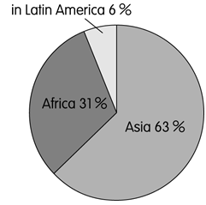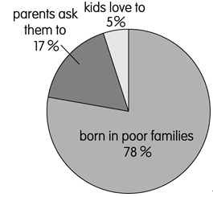

◎hometown 家鄉 labor 勞工 government 政府 chart 圖表
Latin America 拉丁美洲 Africa非洲 Asia亞洲

59. What does starving mean?
(A)Sad. (B)Tired. (C)Mad. (D)Hungry.
60. What can we learn from the reading?
(A)Around 80% of child labor happens in Asia.
(B)Kids work because they need more experiences.
(C)Himani’s parents sent her to work because they were sick.
(D)Child labor often happens in Asia and Africa.

嘉義縣立太保國中111學年度第2學期第二次段考二年級英語科試卷
命題教師:李貞凌 命題範圍:B4 L3-R2 ___ 年 ___ 班 ___ 號 姓名 _________

VI.文意字彙:5%
61. Keeping a d y can help you remember something important in your everyday life.
62. You can’t ride your motorcycle on the s k. It is illegal(違法的).
63. A:What’s the baby’s w t? B:About 3200g.
64. A:What’s your hobby(嗜好)? B:C ting toy cars.
65. David was angry and shouted c y when he fought with his girlfriend.

VII.依提示改寫句子:4%
66. Mr Chen is always a careful driver.(改為副詞並改寫句子)
67. The bean soup smelled bad.(依畫線部分造原問句)

VIII.翻譯填充:11%
68. 我們抵達露營地後就開始生火跟煮水。
We began to (1) a (2) and (3) water after (4) (5) the (6) .
69. 你兒子越來越帥；他看起來就像個明星。
Your son is getting (1) and (2) (3) ; he (4) (5) a star.

--------------------------------------------------------------------------------------------------
答 案 欄
VI.文意字彙:5%

61. _______________ 62. _______________

63. _______________ 64. _______________

65. _______________

VII.依提示改寫句子:4%
66. ___________________________________________________________

67. ___________________________________________________________

VIII.翻譯填充:11%

68. (1)_______________ (2)_______________ (3)_______________

(4)_______________ (5)_______________ (6)_______________

69. (1)_______________ (2)_______________ (3)_______________

(4)_______________ (5)_______________

解 答
- 5 BCCBC 6-10 ACCAC 11-15 BBCCB 16-20 BCDCB
21-25 BABAC 26-30 BDCCB 31-35 BDCAB 36-40 CBCCA
41-45 DBDAB 46-50 BCBDB 51-55 BDCBA 56-60 BCADD
VI.文意字彙:5%
61.diary 62.sidewalk 63.weight 64.Collecting 65.crazily
VII.依提示改寫句子:4%
66. Mr. Chen always drives carefully.
67.How did the bean soup smell?
VIII.翻譯填充:11%
68. (1)make (2)fire (3)boil (4)arriving/getting (5)at/to (6)campsite
69. (1)more (2)more (3)handsome (4)looks (5)like

聽力題目
- CD: (A) The boy is going to finish the meal soon.
(B) The boy just took a bite of the pizza.
(C) The boy ordered a hamburger and some salad.
- CD: (A) The girl put on lots of weight.
(B) The girl likes to eat with much oil.
(C) The girl is becoming much thinner.
- CD: (A) The dog is running around crazily.
(B) The dog is climbing down the stairs.
(C) The dog can jump high to catch the ball.
- CD: (A) The kid is looking for his toy car and laughing loudly.
(B) The kid is lying on the ground and crying out crazily.
(C) The kid is sitting on the floor and playing with his toy car quietly.
- CD: (A) Cathy helped her husband wash the clothes.
(B) Cathy helped her husband boil some water.
(C) Cathy helped her husband hang out clothes.
- CD: What will you do when the movie star shows up?
- CD: Is Alex the most popular person in your class?
- CD: You didn’t eat anything for dinner. What’s the matter?
- CD: W: Could you buy some meat on your way home?
M: Sure. What meat do you want?
- CD: Do you want to change the color of the wall?
- CD: M: You must try the steak. The restaurant has the most delicious steak in town.
W: But I don’t eat beef.
M: Why?
W: My father thinks eating beef will bring the whole family bad luck.
M: Really? Then what do you want to eat?
W: I’ll have vegetable pizza and bean soup.
M: OK. Excuse me, we are ready to order…
Q: What can we learn from the talk?
- CD: M: Sorry, I’m late.
W: No, you’re not. I arrived early.
M: Oh, you’re right. It’s five to seven.
W: Yes, you still have time to go to the toilet before the movie begins.
Q: Which is true about the man?
- CD: M: What are you going to do with the chicken legs?
W: What about making some fried chicken?
M: Sounds great, but we don’t have that much oil at home.
W: You’re right. Are you going to get some, or do we just have chicken soup tonight?
M: I’ll get two bottles of oil. Anything else?
W: We also need flour to make the batter.
M: Got it.
Q: What will the man buy?
- CD: W: Why are you standing out here?
M: It’s cooler outside. Besides, the moon is bright and beautiful.
W: Hmm. It is. We can’t see many stars in the city, but at least we have the moon.
Q: Which is true about the night?
- CD: M: Your name, please.
W: Christine Lee.
M: OK. Your phone number?
W: Excuse me. My first name begins with Ch, not K.
M: Sorry about that.
Q: What went wrong?

