太保國中110學年度第1學期第一次段考一年級英語科試題 P.1
命題教師:李貞凌 範圍:Book1 Get ready~Review1 __年__班__號 姓名_______
Part 1聽力測驗
I.辨識句意：請依據所聽到的句子，選出符合描述的圖片:5%
( ) 1.(A)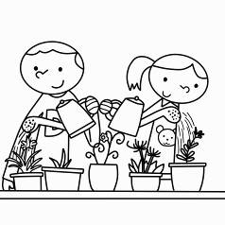 (B)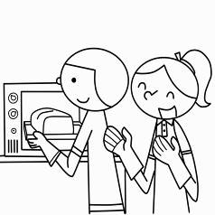 (C)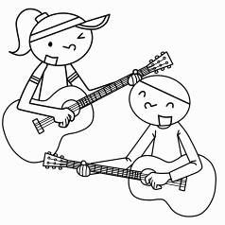
( ) 2.(A)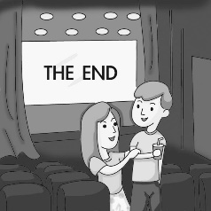 (B)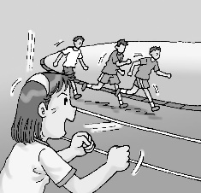 (C)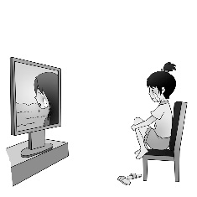
( ) 3.(A)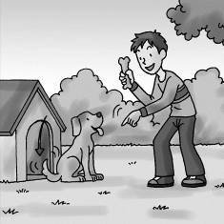 (B)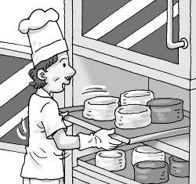 (C)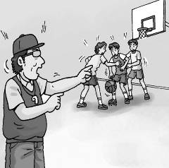
( ) 4.(A)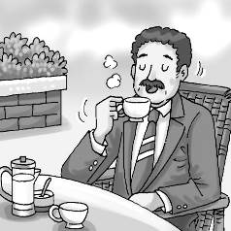 (B)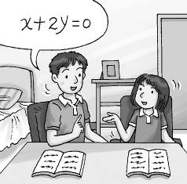 (C)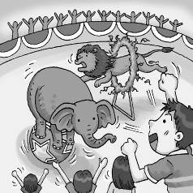
( ) 5.(A)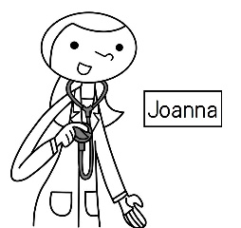 (B)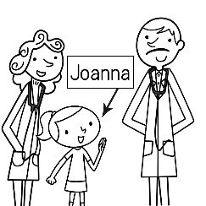 (C)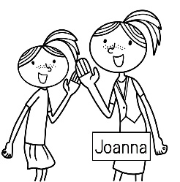

II.聽CD，選出所聽到的字詞:5%
( ) 6.(A) gift (B) cousin (C) daughter
( ) 7.(A) pet (B) aunt (C) gift
( ) 8.(A) uncle (B) family (C) husband
( ) 9.(A) rabbits (B) sheep (C) goats
( )10.(A) zebra (B) smart (C) snake

III.聽CD，配合圖片選出最適當的答案:5%
( )11. 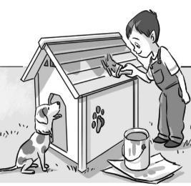 ( )12. 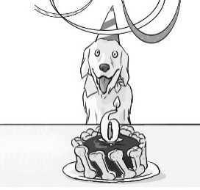
( )13. 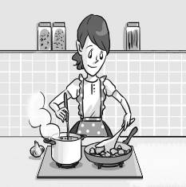 ( )14. 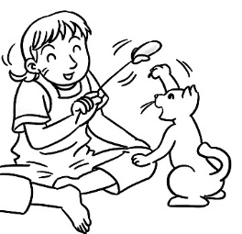
( )15. 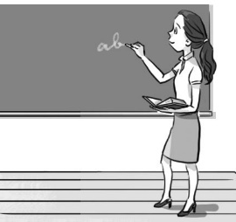

Part 2讀寫測驗
IV.單字、語法及對話測驗:36%
( )16.There is ___ old man in the room.
(A)two (B)a (C)an (D)my
太保國中110學年度第1學期第一次段考一年級英語科試題 P.2
命題教師:李貞凌 範圍:Book1 Get ready~Review1 __年__班__號 姓名_______
( )17.Andy is ___ brother.
(A)me (B)he (C)her (D)you
( )18.A:___ a horse? B:Yes.
(A)Is it (B)It is (C)They are (D)Are they
( )19.Peter, Jill and Lisa ___ my students.
(A)is (B)am (C)are (D)not
( )20.___ are cooks.
(A)I and Bill (B)Bill and you (C)I and he (D)Bill and I
( )21.They are my ___.
(A)pencil box (B)pencils box (C)pencils boxes (D)pencil boxes
( )22.Look at my watch. ___ new.
(A)I’m (B)It’s (C)He’s (D)You’re
( )23.A:Is David Mary’s brother? B:Yes, ___ is ___ brother.
(A)she ; his (B)she ; her (C)he ; her (D)he ; his
( )24.My mom is ___ Chinese teacher.
(A)a (B)not (C)you (D)an
( )25.Is it an ___?
(A)bear (B)fox (C)eraser (D)house
( )26.A:Isn’t Tina your sister? B:___
(A)No, she is. (B)Yes, she is. (C)No, he isn’t. (D)Yes, he isn’t.
( )27.Choose the correct sentence.(請選出正確的句子)
(A)Are you Miss Li? Yes, I’m. (B)Is not it your pen? Yes, it is
(C)Jill is tall but her sister isn’t. (D)I amn’t Tina’s aunt.
( )28.Sally, Andy’s friend, ___ beautiful.
(A)are (B)is (C)am (D)is a
( )29.There are two ___ on the farm.
(A)horse (B)sheep (C)woman (D)mouse
( )30.Wendy:I don’t like the red coat. Clerk(店員):___ the black one?
(A)What are (B)What about (C)Who are (D)Who is
( )31.A:What’s your name? B:___
(A)Your name is Tina. (B)I am Tina. (C)I am her sister. (D)She is my mother.
( )32.A:How are you? B:___
(A)I’m twelve. (B)Nice to meet you. (C)Fine, thanks. (D)I’m a doctor.
( )33.A:Is that Henry’s dog? B:Yes, ___
(A)that is (B)you are (C)it is (D)this is

V.克漏字測驗:12%
[A]
Alex: 34 that in the box?
Cindy: 35 my favorite(最喜歡的) 36 .
Alex: 37 it a dog?
Cindy: 38 It’s a cat.
Alex: Wow, so cute! I like it, too.
( )34.(A)Who’s (B)What’s (C)Who (D)What
( )35.(A)I am (B)We are (C)It is (D)You are
( )36.(A)shoes (B)dog (C)fruit (D)animal
太保國中110學年度第1學期第一次段考一年級英語科試題 P.3
命題教師:李貞凌 範圍:Book1 Get ready~Review1 __年__班__號 姓名_______
( )37.(A)Are (B)Is (C)Am (D)Not
( )38.(A)No, it is. (B)No, it’s not. (C)Yes, it is. (D)Yes, it’s not.
[B]
Lulu: Welcome 39 my home.
Hank: Wow, your house is so big.
Lulu: There are eight people in my 40 , so we need(需要) a big house.
Hank: Who 41 the people in the photo(照片)?
Lulu: 42 my family.
Hank: Is the man behind(在…後面) you your father?
Lulu: No, 43 my uncle.
Hank: 44 is he?
Lulu: He’s a 45 in the new restaurant(餐廳)
( )39.(A)to (B)at (C)in (D)from
( )40.(A)class (B)box (C)family (D)school
( )41.(A)are (B)is (C)am (D)not
( )42.(A)It’s (B)She is (C)You are (D)They’re
( )43.(A)he’s (B)you are (C)she is (D)it is
( )44.(A)Who (B)How old (C)What (D)How
( )45.(A)farmer (B)firefighter (C)nurse (D)cook

VI.閱讀測驗:6%
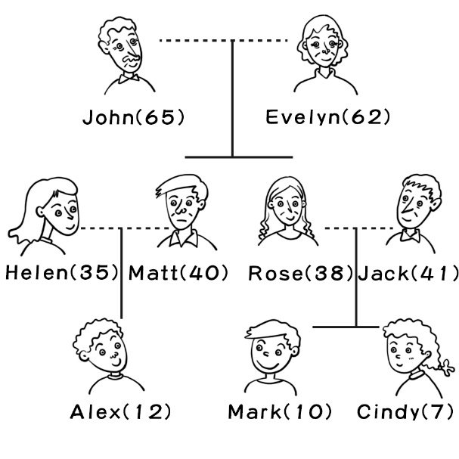
( )46.Who are brother and sister?
(A)John and Rosa. (B)Jack and Cindy. (C)Matt and Rose. (D)Jack and Evelyn.
( )47.Who is Mark’s cousin?
(A)Helen is. (B)Alex is. (C)Cindy is. (D)Helen is.
( )48.Is Matt Cindy’s uncle?
(A)Yes, she is. (B)No, she is. (C)Yes, he is. (D)Yes, he is his uncle.

(以下試題請於答案欄作答)
VII.文意字彙:10%
49.A:Where’s Mom? B:She’s cooking in the k n.
50.Don’t be afraid(別怕). It’s just a rope(繩子), not a s e.
51.Mr. Wu has two children, one son and one d r.
52.A:Who are those w n? B:They’re my aunts.
53.We can see many a ls in the zoo, like monkeys, tigers and lions.

VIII.請依提示改寫句子:6%
太保國中110學年度第1學期第一次段考一年級英語科試題 P.4
命題教師:李貞凌 範圍:Book1 Get ready~Review1 __年__班__號 姓名_______
54.That is a mouse, not a fox.(改為複數句)
55.Judy is a nurse.(改為否定疑問句)
56.The girl is my friend, Ann.(依畫線部分造原問句)

IX.翻譯:15%(57-58每題3分；59-60每格1分)
57.Jenny跟她弟弟是國中生。
58.那個年輕人是做什麼的?
59.A:你是什麼生肖? B:我屬牛。
___ your ___ ___? I’m ___ ___.
60.David像他爸爸；他們都是游泳好手。
David ___ ___ his father ; they ___ good ___.
-----------------------------------------------------------------------------------------------------------
答 案 欄

___ 年 ___ 班 ___ 號 姓名 _____________
VII.文意字彙:10%

49. __________________ 50. __________________ 51. __________________

52. __________________ 53. __________________

VIII.請依提示改寫句子:6%
54. _____________________________________________________

55. _____________________________________________________

56. _____________________________________________________

IX.翻譯:15%(57-58每題3分；59-60每格1分)

57. _____________________________________________________

58. _____________________________________________________

59. _____________ _____________ _____________ _____________ _____________

60. _____________ _____________ _____________ _____________

試題結束，辛苦了!!

太保國中110學年度第1學期第一次段考一年級英語科試題

答 案 卷
I.辨識句意：請依據所聽到的句子，選出符合描述的圖片:5%(每題1分)
1- 5BCCBB
II.聽CD，選出所聽到的字詞:5%(每題1分)
6-10CACCA
III.聽CD，配合圖片選出最適當的答案:5%(每題1分)
11-15BBAAB
IV.單字、語法及對話測驗:36%(每題2分)
16-20CCACD
21-25DBCAC
26-30BCBBB
31-33BCC
V.克漏字測驗:12%(每題1分)
34-35BC
36-40DBBAC
41-45ADACD
VI.閱讀測驗:6%(每題2分)
46-48CBC
VII.文意字彙:10%(每題2分)
49.kitchen 50.snake 51.daughter
52.women 53.animals

VIII.請依提示改寫句子:6%(每題2分)
54.Those are mice, not foxes.

55.Isn’t Judy a nurse?

56.Who is the girl?

IX.翻譯:15%(57-58每題3分；59-60每格1分)

57.Jenny and her brother are junior high school students.

58.What is that young man?/What does that young man do?

59.What’s animal sign an ox

60.is like are swimmers

