太保國中111學年度第一學期第3次段考二年級英文科試卷
命題教師:李貞凌 範圍:B3 L5-R3 二 年 ___ 班 ___ 號 姓名 _________
Part 1聽力測驗
I.辨識句意：每題均有三張圖片，請依據所聽到的句子，選出符合描述的圖片:6%
( ) 1.
(A) 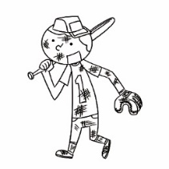 (B) 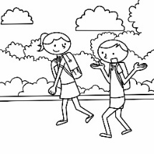 (C) 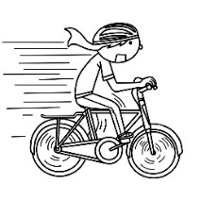
( ) 2.
(A) 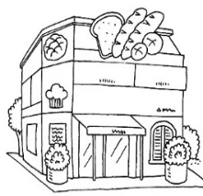 (B) 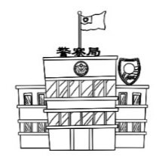 (C) 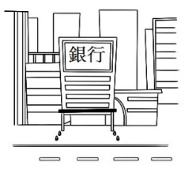
( ) 3.
(A) 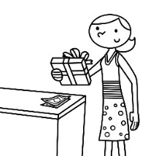 (B) 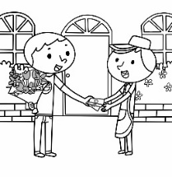 (C) 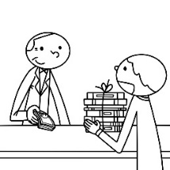
( ) 4.
(A) 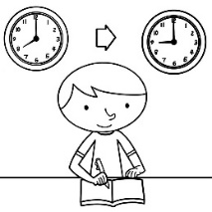 (B) 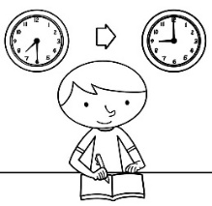 (C) 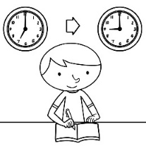

( ) 5.
(A) 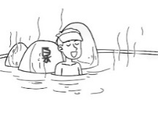 (B) 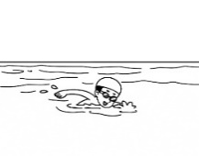 (C) 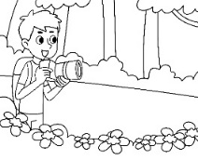
( ) 6.
(A) 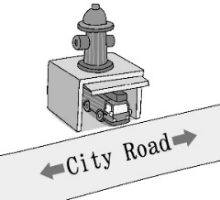 (B) 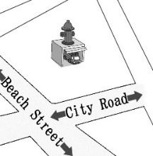 (C) 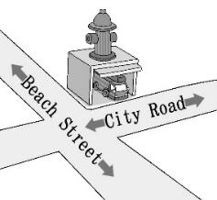

II.基本問答：每題均有三個選項，請依據所聽到的內容，選出一個最適合的回應:6%
( ) 7.(A) I want a computer. (B) I got a smartphone. (C) I paid one thousand dollars.
( ) 8.(A) It will be 120 minutes long. (B) It starts at 7 p.m. on Friday night.
(C) It costs NT$270 dollars.
( ) 9.(A) It was a big mistake. (B) He has a great smartphone.
(C) Oh, I didn’t think of that. It’s a good idea.
( )10.(A) Yes, it’s a five-minute drive. (B) Yes, he will go there by bike.
(C) Yes, he will go there on foot.
( )11.(A) I can teach you skiing. (B) It starts in early January.
(C) It’s open to the public.
( )12.(A) We’re so lucky. Is today a special day?
(B) It’s still early. Let’s rest at the hotel and wait until noon.
(C) I can’t wait to go. The sights there are famous.

III.言談理解：每題均有三個選項，請依據所聽到的對話與問題，選出一個最適當的答
案:6%
( )13.(A) In a flower shop. (B) In a bakery. (C) In a fruit shop.
( )14.(A) She wants to go hiking. (B) She wants to go to the movies.
(C) She wants to spend the day at home.
( )15.(A) The man wants to learn to ride a scooter.
(B) The woman wants to learn to ride a bike.
(C) The woman wants to learn to drive.
( )16.(A) He doesn’t have any money. (B) It costs a lot of money.
(C) It’s too small for him.
( )17.(A) She is buying pancakes. (B) She is cooking dinner.
(C) She is doing the shopping.
( )18.(A) A scooter. (B) A bicycle. (C) Monster toys.

Part 2閱讀測驗
IV.單題:28%
( )19.Mr. Lin ___ two hundred and ninety-nine dollars on the pants.
(A)spent (B)took (C)bought (D)paid
( )20.A: ___ will Mr. and Mrs. Li go to work? B:On foot.
(A)Who (B)How (C)What (D)Where
( )21.There are ___ people waiting in front of the train station.
(A)two thousands (B)two thousand of (C)thousand of (D)thousands of
( )22.How much did you pay ___ the new coat?
(A)in (B)of (C)on (D)for
( )23.It’s raining outside. What about ___ TV at home?
(A)to watch (B)watch (C)watches (D)watching
( )24.There ___ a new restaurant here next month.
(A)are (B)will be (C)is going to (D)are going to be
( )25.A:How long did you spend on the test? B:___
(A)About two thousand dollars. (B)About two hours.
(C)About two feet. (D)About two o’clock.
( )26.Judy ___ shopping with Bill tomorrow.
(A)will (B)is going (C)is going to (D)will be
( )27.We will go bird watching ___ the last day of our trip.
(A)on (B)in (C)at (D)of
( )28.Andy decided ___ a new cap for his brother.
(A)to buy (B)buying (C)bought (D)buy
( )29.The dress ___ my mom NT$2,000.
(A)spent (B)paid (C)cost (D)took
( )30.We are going to hike in the mountains, but my cousin ___.
(A)didn’t (B)won’t (C)isn’t (D)doesn’t
( )31.The post office is ___ the corner ___ First Street and Park Road.
(A)on ; at (B)at ; of (C)of ; on (D)at ; on
( )32.A:___ did the hat ___ you? B:Five hundred dollars.
(A)How many ; take (B)How much ; spend
(C)How much ; take (D)How much ; cost
( )33.___ convenient for me ___ near the supermarket.
(A)That’s ; to live (B)It’s ; to live (C)I’m ; living (D)It’s ; living
( )34.A:___ B:I’m going to visit my old friend.
(A)What did you do last weekend? (B)What will Andy do tomorrow?
(C)What does the boy do after school? (D)What are you going to do this weekend?
( )35.Did it ___ your father a long time to fix the car?
(A)spend (B)cost (C)take (D)pay
( )36.Let’s watch the ___ on the night of December thirty-first near Taipei 101.
(A)nature (B)corner (C)outside (D)fireworks
( )37.A:___ can we get to the library? B:Let’s take Bus 112.
(A)Why (B)Where (C)How (D)When
( )38.Andy spent a lot of money ___ comic books. He didn’t use his money well.
(A)to buy (B)buying (C)buy (D)to buying
( )39.Can we ___?
(A)go there in the bus (B)by bike to there
(C)go to the station by foot (D)take the taxi to the shop
( )40.It ___ Nancy much money ___ the house.
(A)took ; to buy (B)spent ; buying (C)cost ; to buy (D)paid ; for
( )41.Mr. Lin met Andy’s father and ___ hands with him.
(A)shakes (B)shake (C)shook (D)shooks
( )42.It will be fun ___ the movie with Lily.
(A)watching (B)watch (C)watches (D)to watch
( )43.Allen will buy his breakfast before he ___ to school.
(A)will go (B)is going (C)goes (D)went
( )44.I visited Japan ___ times when I was a little girl.
(A)a lot (B)much (C)a dozen (D)one
( )45.My grandpa ___ us in two days.
(A)will visit (B)visited (C)visits (D)was visiting
( )46.___ the English homework will ___ me three hours.
(A)Finish ;cost (B)Finishing ; take (C)To finish ; spend (D)To finish ; took

V.題組:54%
[A]
Dear Mom,
I will go out with my friends from January 13 to January 15. We are going to White Mountain to ski on Saturday and Sunday and then go hiking around the lake near White mountain the last day. We should be back on the night of January 15.
I promise I will be careful. I will stay with my friends and not to ski to quickly on the mountain. I don’t want to crash and hurt my leg like last year! Also. We will not stay out too late at night. We want to wake up early and be the first people to go up the mountain in the morning.
I won’t forget to call you on Sunday night to let you know how I am.
Thanks, Mom.
Love, Teresa

◎promise保證 crash碰撞 might可能

( )47.Why will Teresa not ski too quickly this year?
(A)She is too old to ski quickly. (B)She hurt herself last year.
(C)The weather is too hot. (D)Her mom told her not to ski.
( )48.How long is Teresa’s trip?
(A)For two days. (B)For three days. (C)For four days. (D)For five days.
( )49.Why will Teresa and her friends not stay out too late?
(A)They need to go hiking early. (B)There is nothing to do at night.
(C)It is snowing too much. (D)They want to ski early in the morning.
( )50.How might the weather be during Teresa’s trip?
(A)It might be warm. (B)It might be snowy.
(C)It might be windy. (D)It might be hot.

[B]
Hello, everyone! This is Ricky, your tour guide. Welcome to Coco Island! I want to let you 51 our tour plans today. We are now at the Beach Hotel. The 52 today is a little cloudy and it will have a shower this afternoon, so please take 53 with you. This morning, we will have a walk tour around the island, visit an apple farm and make apple pies for lunch there. Then, we will go visit a lovely fishing village to see the local special fishing skills in the afternoon. We will come back to the hotel around 4:00 p.m. The beach is just a few miles away. You can have fun swimming in the sea this afternoon. Please take good care. The hotel serves good dinner 54 7:00 54 9:00 p.m. every day. But we will also have a free night fishing activity at 8:30 p.m. You are welcome to join us!
Well, please call me at 0932-123-456 if you need any help. I hope you can have a nice holiday here!
◎tour guide導遊 village村莊 local當地的 serve 提供

( )51.(A)to know (B)know (C)knowing (D)knows
( )52.(A)sports (B)time (C)places (D)weather
( )53.(A)your schoolbag (B)your sunglasses (C)an umbrella (D)a scooter
( )54.(A)at ; at (B)in ; to (C)from ; to (D)at ; to
( )55.Why do they want to visit a local fishing village?
(A)Because they want to see their special fishing skills.
(B)Because they want to have good seafood for lunch there.
(C)Because they want to go swimming in the village.
(D)Because there is a good beach near the fishing village.
( )56.What WON’T they do this morning?
(A)Have a walk tour. (B)Visit an apple farm.
(C)Swim in the sea. (D)Make apple pies for lunch.

[C]
(At home)
Jack:Mom, I have a terrible 57 .
Mom:I’ll call the dentist’s office and make an appointment.
Jack:How about school? Can I stay at home today?
Mom: 58 will only take an hour. You can go to school after that. I’ll go with you.
(At the dentist’s office)
Dr. Lin:What is the problem, Jack?
Jack:My tooth hurts so much.
Dr. Lin:Where does it hurt?
Jack:It hurts in the upper left tooth, back here.
Dr. Lin:I see the problem. There is a small cavity. I’ll just clean the cavity and fill it up.
Jack:Oh no…. It’s going to hurt!
Dr. Lin:It was not so bad, right? If you still feel pain, you can 59 some medicine. Remember 60 your teeth carefully 61 you go to bed.
Jack:Thank you, Dr. Lin.
◎dentist牙醫 appointment預約 upper上面的 cavity蛀牙洞 pain痛

( )57.(A)headache (B)fever (C)stomachache (D)toothache
( )58.(A)You (B)It (C)That (D)We
( )59.(A)take (B)eat (C)took (D)ate
( )60.(A)brush (B)brushing (C)to brush (D)brushes
( )61.(A)so (B)because (C)before (D)after

[D]
Listen carefully, everyone. This Saturday, we’re 62 visit the Tea Museum. You can learn lots of interesting things about tea there. We’ll have to leave at 7:20, so please don’t be late. We’ll go there by bus. 63 will take about two hours to get there, and tell your parents we’ll be back at school at about 6.
What’s next? Oh, yes, tickets. Tickets will be 250 dollars each, OK? Don’t forget 64 the money from your parents.
Now, I’m going to give you some work to do at the museum. You will need to write things down, so 65 . We’ll have lunch in the museum coffee shop, so you don’t need to bring any food with you. Well, I think that’s everything.
( )62.(A)will (B)will be (C)going to (D)going
( )63.(A)That (B)They (C)I (D)It
( )64.(A)bringing (B)to get (C)bring (D)brings
( )65.(A)take a pen with you (B)drink some tea
(C)go across the road (D)have a good time
( )66.What is the teacher talking about?
(A)A school trip. (B)Tomorrow’s lunch. (C)A party. (D)Today’s homework.
( )67.Which is NOT true?
(A)Students won’t have to bring lunch with them.
(B)Students will arrive at the Tea Museum at about 9:20.
(C)Students will go without their parents.
(D)Students will get free tickets for the museum.

[E]
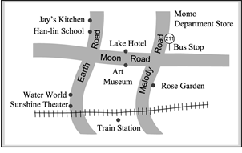
Jenny: 68 I guess I’m lost. Can you help me?
Woman: Sure. Where are you going?
Jenny: To the 69 .
Woman: OK, let’s look at your map. Here we are at the bus stop on Melody Road.
See? So you need to walk along Moon Road and 70 on Earth Road.
It’s next to Water World.
Jenny: And do you know how to get to Jay’s Kitchen? My parents will wait for me
there later. It’s famous 71 its beef noodles and pork dumplings.
Woman: Oh, it’s also on Earth Road. Walk past Han-lin School, and you’ll see it.
Jenny: Thanks a lot.
Woman: You’re welcome.
( )68.(A)I’m sorry. (B)What happened? (C)What’s wrong? (D)Excuse me.
( )69.(A)Rose Garden (B)Sunshine Theater (C)Jay’s Kitchen (D)Art Museum
( )70.(A)turn right (B)go straight (C)go across (D)turn left
( )71.(A)for (B)on (C)in (D)as
( )72.What may Jay’s Kitchen be?
(A)A hotel. (B)A restaurant. (C)A station. (D)A garden.
( )73.Which is NOT right?
(A)There’s a hotel across from the museum.
(B)There’s a school on Earth Road.
(C)Rose Garden is on the corner of Melody Road and Moon Road.
(D)Jenny will watch a movie first and then eat something with her family.

解答
- 5 BABCA 6-10 CBCCC 11-15 BABAC 16-20 BCBAB
21-25 DDDBB 26-30 BAACC 31-35 BDBDC 36-40 DCBDC
41-45 CDCCA 46-50 BBBDB 51-55 BDCCA 56-60 CDBAC
61-65 CCDBA 66-70 ADDBD 71-73 ABC

