太保國中 110學年度 第一學期 二年級 英文科第三次段考試題 出題：王蕙瑩 班級 _______ 座號 ____ 姓名 ____________
一．聽力測驗 15% (每題 1 分)
(A) 單字選擇：選出聽到的單字 5%
( ) 1. (A) temple (B) terrible (C) tomorrow
( ) 2. (A) idea (B) area (C) dollar
( ) 3. (A) city (B) circle (C) country
( ) 4. (A) careful (B) colorful (C) beautiful
( ) 5. (A) magic (B) minute (C) modern

(B) 基本問答：根據聽到的內容，選出合適的回應。 5%
( ) 6. (A) About one and a half hours.
(B) About five thousand dollars.
(C) About three couches in my house.
( ) 7. (A) It is delicious. (B) I like to drink milk tea. (C) It’s not good for my health.
( ) 8. (A) It’ll be rainy after work. (B) Sure. That should be fun. (C) Yes, everything will be fine.
( ) 9. (A) It took him a month. (B) I want to travel by car. (C) The island is really beautiful.
( )10. (A) It’s comfortable. (B) Nope. It’s cheap. (C) Yes, it’s everywhere.

(C) 言談理解：根據聽到的對話內容與問題，選出正確的答案。 5%
( )11. (A) Two minutes. (B) Twelve minutes. (C) Twenty minutes.
( )12. (A) A library. (B) A restaurant. (C) An apartment.
( )13. (A) She is a doctor. (B) She is a teacher. (C) She is a waitress.
( )14. (A) The man and Vincent. (B) The woman and Vincent. (C) The woman and the man.
( )15. (A) $399. (B) $699. (C) $999.

二．單題 50% (每題 2分)
( )16. Jeff likes music. He plays the very well.
- guitar (B) robot (C) jump rope (D) magic
( )17. I love my girlfriend（女友）. She is my .
- city (B) moon (C) honey (D) garbage
( )18. 7-11, Family, and OK are all . People can do many things there.
- department stores (B) libraries (C) convenience stores (D) water
( )19. With a , you can even print a house. (A) visitor (B) magic (C) lamp (D) 3D printer
( )20. There’s a lot of about GEPT online（線上）!
- mud (B) road (C) heart (D) information
( )21. If your stops beating（跳動）, you will die.
(A) design (B) heart (C) team (D) health
( )22. A second-handed（二手的）guitar is very cheap. You can buy it at a price.
(A) favorite (B)low (C)high (D)wrong
( )23. Thai people, Indonesians, and Americans are all to us, and we can help them in need.
(A) foreigners (B) someone (C) everyone (D) nobody
( )24. Mark’s parents are always him. Mark is a nice kid and helps people.
- worried about (B) proud of (C) convenient to (D) free to
( )25. The sofa is very . Everyone likes to sit on it.
- free (B) convenient (C) comfortable (D) easy
( )26. Helping homeless（無家可歸的）animals wonderful for people.
- is (B) are (C) look (D) be
( )27. _____ that last piece of pie? If not, can I have it? I didn’t eat much this morning.
- Are you eating (B) Were you eating (C) Do you eat (D) Are you going to eat
( )28. It Mina three hours the house last Sunday.
- take; cleaning (B) took; to clean (C) spent; cleaning (D) spends; to clean
( )29. _______ a mask（口罩）when you go to the hospital.
- Wear (B) To wear (C) Wearing (D) By wearing
( )30. There ____ a Christmas party at my place next Saturday. Welcome to join us.
(A) is going to (B) will have (C) is going to have (D) will be
( )31. Kevin: People ____ three meals a day. But Luck needs his fourth meal – the night snacks.
Edwar: No wonder he looks so fat.
(A) had (B) will have (C) are having (D) have
( )32. Kevin ____ the tree, but the others aren’t.
(A) climbs (B) will climb (C) is climbing (D) climbed
( )33. My brother spends much time ____ sports. He plays basketball every day and goes swimming
every two days. (A) with (B) on (C) for (D) at
( )34. Our teacher wanted us not to forget ____ our homework during the holidays.
(A) doing (B) does (C) to do (D) do
( )35. It cost me about one thousand dollars ____ the guitar.
(A) to buy (B) buy (C) buying (D) bought
( )36. Hallie: does it take to fly to New York from Taipei?
Jill: Around 15 hours.
(A) How often (B) How long (C) How many (D) How much
( )37. Lily likes and two hours dancing every day.
(A) exercise; spend (B) to exercise; to take (C) exercising; taking (D) exercising; spends
( )38. Nancy to the music thirty minutes later. She is busy working now.
(A) listens (B) is listening (C) listened (D) will listen
( )39. Tom forgot ____ his homework, so his teacher was very angry.
(A) to do (B) doing (C) did (D) will do
( )40. It Mark thirty days the painting.
- takes; finish (B) took; to finish (C) spent; finishing (D) cost; to finish

三．題組 35% (41 ~ 45 每題 1分 46 ~ 60 每題 2分)
It is every athlete’s (運動員) dream to join the Olympic games（奧林匹克運動
會）,but not every athlete’s dream can __41__. It’s not easy to become an excellent（傑
出的）athlete. They __42__ spend a lot of time training and practicing. __43__ is
difficult and practicing is hard work. So many athletes give up halfway（在中途）.

( ) 41. (A) go by (B) dress up (C) pass away (D) come true
( ) 42. (A) would like (B) of course (C) have to (D) thanks to
( ) 43. (A) Training (B) Train (C) A train (D) Trained

Queena: Will you practice playing the piano tonight?
Rita: No. I __44__ dinner with my mom tonight.
Queena: What are you going to cook?
Rita: Some vegetables, pork, fried rice（炒飯）, and soup（湯）. What __45__ eat
for dinner?
Queena: My family and I will have steak（牛排）at the restaurant.
Rita: But it’s raining heavily（猛烈地）outside.
Queena: That’s too bad. __46__ it __46__ tomorrow?
Rita: I’m not sure. But it’s not safe to go out now.
Queena: All right. I guess we can only eat instant noodles（泡麵）tonight.

( ) 44. (A) will cook (B) cook (C) cooked (D) was cooking
( ) 45. (A) are you (B) are you going to (C) do you (D) will you not
( ) 46. (A) Does; raining (B) Is; rain (C) Will; raining (D) Will; rain

Roger’s __47__ is to be a famous magician when he grows up. He __48__ magic tricks every day. His __49__ trick is pulling a rabbit out of a hat. He shows the empty hat to everyone, and he waves his wand (魔杖) over the hat and speak some magic words. Finally, he put his hands into the hat and pulls out a rabbit. Everyone loves his tricks and come to his house to see his magic show. Roger __50__ all the people in his town to his house next weekend and perform a new magic trick that he learned from his teacher.

( ) 47. (A) idea (B) price (C) dream (D) scenery
( ) 48. (A) practices (B) will practice (C) practiced (D) is practicing
( ) 49. (A) fast (B) favorite (C) good (D) poor
( ) 50. (A) invite (B) invited (C) was inviting (D) is going to invite

This is Class A’s timetable. Read it and answer the questions.

Monday Tuesday Wednesday Thursday Friday
9:00 ~ 10:00
10:10 ~ 11:10
English | Chinese | Science |  | Math |  | English
Math | Math | English |  | Chinese |  | Math
Music | Science | Math |  | Chinese |  | Chinese
Lunch Time
Chinese | English |  | Math |  | English |  | Music
Science | English |  | Chinese |  | Science |  | Music
11:20 ~ 12:20

13:00 ~ 14:00
14:10 ~ 15:10

( ) 51. How many English classes does Class A have in a week?
(A) Five. (B) Six. (C) Seven. (D) Eight.
( ) 52. May says they will have math class after lunch. What day is she talking about?
(A) Monday. (B) Tuesday. (C) Wednesday. (D) Thursday.
( ) 53. How long does Chinese class last (持續) on Thursday?
(A) One hour. (B) Two hours. (C) Three hours. (D) Four hours.
( ) 54.
Ted: I forgot to bring my violin today.
Sue: Oh, no. Ms. Lin asked us to bring it today. We will have a test during the lunch
time before the class starts.
Ted: May I borrow yours?
Sue: OK……

What day is today? (A) Monday. (B) Tuesday. (C) Wednesday. (D) Friday.

What comes to your mind, when you think of Taiwan? For many people, the answer
（答案）can be nice food, the beauty（美麗）of nature（自然）, and friendly people. For
foreigners, some local（在地的）Taiwanese food sounds（聽起來）terrible to them when
they hear the names or see the food. There is a list（清單）of top five bizarre Taiwanese
food for foreigners.
1. Chicken Feet. The shape（形體）of chicken feet is like baby’s feet.
2. Stinky Tofu. Its name says everything. It smells（聞起來）terrible and strong.
3. Century Egg. It is also called thousands-year-old egg. The outside of the egg is black and
its inside is gray and jelly（膠狀）. The smell and taste are both quite strong and strange.
Its name sounds strange. Its color is black.
4. Duck Tongue（舌）. Foreigners don’t eat tongues of animals. There is no meat in the
tongue.
5. Pig Blood Cake. It is made of pig’s blood. Its color and taste are strange to them. It is
salty, sweet, and spicy（辣的）at the same time, with a rich（濃郁的）pork taste. It is
chewy（有嚼勁的）.

( ) 55. What does the word bizarre mean?
(A) Delicious. (B) Strange. (C) Amazing. (D) Wonderful.
( ) 56. What is the picture of Century Egg?
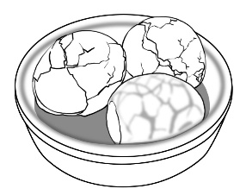
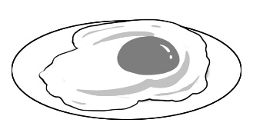
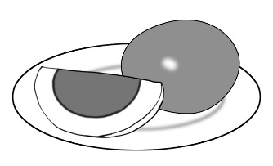
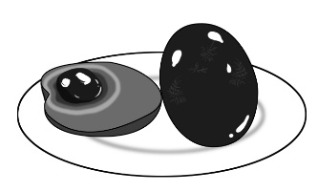
(A) (B) (C) (D)

( ) 57. Which（那一個）of these bizarre food is sweet and salty?
(A) Chicken Feet. (B) Century Egg. (C) Duck Tongue. (D) Pig Blood Cake.

Mom: Macy’s Department Store is going to have a winter sale（拍賣）next week. We need
to get a new lamp.
Dad: Great! I am thinking to buy a 3D printer. It usually costs $699.99. I hope（希望）the
price would go down a little bit（一點）.
Josh: Look! I spent six months saving enough money for my dream guitar. It’s now selling
for only $199.99. I can finally get it! I can’t wait!

The following（下面的）table（表格）shows the prices of 3D printers, guitars, and
lamps. Look at the table and answer（回答）the questions.

( ) 58. Which（哪一個）3D printer does Dad want to buy? How much does it cost during the
winter sale?
(A) Printer A. It costs $179.99 now. (B) Printer B. It costs $199.99 now.
(C) Printer C. It costs $599.99 now. (D) Printer D. It costs $399.99 now.
( ) 59. Mom is planning to buy Lamp B. How much is she going to spend on it during the sale?
(A) Thirty-two dollars and fifty cents. (B) Twenty-two dollars and fifty cents.
(C) Nineteen dollars and fifty cents. (D) Twelve dollars and fifty cents.
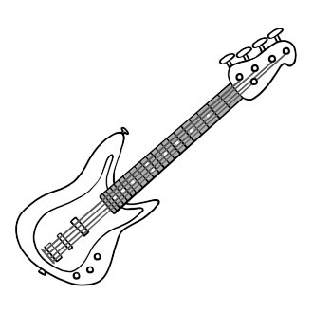
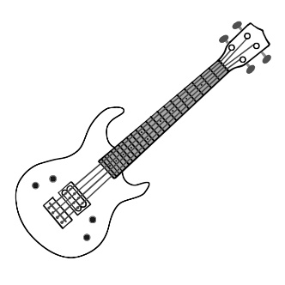
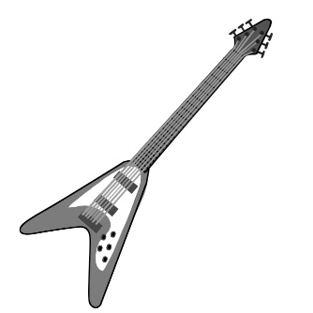
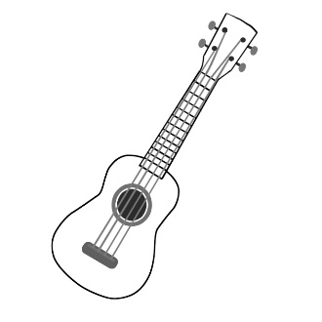
( ) 60. Which is Josh’s dream guitar?
(A) (B) (C) (D)

太保國中 110學年度 第一學期 二年級 英文科第三次聽力試題
(A) 單字選擇：選出聽到的單字 5%
1. We will have a picnic tomorrow.
2. He has a great idea.
3. Tainan is my favorite city in Taiwan.
4. The boy was careful when he rode a bike.
5. Living in a modern apartment is comfortable.

(B) 基本問答：根據聽到的內容，選出合適的回應。 5%
6. How much did these two couches cost?
7. Why do you never drink milk tea?
8. Would you like to watch movies with me after work?
9. How long did it take Tom to travel around the island by bike?
10. Does it cost a lot of money?

(C) 言談理解：根據聽到的對話內容與問題，選出正確的答案。 5%
11. B: How do we get to the library? G: We can get there on foot.
B: Is it near our house? G: Yes. It only takes twenty minutes to walk there.
Question: How long does it take to get to the library on foot?
12. W: Nick, Dad and I are going to Sweet Castle for lunch today. Do you want to come, too?
M: No. I’m going to have lunch with my friend, Peter, today.
W: Actually, you can invite Peter to lunch, too.
M: Really? That’ a great idea. I’ll invite him later.
W: OK.
Question: What is Sweet Castle?
13. M: Helen, long time no see! You started a new job last month, right?
W: Yeah. I looked for one for several months.
M: Good for you. So, how’s it going?
W: Not too bad. Teaching kids is fun. I’m busy, but happy.
Question: What is Helen’s job?
14. W: Guess what? Vincent and I finally bought our own apartment. We’re going to move into our
new house next month.
M: I’m so happy for you! How much did the apartment cost you?
W: It cost us six million dollars.
M: Well, your dream came true. Good for you!
Question: Who will move into the new house next month?
15. W: Excuse me. How much does this pink shirt cost?
M: It costs six hundred and ninety-nine.
W: Oh, that’s too expensive for me. How about the yellow one?
M: That one costs three hundred and ninety-nine.
Question: How much does the yellow shirt cost?

太保國中 110學年度 第一學期 二年級 英文科第三次段考試題 答案卷

1. C 2. A 3. A 4. A 5. C 6. B 7. C 8. B 9. A 10. B
11. C 12. B 13. B 14. B 15. A 16. A 17. C 18. C 19. D 20. D
21. B 22. B 23. A 24. B 25. C 26. A 27. D 28. B 29. A 30. D
31.D 32. C 33. B 34. C 35. A 36. B 37. D 38. D 39. A 40. B
41. D 42. C 43. A 44. A 45. B 46. D 47. C 48. A 49. B 50. D
51. B 52. C 53. B 54. D 55. B 56. A 57. D 58. C 59. A 60. D

1 ~ 15題，每題1分；16 ~ 40題，每題2分；41 ~ 45 每題 1分 ； 46 ~ 60 每題 2分

總分 100分

