- 聽力(辨識句意)-根據聽到的內容，選出正確的
圖片代碼：每題1分，共5分

- (A) 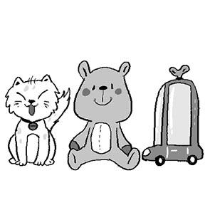 (B) 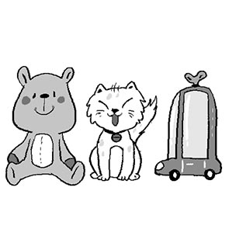 (C) 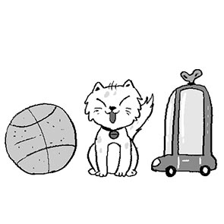

- (A) 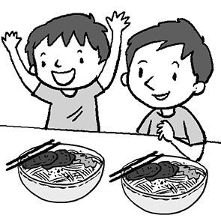 (B) 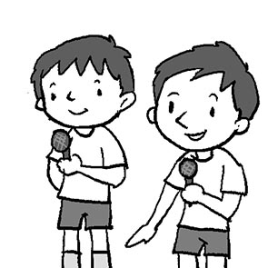 (C) 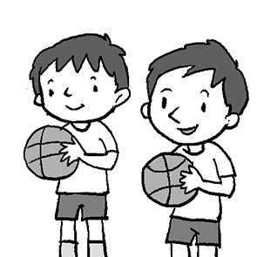

- (A) 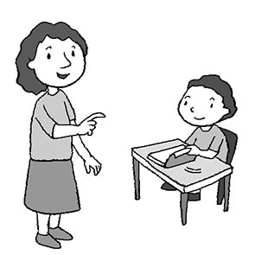 (B) 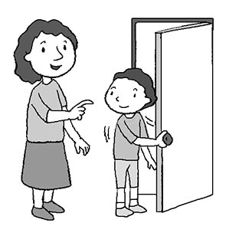 (C) 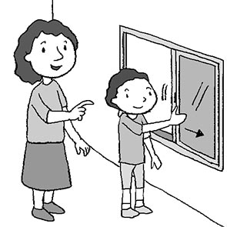

- (A) 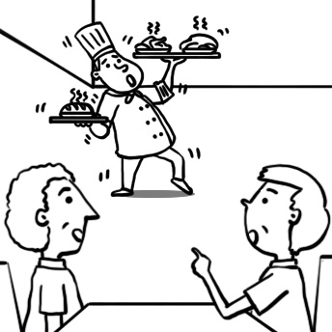 (B) 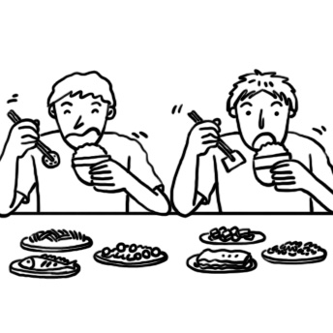 (C) 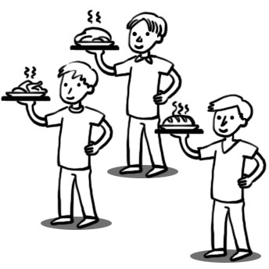

- (A) 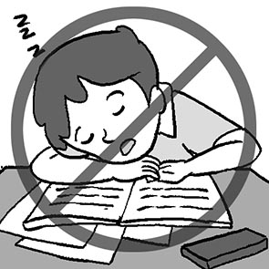 (B) 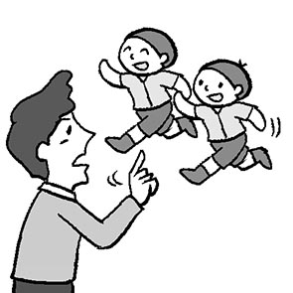 (C) 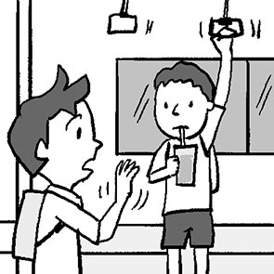

- 聽力(基本問答)-根據聽到的內容，選出合適的
回應：每題1分，共5分

- (A) She is fifty.
(B) In the garden.
(C) Let’s try again.
- (A) It’s on me.
(B) It’s a potluck.
(C) It’s from 6 p.m. to 9 p.m.
- (A) No, it is behind the sofa.
(B) She is in the dining room.
(C) It is between the desk and the door.
- (A) Let’s go.
(B) Okay, Mom.
(C) I am very angry.
- (A) It’s a bear.
(B) That’s Ben.
(C) He’s seven.

- 聽力(言談理解)-根據聽到的對話內容與問題，
選出正確的答案：每題2分，共10分
- (A) In the bedroom.
(B) In the living room.
(C) In the mother’s bag.
- (A) The elephants are dirty.
(B) The boy and the girl are at the zoo.
(C) The pandas are the boy’s favorite animals.
- (A) It’s a girl.
(B) Its name is Mochi.
(C) It’s small and clean.
- (A) 8:30.
(B) 8:50.
(C) 9:00.
- (A) Cake.
(B) Tacos.
(C) Beef noodles.

四、字彙與文法選擇:每題1分，共20分
- Kevin, please don’t during the class.
(A) take (B) join (C) tell (D) talk
- These dishes are very . Let’s eat together.
(A) delicious (B) fun (C) easy (D) touching
- Please bring your favorite dishes the party.
(A) at (B) to (C) with (D) of
- Let’s the basketball game. It is fun.
(A) bring (B) joy (C) put (D) join
- Don’t play with the . It is dangerous（危險的）.
(A) knifes (B) know (C) knive (D) knife
- Welcome to the party. Let’s have together.
(A) fun (B) hand (C) way (D) fan
- A: What is in the box?
B: It’s a for you. Happy birthday!
(A) wear (B) gift (C) party (D) smart
- The garden is the house. It’s big and beautiful.
(A) behind (B) next (C) between (D) during
- There is a beautiful on her jacket.
(A) pin (B) use (C) fun (D) but
- Hellen: Who’s the girl _____ Tom and Betty?
Dora: She’s Susan. She’s my good friend.
(A) into (B) inside (C) behind (D) between
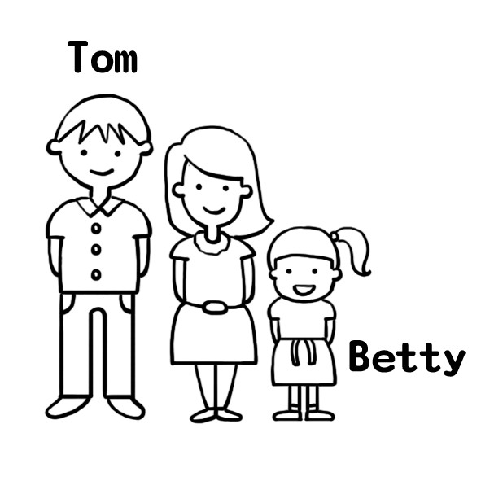
- There are many animals on Uncle Jeff’s farm, but there any pigs.
(A) aren’t (B) isn’t (C) are (D)are
- Kevin, please nice to your classmates.
(A) is (B) are (C) am (D) be
- Jack a good student at school.
(A) be (B) to be (C) is (D) are

- Wade, put your bag on the dining table.
(A) don’t be (B) be not (C) don’t (D) not
- We are in the museum. Let’s eat or drink.
(A) not please (B) please not (C) don’t (D) not
- A: Is the parrot in the cage（籠子）?
B:
(A) Yes, it is. (B) No, it not. (C) Yes, they are. (D) No, they aren’t.
- A: Where is the park?
B: It’s the school.
(A) on (B) near (C) at (D) in front
- A: Are there sofas in the living room?
B: Yes, there are sofas in the living room.
(A) some; some (B) any; any (C) any; some (D) some; any
- There is in the box.
(A) a cake (B) not cakes (C) many cakes (D) some cakes
- Frank: Where’re the hippos?
George: They’re the pool. You can see their eyes and ears.
(A) in (B) on (C) behind (D) in front of
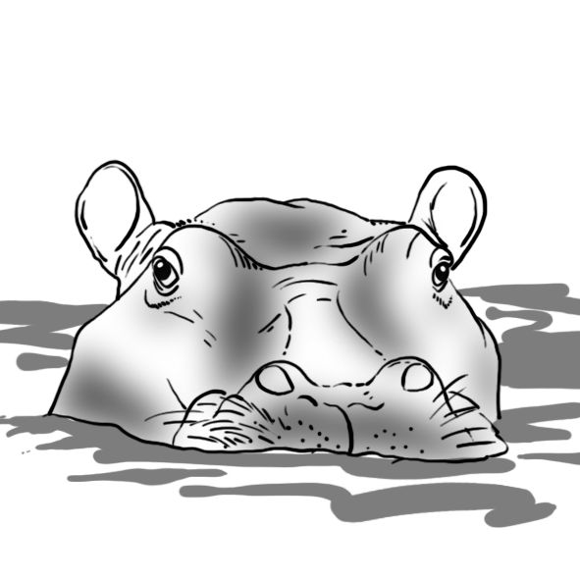

五、克漏字選擇：每題1分，共10分
- A: It’s dinner time. (36) have tacos.
B: The tacos are delicious.
A: (37) use chopsticks. Use your hands.
B: That’s easy. This is my dish, fried chicken. (38) it.
A: Well, it is delicious, too.
36. (A) We’re (B) Let’s (C) It’s (D) You’re
37. (A) Don’t please (B) Please don’t
(C) Please not (D) Not please
38. (A) Try (B) Use (C) Bring (D) Put

- Mrs. Lin: Students. It’s time for class. Please sit down
and (39) quiet.
Students: OK. Mrs. Lin.
Mrs. Lin: Please put your book on the desk. Don’t
eat or drink (40) .
Students: OK. Mrs. Lin.
Mrs. Lin: Robert, you are late for school. Please (41)
late next time.
Robert: Yes, Mrs. Lin.
39. (A) to be (B) being (C) be (D) to being
40. (A) in classroom (B) in class
(C) on classroom (D) on class
41. (A) don’t be (B) be not (C) not be (D) be don’t
- (Lunch time)
Amy: It’s (42) . Let’s have lunch together.
Judy: OK. What’s something delicious (43) today?
Amy: They are eggs, fish, vegetables, and some rice.
Judy: Wow! Fish is (44) favorite.
Amy: What about you? What is your lunch today?
Judy: Dumplings（水餃）. Dumplings are convenient（方
便的）to me.
Amy: Dumplings are delicious, (45) .

42. (A) 11:55 (B) 10:00 (C) 08:50 (D) 15:10
43. (A) between them (B) in your lunch
(C) in your lunch box (D) in front of the clock
44. (A) a (B) the (C) I (D) my
45. (A) too (B) again (C) please (D) also

六、閱讀測驗：每題2分，共18分
- There is a small cabin（小木屋）in the forest. In the living
room, there is a picture on the wall. Snow White and seven
little men are in the picture.
In the dining room, Snow White is at a big table. On the
table, there are eight bowls and plates. Some knives and forks
are on it, too.
It’s Snow White’s birthday today. All the little men are in
the kitchen now. A big meal is ready!

46. What is it in the reading?
(A) The table. (B) The bowl. (C) The plate. (D)The fork.
47. Where is Snow White?
(A) She’s in the kitchen. (B) She’s in the dining room.
(C) She’s in the living room. (D)She is in her bedroom.
48. Which is right about the meal?
(A) It’s on the table now. (B) It’s for seven people to eat.
(C) It’s for Snow White's wedding. (D)It’s in the kitchen.

- Here are the rules for all the family.
(１) Wash your hands before（在…之前）dinner.
(２) Be quiet during the meal.
(３) No cellphones at the dinner table.
(４) Don’t play with the chopsticks or spoons.
(５) Don’t say no to vegetables(蔬菜). Give it a shot.
(６) Don’t watch TV during the meal.
49. Where can you see the rules?
(A) In the living room. (B) In the garden.
(C) In the bathroom. (D) In the dining room.
50. What is NOT the rule for all the family?
(A) Eat vegetables.
(B) Don’t use cellphones during the meal.
(C) Don’t run near the table.
(D) Clean your hands before you eat.

3. Tina’s school is small but beautiful. There are many trees
in the center（中間）of her school. There is a pool behind the
science（科學）classroom. The English classroom is next to it.
It is Tina’s favorite place（地方）. Her friends study at this school,
too. There is a big tree in front of Alice’s classroom. Judy’s
classroom is next to Teacher’s Office. Where is Kevin’s
classroom? It is between Alice’s and Judy’s classrooms.
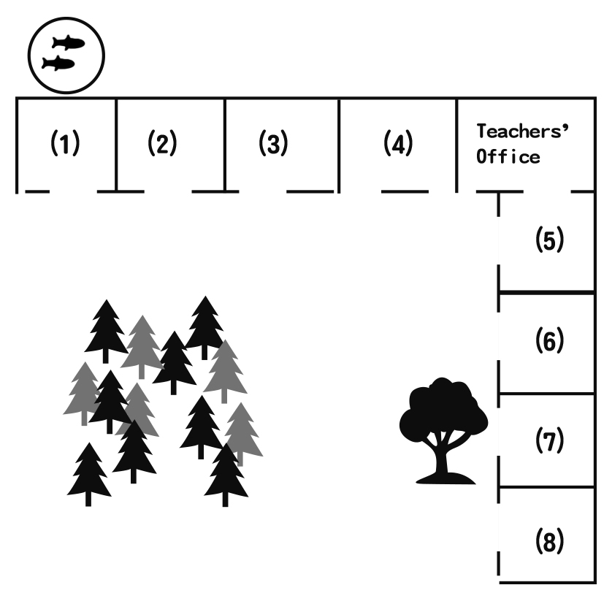
51. Where is Tina’s favorite place?
(A) (１). (B) (２). (C) (３). (D) (４).
52. Where is Kevin’s classroom?
(A) (５). (B) (６). (C) (７). (D) (８).

4. (Peter and Rita are chatting on LINE.)

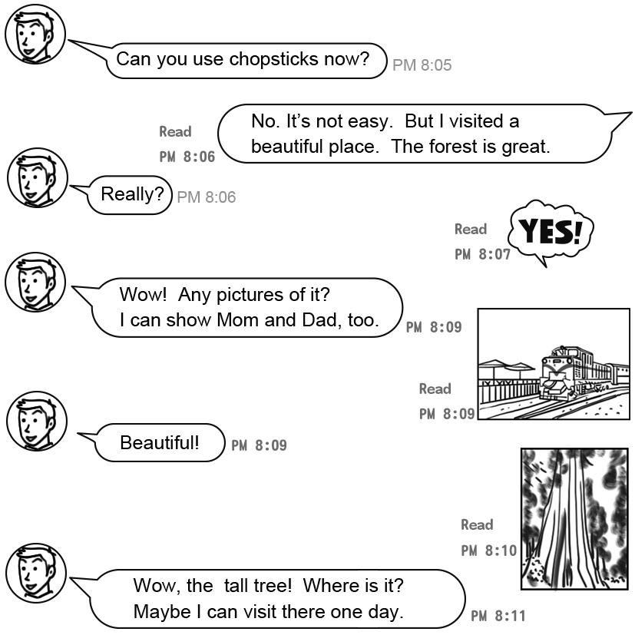
53. Where may(可能) Rita be now?
(A)
(B)
(C)
54. Who are Peter and Rita?
(A) They are mother and son.
(B) They are friends.
(C) They are brother and sister.
(D) They are father and daughter.
七、依提示作答:每題3分，共15分
55. Don’t stand up.（加入Please與students)

56. Where is the mouse? (請用「在盒子裡」回答)

57. The boys are in front of the big tree.
(依畫線部分造原問句)

58. Are there three girls in the swimming pool?
(請用「一位女孩」回答)

59. Where are you from? (請用「Taiwan」回答)

八、翻譯填空:每格1分，共12分
60. 不要用筷子，用手就好。
Don’t use . use your hands.
61. 請帶著你最愛的菜餚，並穿著來自你的國家的服飾。
Please bring your dishes and
something from your .
62. Dr. Wildman 是個有名的動物醫生，他仁慈且工作認真。
Dr. Wildman is a animal doctor. He is kind and .
63. 我們邀請Tom來我們的派對吧。
Let’s Tom ________ our party.
64. 別站在樹下。那裡有猴子。
Don’t the tree.

There are there.

【辛苦了!請交回手寫卷，謝謝!】

