嘉義縣立太保國中110學年度第2學期八年級英語科第2次段考 (P.1)
命題教師:李貞凌 範圍:Book4Lesson3~Review2 __年__班__號 姓名_______
Part 1聽力測驗
I.辨識句意-根據聽到的內容，選出正確的圖片代碼：5%
( ) 1. (A) (B) (C)
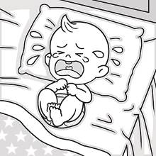 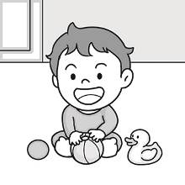 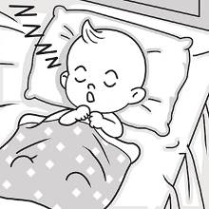
( ) 2. (A) (B) (C)
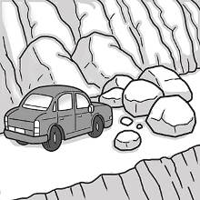 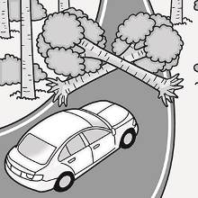 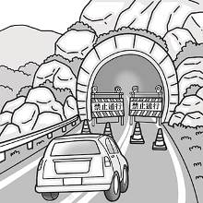
( ) 3. (A) (B) (C)
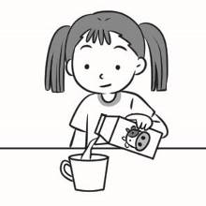 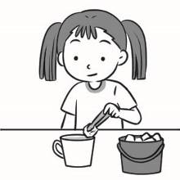 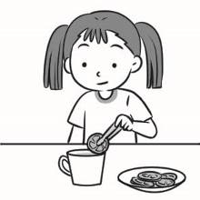
( ) 4. (A) (B) (C)
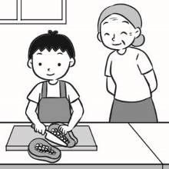 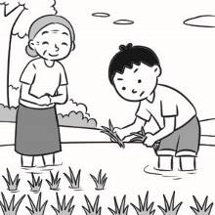 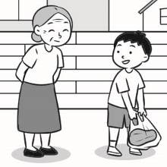
( ) 5. (A) (B) (C)
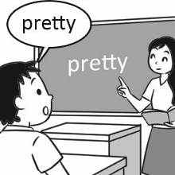 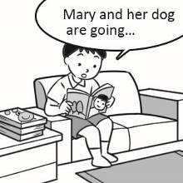 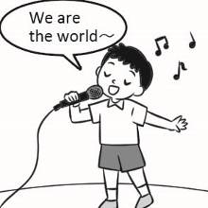
II.基本問答-根據聽到的內容，選出合適的回應：5%
( ) 6. (A) No, we’re classmates.
(B) No, we’re just neighbors.
(C) No, we don’t have class today.
( ) 7. (A) Wow, even its tail is big!
(B) Right. The river looks clean.
(C) Yes. Their fish is always the best!
( ) 8. (A) They are not in season.
(B) I don’t like sweet food.
(C) Would you like more sugar?
( ) 9. (A) She showed me a picture.
(B) She wrote a birthday card to me.
(C) She told me to wash the car on the weekend.
( )10.(A) Wow. She is a brave girl.
(B) Right. This summer is very long.
(C) Cool. Will you send me a postcard?

III.言談理解-根據聽到的對話內容與問題，選出正確的答案：5%
( )11. (A) Working with the woman.
(B) Watching movies at home.
(C) Buying a comfortable couch.
( )12. (A) He fell in the hole this morning.
(B) He didn’t notice the hole on the road.
(C) He helped the woman out of the hole.
( )13. (A) He sent Jane some fruit.
(B) He helped Jane carry the fruit.
(C) He bought some fruit for Jane.
( )14. (A) To see her father.
(B) To send her some peaches.
(C) To give her grandma a ride.
( )15. (A) She isn’t wearing a mask.
(B) She left her money at home.
(C) She needs to go back to work.

Part 2讀寫測驗
I.綜合測驗:38%
( )16. The girl is Mr. Lin’s daughter. She dances ___.
(A)good (B)well (C)goodly (D)bad

嘉義縣立太保國中110學年度第2學期八年級英語科第2次段考 (P.2)
命題教師:李貞凌 範圍:Book4Lesson3~Review2 __年__班__號 姓名_______
( )17. Judy’s mom told her ___ home so late.
(A)didn’t come (B)not to come (C)not coming (D)not to coming
( )18. The Known-You Company improved ___ lives.
(A)farmers (B)farmer’s (C)farmer (D)farmers’
( )19. Billy studies as ___ as Willy. They are both good students.
(A)harder (B)hardest (C)hardly (D)hard
( )20. Guys, please don’t talk so ___. It’s late now.
(A)quiet (B)quietly (C)loudest (D)loudly
( )21. It’s ___ to sit in Andy’s car because he always drives ___.
(A)safe ; careful (B)safe ; carefully (C)safely ; careful (D)safely ; carefully
( )22. David didn’t come because of ___.
(A)it rained heavily (B)the heavy rain (C)the rain heavily (D)it is raining
( )23. A:Do you know? William plays basketball ___ than Mike.
B:Yes. He is also the ___ player in our class.
(A)better ; best (B)well ; better (C)well ; good (D)better ; well
( )24. The movie made me ___.
(A)sadly (B)more sadly (C)sad (D)saddly
( )25. The little girl was ___. Luckily, the brave man saved her ___.
(A)dangerous ; successful (B)dangerous ; successfully
(C)in danger ; successful (D)in danger ; successfully
( )26. A:How would you like your juice?
B:___
(A)I don’t like juice. (B)Quarter sugar, less ice, please.
(C)Water, please. (D)Can I have a glass of juice?
( )27. Willy ___.
(A)give his wife a gift (B)bought a gift for his wife
(C)asked his wife mop the floor (D)had his wife to wash the clothes
( )28. Susan is ___ opening her birthday gift.
(A)happily (B)happy (C)happier (D)happiest
( )29. Who sings ___, Tina or Susan?
(A)beautiful (B)more beautifully (C)most beautiful (D)most beautifully
( )30. Jenny danced as ___ as Monica. In the end, they both won the dancing
contest(比賽).
(A)good (B)better (C)well (D)best
( )31. The baby cries ___ when he gets ___.
(A)loud ; hungry (B)loudly ; hungrily (C)loud ; hungrily (D)loudly ; hungry
( )32. Please help Sue ___.
(A)doing her homework (B)does the work
(C)with the math homework (D)to doing her homework
( )33. A:Why did the runner look ___ at that time?
B:He came in first in the race, so he looked ___ at his coach(教練).
(A)happily ; happy (B)more happily ; happy (C)happy ; happily (D)happy ; happier
( )34. How many ___ did you buy?
(A)glass of juice (B)watermelon (C)box of papayas (D)baskets of strawberries

II.題組:25%
[A]
There are many different kinds of energy(能源). However, as we all know, the world is short of energy now, so 35 energy is very important to us. We can do a lot of things to save energy and 36 protect(保護) the Earth.
As a student, we can start from our home and school. For example, we can turn off the lights when we leave the room for more than three minutes. Also, when some things like TVs, computers, cellphones are old, we can 37 our friends or family instead of(而不是) throwing them away. When we wash our hands or brush our teeth, don’t keep the tap(水龍頭) 38 .
What’s more, we can invite our friends and family to save the energy with us. We can drive less and walk or ride a bike to school or work. Taking a bus or the MRT 39 also a good way. In this way, we can use 40 energy. These are very easy things for us to do in our lives. 41 energy we save, 41 Earth we have.
( )35. (A)save (B)saving (C)to saving (D)saved
( )36. (A)ask (B)keep (C)want (D)help
( )37. (A)sell them for (B)bought them to (C)give them to (D)show to them
( )38. (A)running (B)to run (C)ran (D)run
( )39. (A)are (B)is (C)do (D)does
( )40. (A)more (B)better (C)less (D)much
( )41. (A)The less ; the better (B)The more ; the worse
(C)The more; the better (D)The less ; The cleaner

嘉義縣立太保國中110學年度第2學期八年級英語科第2次段考 (P.3)
命題教師:李貞凌 範圍:Book4Lesson3~Review2 __年__班__號 姓名_______
[B]
Adam:Hey, David. You look so tired. Didn’t you sleep 42 last night?
David:No, I didn’t. 43
Adam:Why did you stay up?
David:I 44 with my friend on the Internet.
Adam:Then you shouldn’t drive now.
David:Don’t worry. I’m a good driver. I won’t drive 45 .
Adam:No way! I’ll drive the car, and you can take some rest.
David:Come on! I’m fine.
Adam:No. It’s not safe 46 a car when you feel tired. That may 47 you or take away other people’s lives.
David: 48 All right. I’ll let you 49 the driver this time.
( )42. (A)well (B)good (C)nice (D)the best
( )43. (A)I had a sweet dream. (B)I ate a lot.
(C)I only slept for two hours. (D)I went to bed at nine.
( )44. (A)am chatting (B)chats (C)will chat (D)chatted
( )45. (A)early (B)late (C)fast (D)fastly
( )46. (A)to drive (B)driving (C)to driving (D)drove
( )47. (A)help (B)practice (C)improve (D)kill
( )48. (A)That sounds serious. (B)Keep quiet.
(C)Of course not. (D)Don’t worry.
( )49. (A)do (B)to do (C)be (D)being

[C]
Hi, Kate! How are you? I really feel 50 . This morning I felt like 51 a baseball game on TV, but my mom made me 52 my brother, Billy with his math homework, so I stopped 53 it. Do you have time now? If yes, why not 54 out with me at Mr. Wilson’s? I think its spaghetti is 55 of all in town. I 56 you at your place in 30 minutes. Is that OK?
( )50. (A)angry (B)angrily (C)anger (D)more angrily
( )51. (A)to watch (B)to watching (C)watched (D)watching
( )52. (A)to help (B)helping (C)help (D)helped
( )53. (A)to watch (B)watching (C)watch (D)watched
( )54. (A)eat (B)ate (C)eating (D)to eat
( )55. (A)more delicious (B)the most delicious (C)deliciously (D)delicious
( )56. (A)met (B)will meet (C)meet (D)meets
( )57. What place is Mr. Wilson’s?
(A)A library. (B)A Station. (C)A restaurant. (D)A bakery.

[D]
Dear Dr. James,

I’m a senior high school student. I’m in big trouble. There are bullies(惡霸、霸凌) at my school, and they are very mean(兇惡的) to me. Sometimes they walk to my classroom and shout loudly at me. No one in the classroom helps me because everyone is afraid of getting into trouble, too. Yesterday, they did something even worse. They pushed me around and told me to give them money. I refused at first, but one of them punched(猛擊) me hard in my stomach. It really hurt! He said, “Give us money, or I’ll give you more punches.” I was very afraid, so I gave them all my pocket money and didn’t tell anyone about this. What can I do?

Zack
------------------------------------------------------------------------------------------------------------------
Dear Zack,
That’s a serious problem. You have to do something, or they will keep bullying you. You can talk to your teachers and parents about this. Don’t be afraid to speak it out and learn to protect yourself.
***If you need more help, call at 0800-200-885.

Dr. James
( )58. Why did Zack write this e-mail to Dr. James?
(A)Because he wants to make friends with Dr. James.
(B)Because Dr. James can help him fix his computer.
(C)Because some students bullied him and even hurt him.
(D)Because he planned to invite Dr. James to go to school with him.
( )59. What does “refused” mean in the reading?
(A)To agree with something. (B)To speak out for something.
(C)To say you won’t do something. (D)To help others do something.
嘉義縣立太保國中110學年度第2學期八年級英語科第2次段考 (P.4)
命題教師:李貞凌 範圍:Book4Lesson3~Review2 __年__班__號 姓名_______
III.依提示改寫句子:6%
60. Judy answered the question carefully.(依畫線部分造原問句)
61. Tina swam better than Judy and Sue. (用Tina…of the three改寫句子)
62. Mrs. Lin wanted her daughter to mop the floor.(畫線部分改為使役動詞make)

IV.翻譯填充:11%(每格1分)
63. Tommy生長在一個老師的家庭，所以她的父母總是要他用功讀書。
Tommy ___ up in a family ___ teachers, so his parents always ___ him ___ ___.
64. A:你看起來很害怕。怎麼了?
B:我的喉嚨有點不對勁。我沒辦法大聲地說話。
A: You looked ___. ___ ___?
B: There’s ___ ___ with my throat. I can’t speak ___.

-------------------------------------------------------------------------------------------------------------
答 案 欄

___ 年 ___ 班 ___ 號 姓名 ______________

III.依提示改寫句子:6%

60. ______________________________________________

61. ______________________________________________

62. ______________________________________________

IV.翻譯填充:11%(每格1分)

63. ______________ ______________ ______________

______________ ______________

64. ______________ ______________ ______________

______________ ______________ ______________

~~~試題結束~~~

解答:
- 5 AACAB
6-10 BAACA
11-15 BBBBA
16-20 BBDDD
21-25 BBACD
26-30 BBABC
31-35 DCCDB
36-40 DCABC
41-45 CACDC
46-50 ADACA
51-55 DCBAB
56-59 BCCC
60.How did Judy answer the question?
61.Tina swam the best of the three.
62.Mrs. Lin made her daughter mop the floor.
63.grew of made study hard
64.scared What happened something wrong loudly
英聽題目:
一、辨識句意-根據聽到的內容，選出正確的圖片代碼：每題1分、共5分
- The baby is crying loudly in the bedroom.
- Some rocks are blocking the road, so the car can’t go through it.
- Josephine put a slice of lemon in her tea.
- Steven helped his grandma cut the papaya.
- Frank read several English stories this weekend.
二、基本問答-根據聽到的內容，選出合適的回應：每題1分、共5分
- Are you guys classmates?
- Look at that giant fish over there.
- Why are mangoes less sweet now?
- What did Jenny tell you yesterday?
- My friend, Jenna, is going to travel abroad alone this summer.
三、言談理解-根據聽到的對話內容與問題，選出正確的答案：每題1分、共5分
- W: Hank. Do you have any plans for the weekend?
M: Yes, I want to stay home this weekend.
W: Come on! We can go out and have some fun.
M: I’m sorry. After working so hard for five days, I just want to sit comfortably on my couch and enjoy some movies during the weekend.
Q: What is the man’s plan for the weekend?
- W: Hey, watch out! There’s a hole!
M: Oh, thank you so much! I didn’t notice the hole.
W: You should walk more carefully. A boy fell in that hole this morning.
M: Oh no, that’s terrible! I will be more careful next time.
Q: What happened to the man?
- B: What’s in the basket, Jane?
G: There are some papayas. My mom asked me to send them to a neighbor of ours.
B: Let me help you carry it.
G: You’re so kind. It’s really heavy.
Q: What did the boy do?
- M: Hey, Mary. Where are you going?
W: I’m going to my grandma’s house. She is sick. My mom bought some peaches and is having me take them to her.
M: Where is your grandma’s house? Maybe I can give you a ride.
W: I’m good. My father will take me there. Here he comes! Goodbye.
Q: Why is Mary going to her grandma’s house?
- M: Excuse me. Do you have your mask with you?
W: Let me see … my mask …. Oh no, I left it at home.
M: I’m sorry. I can’t let you go into the supermarket without a mask. You must wear your mask.
W: OK. I’ll come back later. Thank you.
Q: Why can’t the woman go into the supermarket?

