太保國中110學年度第1學期第二次段考二年級英語科試題 P.1
命題教師:李貞凌 範圍:Book3 Lesson3~Review2 __年__班__號 姓名_______
Part 1聽力測驗
I.辨識句意(根據聽到的內容，選出正確的圖片代碼):5%
( ) 1. (A) (B) (C)
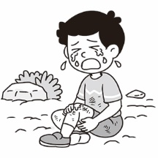 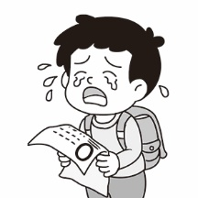 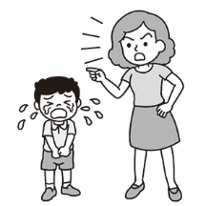
( ) 2. (A) (B) (C)
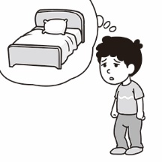 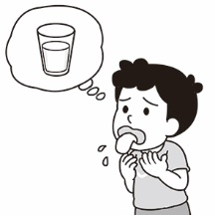 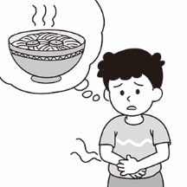
( ) 3. (A) (B) (C)
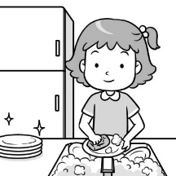 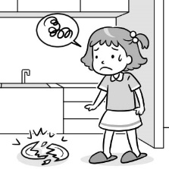 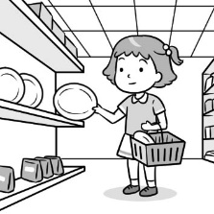
( ) 4. (A) (B) (C)
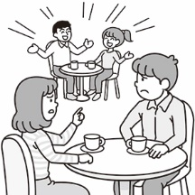 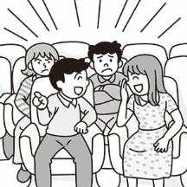 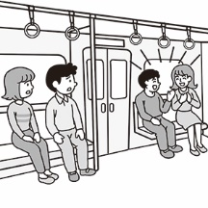
( ) 5. (A) (B) (C)
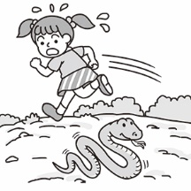 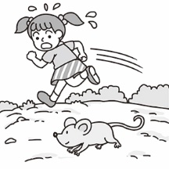 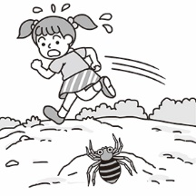
II.基本問答(根據聽到的內容，選出合適的回應):5%
( ) 6. (A) On the computer.
(B) It was full of mud.
(C) When I was on the bus.
( ) 7. (A) I like the game.
(B) Only two hours.
(C) Two hours a week.
( ) 8. (A) Well, I finally found a work.
(B) I started it just after 10 o’clock.
(C) Yes. I have two math classes today.
( ) 9. (A) I love going surfing.
(B) We plan to go fishing.
(C) In a small water factory.
( )10.(A) I was helpless.
(B) I was still sleeping then.
(C) I wasn’t at home this morning.
III.言談理解(根據聽到的對話內容與問題，選出正確的答案):5%
( )11.(A) Sally wrote a card yesterday.
(B) Today is the boy’s special day.
(C) Sally likes the card from the boy.
( )12.(A) The boy ran away from the kitchen.
(B) The woman saw a spider in the kitchen.
(C) The boy tried to catch a spider in the kitchen.
( )13.(A) The man likes cooking.
(B) The woman is a good basketball player.
(C) The man started playing basketball when he was three.
( )14.(A) Watch movies on TV.
(B) Go to the movie theater.
(C) Go out with the woman.
( )15.(A) She can’t find the man.
(B) She is scared of the man.
(C) She saw a rat in the kitchen.
太保國中110學年度第1學期第二次段考二年級英語科試題 P.2
命題教師:李貞凌 範圍:Book3 Lesson3~Review2 __年__班__號 姓名_______
Part 2讀寫測驗
IV.單題測驗:27%
( )16.Judy ___ with her boyfriend when I met her on the bus.
(A)chated (B)chats (C)was chatting (D)is chatting
( )17.You have to turn off all the lights before ___.
(A)you are leave (B)leaving (C)left (D)leave
( )18.A:When did your parents ___ there? B:Last night.
(A)arrive at (B)arrive (C)get in (D)arrive in
( )19.A:Do you see the ___? B:Yes, they are so cute.
(A)bear (B)sheep (C)child (D)rabbit
( )20.A:David plays basketball well.
B:He spends much time ___ it every day.
(A)practice (B)to practice (C)practicing (D)practices
( )21.Mr. Wang ___ a big house after he made much money.
(A)was buying (B)is buying (C)buys (D)bought
( )22.Helen ___ the piano at nine last night.
(A)was playing (B)plays (C)played (D)is playing
( )23.A:What are you up to these days? B:___
(A)I have many friends. (B)I looked after horses and cows on my uncle’s farm in Ilan.
(C)I’m cooking now. (D)I was watching TV.
( )24.A:___ B:What a wonderful experience!
(A)My grandpa passed away last week. (B)I left my wallet on the bus.
(C)Peter broke his arm in the accident. (D)I went surfing with Sam yesterday.
( )25.Judy ___ shopping with Bill yesterday and had lots of fun.
(A)was going (B)goes (C)went (D)go
( )26.What___ you ___ when Lily came in?
(A)did ; do (B)were ; doing (C)are ; doing (D)do ; do
( )27.A:Why didn’t you answer my phone this morning?
B:What time did you call?
A:At about seven.
B:Oh, I ___ at that time.
(A)sleep (B)sleeps (C)was sleeping (D)am sleeping
( )28.I planned ___ beef noodles for dinner, and Tom ___, too.
(A)to have ; is (B)having ; is (C)to have ; did (D)having ; does
( )29.A:Why ___ Linda ___ the phone last night?
B:Because she was too busy.
(A)wasn’t ; answering (B)didn’t ; answer (C)didn’t ; answering (D)isn’t ; answering
( )30.Peter wants ___ a good doctor in the future.
(A)to be (B)being (C)to do (D)to doing
( )31.Linda called her mom after ___ Japan.
(A)She arrives in (B)arriving in (C)arrived (D)arrive
( )32.I enjoy ___ a hot bath ___ it is very cold.
(A)taking ; because of (B)to take ; and (C)taking ; when (D)to take ; but
( )33.When I heard the news, I was ___.
(A)surprised (B)surprising (C)surprise (D)surprised at
( )34.A:Cathy and Judy were running on the street ___.
B:Why?
A:A big dog was running after them.
(A)yesterday (B)right now (C)on weekends (D)when I saw them
( )35.A:When ___ your father ___ for America?
B:Three days ago.
(A)was ; leaving (B)is ; leaving (C)did ; leave (D)does ; leave
太保國中110學年度第1學期第二次段考二年級英語科試題 P.3
命題教師:李貞凌 範圍:Book3 Lesson3~Review2 __年__班__號 姓名_______
( )36.Annie likes reading comic books and ___ music.
(A)to listen (B)listening to (C)to listen to (D)listening
( )37.A:___ your dog ___ when I saw you at the beach?
B:Yes. It loves to swim and catch balls.
(A)Did ; swim (B)Is ; swimming (C)Did ; swimming (D)Was ; swimming
( )38.Jenny ___ helping poor people. Let’s help her to do that.
(A)wants (B)like (C)needs (D)enjoys
( )39.Emily is ___ a working holiday in Canada.
(A)enough old to take (B)old enough taking
(C)enough old taking (D)old enough to take
( )40.Judy spent three hours ___ her homework.
(A)to do (B)do (C)on (D)of
( )41.My parents always tell me ___ computer games too often.
(A)not playing (B)not to play (C)to not play (D)not play
( )42.The road was wet ___ the rain.
(A)because (B)when (C)because of (D)on
V.題組測驗:30%
[A]
Mary：Where 43 you at eight last night?
Linda：My sister Kelly and I were at Sogo Department Store. Why?
Mary：Well, I went to your home, but you were not there. You don’t like 44 . What were you doing at Sogo Department Store?
Linda：We were picking a gift for my dad and buying something for the party. My father’s birthday is just around the corner. It is this Saturday, and it’s his 45 birthday.
Mary：Oh, I see. Did you get all the things?
Linda：Not yet. Kelly and I were looking for a camera from Japan, but we couldn’t find one.
Mary：Hey, I know a place. It has many 3C products(產品) from Japan. Maybe you
can find your dad’s birthday gift there.
Linda：Great! Can you take me there after work today? After that, we can have
dinner together.
Mary：No problem. See you then.
( )43.(A)are (B)were (C)did (D)do
( )44.(A)shop (B)to shopping (C)shops (D)shopping
( )45.(A)fifteen (B)fifty (C)the fiftieth (D)fiftieth
( )46.When a day is “around the corner,”means it ___.
(A)never happens (B)just happened (C)is four months away (D)is coming
( )47.What does “one” mean in the dialogue(對話)?
(A) (B) (C) (D)
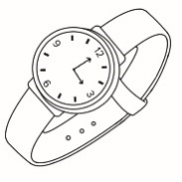
[B]
Anita loves comic books. She 48 to Taipei for a book fair(書展) last weekend. 49 for the signature(簽名) of her favorite comic artist when a reporter came to ask her some questions about the artist. Then she won a prize(獎品) 50 she answered those questions. She was shy but happy when many people 51 her. Then she saw her favorite comic artist and 52 . When she got home, she showed the prize, photos, comic books, and the artist’s signature 53 her parents. They were happy for her, too. It was a special 54 for Anita.

太保國中110學年度第1學期第二次段考二年級英語科試題 P.4
命題教師:李貞凌 範圍:Book3 Lesson3~Review2 __年__班__號 姓名_______
( )48.(A) goes (B) is going
(C) went (D) was going
( )49.(A)She was reading her comic book
(B)She was sitting on the bench
(C)She was playing cards
(D)She was waiting in line
( )50.(A)so (B)or (C)but (D)because
( )51.(A)was looking at (B)looked at (C)looking at (D)are looking at
( )52.(A)took some photos with him (B)drew comic books for him
(C)spoke to the reporter (D)sang for him
( )53.(A)for (B)to (C)at (D)of
( )54.(A)waiter (B)factory (C)experience (D)bottom
[C]
Shohei Ohtani(大谷翔平) is a world-famous baseball player from Japan. When he was a little boy, everything was interesting to him, and he was just like a copycat. He enjoyed doing the same thing as his brother and sister did. When he was ten, he started to practice baseball. It was difficult for him to pitch(投球) a ball then, so his pitching wasn’t very good.
One day, he got an idea when he was watching TV. He found a golf(高爾夫) player swinging(揮桿) in an easy way, so he planned to learn from him, and he made it. Baseball players usually need to decide to be a pitcher(投手) or a batter(打者), so they can practice either pitching or swinging. However, Ohtani wanted to be good at both. He listened to Steve Jobs’ speech once, and that made him decided to train as a pitcher and a batter, too. Sometimes he pitched a lot, and sometimes he hit balls all day long. It was very difficult, but he enjoyed doing it. Finally, now Shohei Ohtani is a popular baseball player around the world.
pitch 投球 golf 高爾夫球 swing 揮桿／棒 either… or… 不是……就是…… pitcher 投手 batter 打者 speech 演講 hit 打擊
( )55.Who is a “copycat”?
(A) Jimmy. He wants his brother to help him with his math homework all the time.
(B) Tammy. She and her sister often fight each other for a toy cat.
(C) Johnny. He always says the same as his cousin.
(D) Sammy. Her brother likes to read, but she never does.
( )56.How did Ohtani change his way of pitching?
(A) He learned from a golf player on TV.
(B) He practiced only in the morning.
(C) He listened to Steve Jobs’ speech.
(D) He did it the same way as his brother did.
( )57.Which is NOT true about Ohtani?
(A) He is from Japan, and now he is famous all around the world.
(B) He began playing baseball when he was ten.
(C) He is a pitcher and a batter, too.
(D) When he was little, only baseball was interesting to him.

(以下試題請於答案欄作答)
VI.請寫出正確的動詞形式:9%
58.Jenny spent a year ___(work) in Taiwan.
59.Mr Smith needs ___(pick) up his daughter after work.
60.It’s not possible for Taylor the Toad ___(jump) out of the hole.
61.The old man passed by and ___(say) hello to me.
62.Linda ___(talk) on the phone when I opened the door.
63.The baby kept ___(cry) because she was hungry.
太保國中110學年度第1學期第二次段考二年級英語科試題 P.5
命題教師:李貞凌 範圍:Book3 Lesson3~Review2 __年__班__號 姓名_______
64.Mom is always busy ___(cook) dinner after work.
65.How did you feel when you ___(hear) the news?
66.Mr. Wu enjoyed ___(go surfing) when he worked in Australia.
VII.翻譯:14%(每格1分)
67.我等不及要跟Andy玩新的電動。
I cannot ___ ___ ___ the new computer game ___ Andy.
68.幸虧有你們，我才能及時完成工作。
___ ___ you, I can finish my work ___ ___.
69.我有當推銷員的經驗。
I have an ___ of working ___ a ___.
70.當我看到David的時候，他正在自拍。
David was ___ ___ when I ___ him.

-----------------------------------------------------------------------------------------------------------
答 案 欄

___ 年 ___ 班 ___ 號 姓名 _____________

VI.請寫出正確的動詞形式:9%

58. ____________________ 59. ____________________

60. ____________________ 61. ____________________

62. ____________________ 63. ____________________

64. ____________________ 65. ____________________

66. ____________________
VII.翻譯:14%(每格1分)

67. ____________________ ____________________ ____________________

____________________

68. ____________________ ____________________ ____________________

____________________

69. ____________________ ____________________ ____________________

70. ____________________ ____________________ ____________________

試題結束，辛苦了!!

解答
(每題1分)
- 5 BBBBC
6-10 CBBAB
11-15 CCAAC
16-20 CBBBC
21-25 DABDC
26-30 BCCBA
31-35 BCADC
36-40 BDDDC
41-42 BC

(每題2分)
43-45 BDD
46-50 DBCDD
51-55 BABCC
56-57 AD

VI.請寫出正確的動詞形式:9%

58.working 59.to pick

60.to jump 61.said

62.was talking 63.crying

54.cooking 65.heard

66.going surfing

67. wait to play

with

68. Thanks to in

time

69. experience as salesman

70. taking selfies saw

聽力試題
一、聽力(辨識句意)-根據聽到的內容，選出正確的圖片代碼：每題1分、共5分
- 答案：B
解析：Andy cried when he got a zero on the test.
- 答案：B
解析：Peter needs to drink some water.
- 答案：B
解析：The girl was unhappy after she broke the plates.
- 答案：B
解析：People can’t enjoy the movie because the man keeps talking in the movie theater.
- 答案：C
解析：The girl ran away when she saw a spider.
二、聽力(基本問答)-根據聽到的內容，選出合適的回應：每題1分、共5分
- 答案：C
解析：When did you get this message?
- 答案：B
解析：How much time did you play the computer game yesterday?
- 答案：B
解析：When did you start doing your math homework?
- 答案：A
解析：What kind of water sports do you like to do?
- 答案：B
解析：What were you doing around eight this morning?
三、聽力(言談理解)-根據聽到的對話內容與問題，選出正確的答案：每題1分、共5分
- 答案：C
解析：B: It was Sally’s birthday yesterday.
G: Did you do anything special for her?
B: I wrote a birthday card for her. She was very surprised when she got it.
G: That was so nice and sweet of you.
Q: What do we know from the dialogue?
- 答案：C
解析：W: What were you doing in the kitchen, Peter? You spent a long time in there.
B: I saw a big spider and I was trying to catch it.
W: Oh. Did you catch it?
B: No. It ran away.
Q: What do we know from the dialogue?
- 答案：A
解析：W: You are a really good basketball player.
M: Thank you.
W: Tell me. When did you start playing basketball?
M: I started playing it when I was nine.
W: Wow, that’s so early. And what else do you like to do?
M: I like to cook, too. I started cooking when I was thirteen.
Q: What do we know from the dialogue?
- 答案：A
解析：W: Hey, do you want to go out with me this afternoon?
M: No. I don’t want to go out this afternoon.
W: OK. Do you have any plans?
M: Yes. There are some great movies on TV in the afternoon. I want to watch them.
Q: What does the man plan to do in the afternoon?
- 答案：C
解析：W: Mike! Help me!
M: What happened?
W: There was a rat when I was in the kitchen one minute ago! I was so scared!
M: Is it still in the kitchen now?
W: Yes, but I can’t find it.
Q: What happened to the woman?

