嘉義縣太保國民中學109學年度第一學期二年級第二次段考英文科試題

命題老師：陳湘宜 範圍：Lesson 3～ Review 2 二 年 班 號 姓名：
- 聽力(辨識句意)-根據聽到的內容，選出正確的圖片代碼：每題1分，共5分
1. (A) (B) (C)
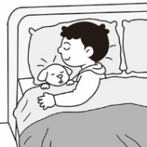
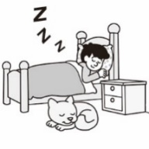
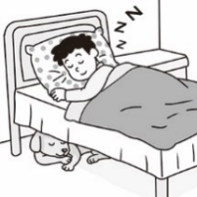

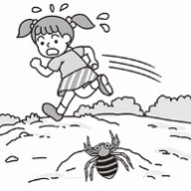
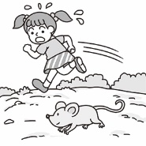
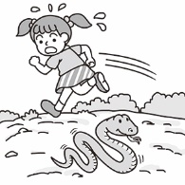
2. (A) (B) (C)

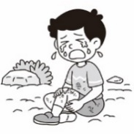
3. (A) (B) (C)
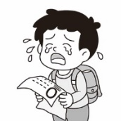
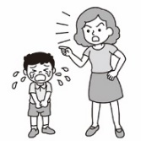

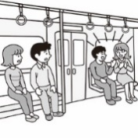
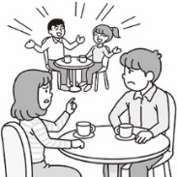
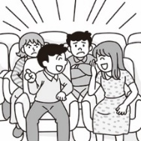
4. (A) (B) (C)

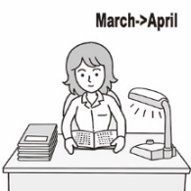
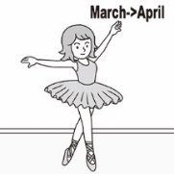
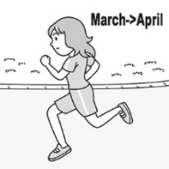
- (A) (B) (C)

- 聽力(基本問答)-根據聽到的內容，選出合適的回應：每題1分，共5分
- (A) On Thursdays. (B) Two years ago. (C) She always does.
- (A) I was happy, too. (B) How were you yesterday? (C) What was wrong with him?
- (A) Three hours. (B) From six o’clock. (C) I love doing homework.
- (A) I love going surfing. (B) We plan to go fishing. (C) In a small water factory.
- (A) A frog jumped out. (B) It’s very big and deep. (C) Before he arrived at the party.
- 聽力(言談理解)-根據聽到的對話內容與問題，選出正確的答案：每題2分，共10分
- (A) The man cried at the end of the movie. (B) The woman watched the movie last night.
(C) The woman had to prepare for the math test during the movie.
- (A) The boy ran away from the kitchen. (B) The woman saw a spider in the kitchen.
(C) The boy tried to catch a spider in the kitchen.
- (A) Watch movies on TV. (B) Go to the movie theater. (C) Go out with the woman.
- (A) Buy a house. (B) Make a cake. (C) Write a card.
- (A) She cried. (B) She laughed. (C) She was surprised.
四、字彙與語法選擇：每題1分，共27分
16. My father is a . He catches a lot of fish every week.
(A) fisherman (B) waiter (C) waitress (D) salesman
17. I bought a new yesterday. I can use it to take pictures and chat with my friends.
(A) computer (B) television (C) cellphone (D) telephone
18. The work is too hard. It’s not for me to finish it. (A) unhappy (B) fresh (C) clear (D) possible
19. Ted’s is this Friday. Let’s have a party for him. (A) bottom (B) butterfly (C) birthday (D) factory
20. My uncle’s son is my . (A) sister (B) brother (C) father (D) cousin

嘉義縣太保國民中學109學年度第一學期二年級第二次段考英文科試題

命題老師：陳湘宜 範圍：Lesson 3～ Review 2 二 年 班 號 姓名：
21. Many people like to watch the at the beach. (A) air (B) farm (C) sunset (D) bee
22. Jack was mopping the floor when David into the classroom.
(A) walking (B) walks (C) is walking (D) walked
23. Thanks your help, I can finish the work. (A) of (B) with (C) to (D) in
24. The teacher always us to tell the truth. (A) wants (B) finishes (C) keeps (D) stops
25. I wish I could be an actor you. (A) of (B) like (C) at (D) to
26. Nancy enjoyed the violin when she was little. Now she is a music teacher.
(A) playing (B) was playing (C) played (D) to play
27. Mary wants a famous singer in the future. (A) become (B) to become (C) became (D) becomes
28. A: What were these students doing ? B: They were watching a play about a queen and her soldiers.
(A) now (B) next week (C) then (D) yesterday
29. Jason kept on the phone when his mother came home yesterday.
(A) talk (B) talking (C) to talk (D) talks
30. Darren and Stanley at 9 p.m., but Lesley was.
(A) are sleeping (B) were sleeping (C) aren’t sleeping (D) weren’t sleeping
31. I’m sorry for you so long because I didn’t catch the bus.
(A) keep; waiting (B) kept ; waited (C) keeping; wait (D) keeping; waiting
32. After she read the story, she . (A) crys (B) was crying (C) cried (D) to cry
33. Jenny to do the dishes. (A) keeps (B) enjoys (C) practices (D) needs
34. Sam started in a shoe factory at a young age. (A) to working (B) worked (C) work (D) to work
35. Alice practices every day. (A) to swim (B) swimming (C) swam (D) swim
36. When Peter home, his mother dinner
(A) arrived; is cooking (B) arrived; was cooking (C) was arriving; cooked (D) arrive; cooked
37. Lynn: When did Josephine to dance? Rex: She dancing when she was five.
(A) begin; began to (B) begin; began (C) begin; was beginning (D) began; begins to
38. Zoe was surprised when she the news.
(A) saw (B) sees (C) was seeing (D) seeing
39. (Tina gets into May’s home.)
Tina: You’re home! Why didn’t you answer my phone?
May: When? My phone is with me all day long today.
Tina: This morning.
May: Oh, to music with my sister then. Sorry, Tina.
(A) I was dancing (B) I’m dancing (C) I danced (D) I dances
40. James jogged in the park after he fed his dog.＝
- After James jogged in the park, he fed his dog. (B) Before James jogged in the park, he fed his dog.
(C) James fed his cat in the park before he jogged. (D) James fed his dog after he jogged in the park.
41. Bella: English is really difficult. Elaine: Yes. It is difficult, so you should .
(A) to keep to practice (B) keeping practicing (C)keep to practice (D) keep practicing
42. My husband and I plan three months around the world.
(A) spending; to travel (B) to spend; to travel (C) spending; traveling (D) to spend; traveling

嘉義縣太保國民中學109學年度第一學期二年級第二次段考英文科試題

命題老師：陳湘宜 範圍：Lesson 3～ Review 2 二 年 班 號 姓名：
五、克漏字選擇:每題1分，共10分
(一)
Yesterday was the Lion King’s birthday. 43. his birthday, everyone was busy 44. for it. The butterflies were picking flowers in the garden. The flowers were gifts for the Lion King. The ants were collecting fruit for the party. The fox was practicing 45. some songs because she would be on stage at the party.
Everyone spent a lot of time, and the lion had a 46. time.

43. (A) After (B) As (C) When (D) Before
44. (A) prepare (B) preparing (C) prepared (D) to prepare
45. (A) sing (B) to sing (C) singing (D) sang
46. (A) sad (B) cute (C) clear (D) wonderful
(二)
We 47. a picnic in the park when it suddenly rained yesterday afternoon. We were all wet before we ran
back home. When we arrived home, Mom said, “Wait! Look at the 48. of your shoes. Take them off 49.
you come in. I don’t want mud all over my house.”

- (A) have (B) were having (C) can have (D) are having take off 脫掉
- (A) bottom (B) spider (C) hole (D) face
- (A) before (B) after (C) , when (D) during
(三)
Many people in Taiwan enjoy 50. . On weekends, bike lovers ride bicycles on roads or bike paths. The Huang family loved bike riding very much and they had a dream. They 51. to travel around the world by bike. They spent many years 52. the trip, and finally they made it.
50. (A) cycle (B) to ride bikes (C) to cycling (D) cycling
51. (A) wanted (B) finished (C) practiced (D) were wanting
52. (A) do (B) to plan (C) planning (D) doing
六、閱讀測驗：每題2分，共12分
(一)
Liz: Oh, my! What happened to you?
Joe: I fell into a manhole on the way home.
Liz: How was it possible? Didn’t you see the hole?
Joe: Well, I was looking at my cellphone when I walked, so....
Liz: That was dangerous! I have no words. How did you get out? Did you cry for help?
Joe: The hole wasn’t very deep, so I just climbed out.
Liz: Are you hurt?
Joe: No, I’m fine. But I’m all wet, and there’s mud all over my clothes.
Liz: I hope your cellphone is fine, too.
Joe: My cellphone? Let’s see..., oh no! It doesn’t work anymore!

manhole 下水道出入孔

嘉義縣太保國民中學109學年度第一學期二年級第二次段考英文科試題

命題老師：陳湘宜 範圍：Lesson 3～ Review 2 二 年 班 號 姓名：

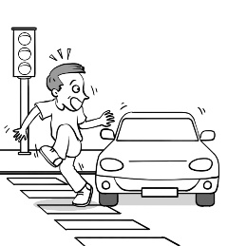
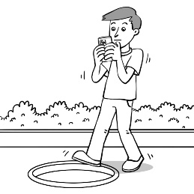
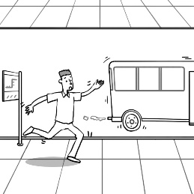
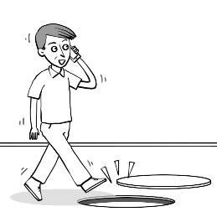
- Which picture tells the whole（整個的）dialogue?

(A) (B) (C) (D)
- What did Joe do after he fell into the hole?
(A) He cried for help but nobody heard him. (B) He sent a message to Liz.
(C) He climbed out without help. (D) He died at the bottom of the hole.
- What do we know from the dialogue?
(A) Joe’s clothes were dirty. (B) Joe’s cellphone is fine.
(C) Liz wasn’t surprised at all. (D) Joe broke his arm.
(二)
Many people go on a working holiday now. For young people, working holiday means a chance to get experience and an easy way to make money. It also lets people live in a foreign country for a while. During working holiday, people work as workers in the farm, waiters or waitresses in a restaurant, and so on. People can enjoy traveling in free time. They can also meet foreign friends when traveling. It is a good chance to know different cultures around the world. But some dangers may happen when they go on a working holiday. The best way to stay safe is to keep in touch with friends and family. It is never late to go on a working holiday. Let’s prepare for a working holiday!
for a while 一陣子 culture 文化 best 最佳的 keep in touch 保持聯繫
- What is this article about?
(A) Dangerous things in foreign countries. (B) Working holiday. (C) Different cultures in the world. (D) Making money.
- What can people NOT do during a working holiday?
(A) Meet foreign friends. (B) Get experience by working. (C) Stay in the foreign country for twenty years.
(D) Know different cultures.
58. What is the best way to avoid（避免）dangers?
(A) Keep in touch with family and friends. (B) Talk to strangers. (C) Walk alone on the street.
(D) Never go out with anyone.
七、依提示作答:每題3分，共9分(請在答案欄作答)
59. Ben and Vivian were reading books at that time. (依畫線部分造原問句)
60. Before Tony went to the birthday, he bought a gift. (以…after…改寫)
61. Terry likes having a cup of milk tea in the morning. (將畫線部分換成need並改寫句子)
八、翻譯填空:每格1分，共17分 (請在答案欄作答)
62.Fred 也覺得很累，但是他仍然不斷嘗試。
Fred was also , but he was still (t) .
63.Fred再試一次，然後終於跳出洞口。
Fred gave it another try, and he jumped out of the .
64.因為你們鼓勵我，所以我沒有放棄。
I didn’t because you me on.

嘉義縣太保國民中學109學年度第一學期二年級第二次段考英文科試題

命題老師：陳湘宜 範圍：Lesson 3～ Review 2 二 年 班 號 姓名：
65. 我花了一個月的時間找工作。
I a month work.
66.當我年紀夠大時，我也想要去打工度假。
When I am old , I want to a working (h) too.
67. 一開始時我很不快樂因為我不理解澳洲式英語。
In the (b) , I was unhappy because I could not (u) Australian English.
68. 昨天晚上七點我正為了明天的考試做準備。
I (p) for the test tomorrow at seven last night.

【 答 案 欄 】
七、依提示作答:每題3分，共9分
59.
60.
61.
八、翻譯：每格1分，共17分
62.
63.
64.
65.
66.
67.
68.

【請交回此卷，謝謝!】

