太保國中109學年度第二學期第1次段考一年級英語科試卷(P.1)
命題教師:李貞凌 命題範圍:B2L1~B2R1 ___ 年 ___ 班 ___ 號 姓名 ______
PART I聽力測驗
1~47題請將答案畫在電腦卡上
I.辨識句意(根據聽到的內容，選出正確的圖片代碼)：5%
( ) 1. (A) (B) (C)
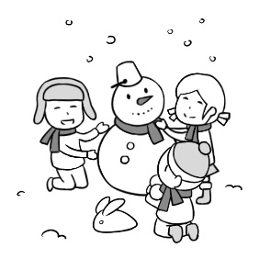 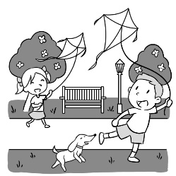 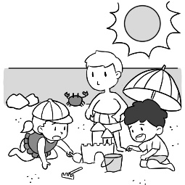
( ) 2. (A) (B) (C)
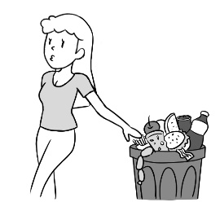 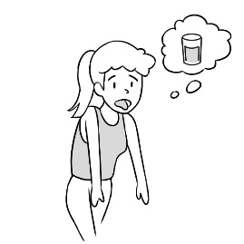
( ) 3. (A) (B) (C)
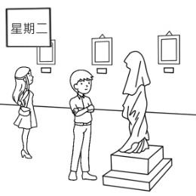 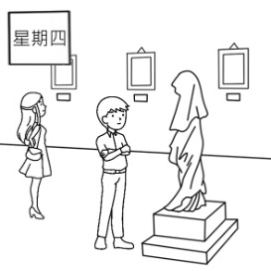 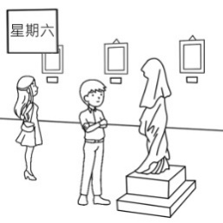
( ) 4. (A) (B) (C)
( ) 5. (A) (B) (C)
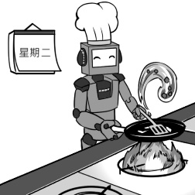
II.基本問答(根據聽到的內容，選出合適的回應)：5%
( ) 6. (A) Yes, he does.
(B) No. Who’s he?
(C) How do you know?
( ) 7. (A) It’s salty.
(B) Don’t waste it.
(C) Almost every day.
( ) 8. (A) Yes, everything’s fine.
(B) Yes, they have different styles.
(C) No, we go to different schools.
( ) 9. (A) It’s very special.
(B) It’s on Wednesday.
(C) It’s cool and cloudy.
( )10. (A) Only vegetables.
(B) Everything is great.
(C) No, she doesn’t have it.
III.言談理解(根據聽到的對話內容與問題，選出正確的答案)：10%
( )11. (A) On Fridays.
(B) On Tuesdays.
(C) On Thursdays.
( )12. (A) Monday.
(B) Tuesday.
(C) Wednesday.
( )13. (A) They build the charity.
(B) They help hungry people.
(C) They cook for their daughter.
( )14. (A) On Fridays.
(B) On Mondays.
(C) On Thursdays.
( )15. (A) Only meat.
(B) Only snacks.
(C) Only vegetables.

PART II讀寫測驗
IV.綜合測驗:40%
( )16. A: ___ the weather ___ here in summer? B: It’s hot and wet.
(A)How does ; like (B)What is ; like
(C)How is ; like (D)What is ; x
( )17. There are ___ people watching the exciting game now.
(A)three millions (B)five million of (C)millions of (D)three millions of
太保國中109學年度第二學期第1次段考一年級英語科試卷(P.2)
命題教師:李貞凌 命題範圍:B2L1~B2R1 ___ 年 ___ 班 ___ 號 姓名 ______
( )18. A: I can’t find my notebook. B: ___ Is this your notebook?
(A)Here is it. (B)Here is a notebook.
(C)Here they are. (D)Here your notebook is.
( )19. A:Is Lucy a singer or a writer? B:___
(A)Yes, she’s a singer. (B)She’s not a cook.
(C)No, she’s not a dancer. (D)She’s a writer.
( )20. David, my new friend, ___ to school every day.
(A)walk (B)walks (C)is walking (D)are walking
( )21. A: Who ___ your room every day? B: My mom ___.
(A)clean ; is (B)clean ; does (C)cleans ; does (D)is cleaning ; is
( )22.Many people in my class ___ fast food.
(A)like (B)likes (C)are liking (D)doesn’t like
( )23. Peter plays computer games ___ every Sunday.
(A)in (B)x (C)on (D)at
( )24. What ___ the robot do?
(A)is (B)do (C)are (D)can
( )25. ___ rains a lot in Taipei in winter.
(A)That (B)We (C)It (D)There
( )26. A: ___ our plan ___ this Sunday? B: Let’s go shopping.
(A)How’s ; for (B)Where’s ; in (C)What’s ; on (D)What’s ; for
( )27. Every boy in my class ___ tall and strong.
(A)are (B)do (C)is (D)does
( )28. The cat is ___ the mouse.
(A)fast enough to catch (B)enough fast to catch
(C)fast enough catching (D)enough fast catching
( )29. A: ___ your mom go to the market every day?
B: ___. She goes there only on the weekend.
(A)Does ; No, she doesn’t. (B)Is ; No, she isn’t.
(C)What ; No, she doesn’t. (D)Does ; Yes, she does.
( )30. A: ___ B: He is a baseball player.
(A)What is Tom doing? (B)What does Mr. Li do?
(C)What can Peter do? (D)What do you do?
( )31. A:What day is the meat-free day at your school? B:___
(A)It’s Friday. (B)We can have only meat on that day.
(C)It’s on Tuesday. (D)We have meat on Mondays.
( )32.Be careful! The vase(花瓶) is made ___ glass.
(A)in (B)on (C)of (D)with
( )33. Mr. and Mrs. Wang ___ a table on Christmas at this restaurant.
(A)throw (B)know (C)plan (D)book
( )34.Judy helps her mom ___ the bathroom every day.
(A)cleaning (B)to cleaning (C)clean (D)with clean
( )35.Don’t waste your time ___ TV all day.
(A)watching (B)to watch (C)watch (D)to watching
V.閱讀測驗:12%
[A]
Larry’s Kitchen
Meal | Time | Adult | Children  100cm to 140cm
Breakfast | 6:00~10:00 | $300 | $200
Lunch | 11:00~14:00 | Weekday:$300 | $250
 |  | Weekend:$400 | $350
Dinner | 17:00~21:00 | Weekday:$400 | $350
 |  | Weekend:$500 | $450
- We provide(提供) meat-free meal only on the second weekend of the month(月).
- Children under 100cm are free.
- You can get 20% off on your birthday.

TEL:(02)2712-4567
Address:100 Chunsang North Rd., Taipei.
( )36. Cindy takes her 95-cm-tall son and 125-cm-tall daughter to Larry’s Kitchen at 6 o’clock on Tuesday evening. How much should they pay?
(A)$850. (B)$900. (C)$750. (D)$650.
太保國中109學年度第二學期第1次段考一年級英語科試卷(P.3)
命題教師:李貞凌 命題範圍:B2L1~B2R1 ___ 年 ___ 班 ___ 號 姓名 ______
( )37. Mr. and Mrs. Huang are vegetarians(素食者). What day can they have meals at Larry’s Kitchen?
(A)On Tuesday. (B)On Monday. (C)On Saturday. (D)On Friday.
( )38. Today is Sunday and it is also Henry’s birthday. He wants to have dinner to celebrate(慶祝) his birthday with his wife at Larry’s Kitchen. How much should they pay?
(A)$950. (B)$900. (C)$1000. (D)$850.
[B]
Wanted (English Speaking Teacher) |  | Wanted(Piano Teacher)
*Good English, some Chinese  *Over one-year teaching experience(經驗)  *Age: 30~45  *Love to teach kids  *Work five days a week  *NT$2,000/day  E-mail:Sara@yahoo.com.tw |  | *Teach kids piano on Tuesday and Friday evenings  *NT$500 per(每) hour  Hoho Music School(No. 102, Zhongshan North Rd., Taipei)
Wanted(Tour Guide) |  | Wanted(Waitress)
*Enjoy traveling and can speak good English  *To take visitors from the USA to some famous places in Taiwan  *Age: 25~40(men only)  *NT$10,000/5 days(March(三月) 5~March 9)  Please call Mr. Chen at 02-86651234 |  | *Age: 18~25  *Work 6 hours on Saturday  *NT$150 per hour  Call Mandy at 2568-8988
( )39. Nancy loves teaching piano, and she is free in the evening on weekdays. How can she get a part-time(兼差) job?
(A)Call Mr. Chen. (B)Call Mandy. (C)Go to Hoho Music School. (D)E-mail Sara.
( )40. Jessie is an international student in Taiwan. She wants a part-time job on weekends. How much can she get in a week?
(A)$10,000. (B)$3,000. (C)$1,200. (D)$900.
( )41. Who can be a tour guide?
(A)Jeff. He is 42 and loves traveling around the world.
(B)Wendy. She is 20 and speaks good English.
(C)Nick. He is 35 and good at English. He also loves traveling.
(D)Nina. She is a 32-year-old woman. She loves cooking.
VI.克漏字測驗:6%
[A]
(Sara has a job interview(面試). Now she is talking 42 Mr. Hill.)
Mr. Hill: Please sit down.
Sara : Thank you.
Mr. Hill: I have to make sure some things first. What languages(語言) 43 you good at?
Sara : Chinese, of course. I can also 44 good English and a little Japanese.
Mr. Hill: Good. By the way, everyone in this office 45 how to use a computer. How about you?
Sara : Sure. I can use Word, Excel, and PowerPoint.
Mr. Hill: Great. Well, 46 you like sports?
Sara : Yeah! I like tennis and basketball. I like water sports most(最), and 47 is my favorite.
Mr. Hill: Good. Everyone in our office needs a strong body because it is a tiring(累人
的) job. OK. Thanks for your time. I’ll call you soon.
Sara : Thank you.
( )42. (A)about (B)at (C)with (D)x
( )43. (A)do (B)are (C)does (D)can
( )44. (A)say (B)talk (C)tell (D)speak
( )45. (A)knows (B)is knowing (C)know (D)to know
( )46. (A)are (B)what (C)does (D)do
( )47. (A)baseball (B)swimming (C)bird-watching (D)shopping

太保國中109學年度第二學期第1次段考一年級英語科試卷(P.4)
命題教師:李貞凌 命題範圍:B2L1~B2R1 ___ 年 ___ 班 ___ 號 姓名 ______
48~58題請將答案寫在答案欄
VII.文意字彙:6%
___48. A: Are you h y now?
B: No, I can’t eat anything. I’m full now.
___49. Mr. Wang is kind and helpful(樂於助人的). He is a v r in the hospital.
___50. It’s w y today. Let’s fly a kite(風箏) in the park.
___51. Can I have some water? The dish is s y.
___52. Elementary school(國小) students don’t have class on W ys.
___53. Andy is c ing on the phone with his friend.
VIII.翻譯(54~56每格1分；57~58每題3分):16%
54.我們住這家飯店吧! 它的早餐很特別。
Let’s ___ at the ___! Its breakfast is ___.
55.今年冬天，他們用冰來建造不同風格的房間。
They ___ the rooms of different ___ ___ ice this winter.
56.這位老先生每年給這個慈善機構很多錢。
The old man ___ ___ money ___ the ___.
57.這裡有一個Uncle Bill給的禮物。(用Here開頭)
58.Wendy星期天早上都在家讀英文。

答 案 欄

____ 年 ____ 班 ____ 號 姓名 ____________
VII.文意字彙:6%

48. ____________ 49. ____________

50. ____________ 51. ____________

52. ____________ 53. ____________

VIII.翻譯(54~56每格1分；57~58每題3分):16%

54. ____________ ____________ ____________

55. ____________ ____________ ____________

56. ____________ ____________ ____________ ____________

57. ___________________________________________________

58. ___________________________________________________

太保國中109學年度第二學期第1次段考一年級英語科試卷(P.5)
命題教師:李貞凌 命題範圍:B2L1~B2R1 ___ 年 ___ 班 ___ 號 姓名 ______
解答
1-10每題1分
11-41每題2分
42-47每題1分
- 5 BCCAA 6-10 BCCCA 11-15 BABAC
16-20 BCBDB 21-25 CABDC 26-30 DCAAB
31-35 CCDCA 36-40 CCBCD 41-45 CCBDA
46-47 DB
VII.文意字彙:6%

48. hungry 49. volunteer

50. windy 51. salty

52. Wednesdays 53. chatting

VIII.翻譯(54~56每格1分；57~58每題3分):16%

54. stay hotel special

55. build styles with

56. gives much to charity

57. Here is a gift from Uncle Bill.

58. Wendy studies English at home on Sundays(every Sunday).

